**Premise Priority Clearance Plan**

Snow and Ice



**Premise: Catrine Primary School**

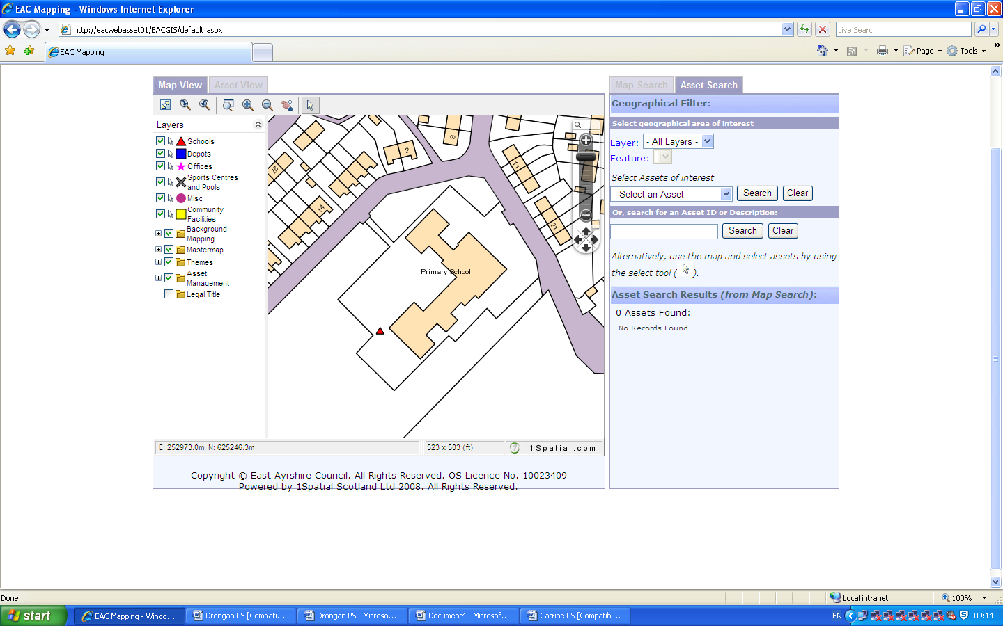

Pupil Entrance

**Infant**

**Entrance**

**Main Entrance**