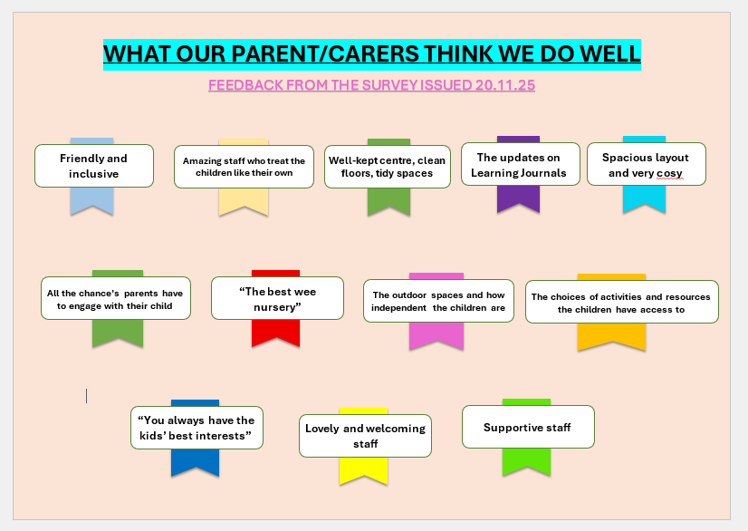
We are always looking to improve our service and really appreciate the time families take to complete questionnaires to help us try to do this.
We received 9/39 responses and have actioned/planned actions for each.
Thank you to everyone who completed the FORM
