Catrine Early Childhood Centre
Trip to Kelburn Country Park 2025
ITINERARY

8.45am – 9am | ECC gates will open for a prompt 9am registration taking place outdoors in the playground area | Children’s ECC waterproofs available
9.15am | Bus departs Catrine ECC | 
10am | Bus arrives at Kelburn Country Park  Follow Group Leader to first station
10.15am – 11.25am | 2 x stations before lunch  10.15 – 10.45am then 10.55 – 11.25am  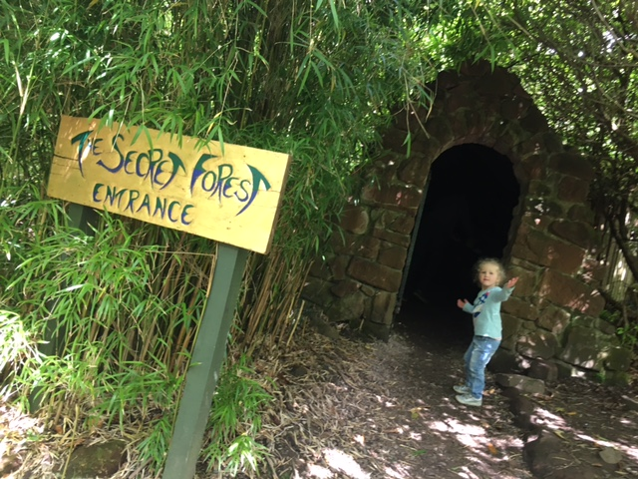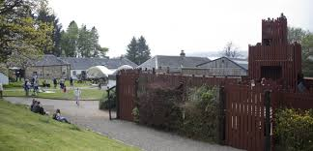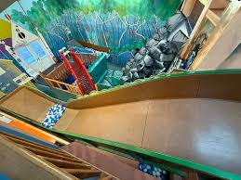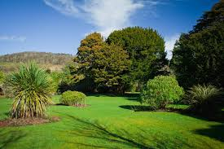 | Adult participation at each will be encouraged for a fun filled afternoon of laughs and engagement.
11.30am -12pm   | Lunch (In The Museum and an overspill area near The Cafe)  Packed lunches will be distributed to the children by the ECC staff  We would advise parent/carers to bring their own packed lunch in case we are not based near a café or it has large queues etc | We have paid for a sheltered area for the children’s lunch in case of bad weather
12.10pm – 1.20pm | Remaining 2 x stations  12.10 – 12.40pm and 12.50 – 1.20pm | Adult participation continued
1.20pm – 2pm | Free time to visit gift shop if you would like to, animals, Glen Walk, toilets etc then make way to bus | Staff pack away items on bus
2pm | Prompt bus departure
2.45pm | Bus arrives back at Catrine ECC | Hand in any ECC medication

