**Premise Priority Clearance Plan**

Snow and Ice



**Premise: Catrine Early Childhood Centre**

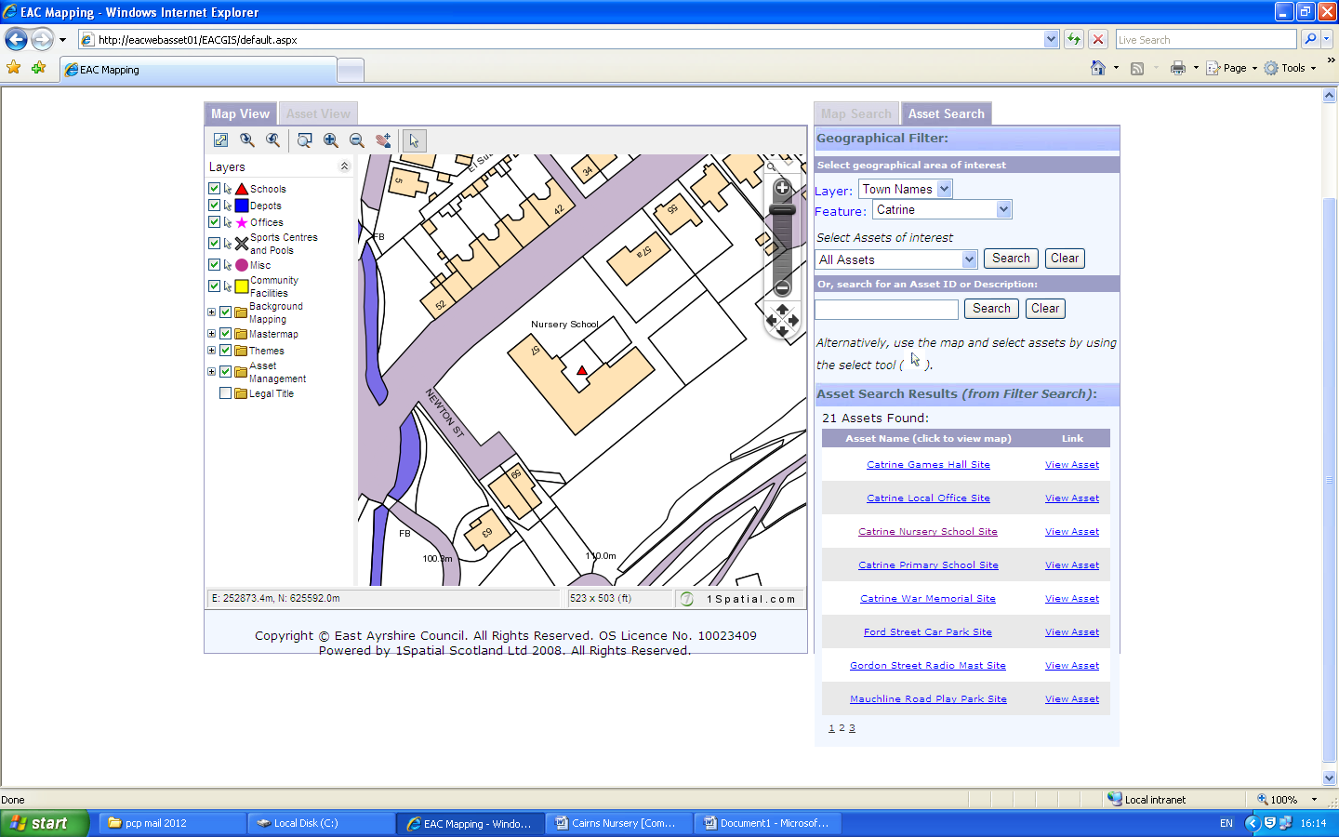

**Main**

**Entrance**

**Newton Street**

**Review date: November 2025**

**JF/JG**