

Catrine Early Childhood Centre

Parental Engagement

We would like to take this opportunity to invite **all parent/carers of children who still use a dummy and/or are not fully toilet trained to a parent workshop/appointment on** **Tuesday 5th September here at Catrine ECC at 9am.**

This session will be led by our Community Practitioner Lauren who will offer support, guidance and advice on both topics.

It will give you a chance to hear other parent/carer challenges, as well as give you the opportunity to ask questions and feel part of a supported network as we work alongside families to support your child.

We are aware that some parents may not be able to attend due to work commitments however if this is the case home visits can be arranged from the Health Visiting team.

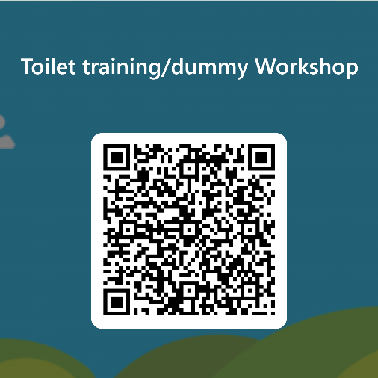

Please use the QR Code opposite, OR follow the link below to confirm your attendance at the workshop.

We thank you in your support with this.

<https://forms.office.com/Pages/ResponsePage.aspx?id=oyzTzM4Wj0KVQTctawUZKRqhoaEMY8FHkTJQGETc2XZUNTlTSE5OQlVTQ0NGQzE3Wk1JUk9NM1NFSC4u>