Early Years Menu 2023/24 – Week 3
Monday | Tuesday | Wednesday | Thursday | Friday
LUNCH | LUNCH | LUNCH | LUNCH | LUNCH
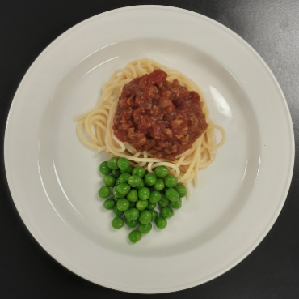 | 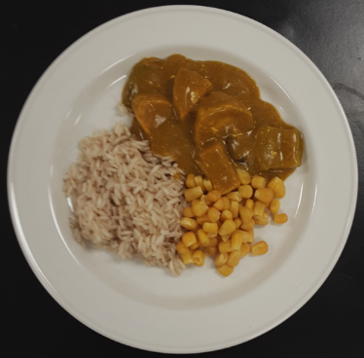 | 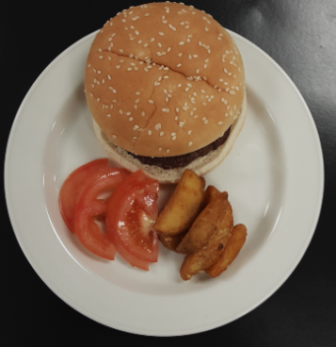 | 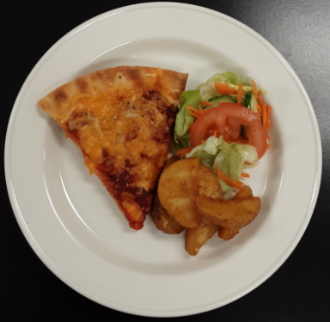 | 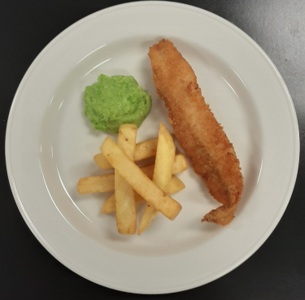
Spaghetti Bolognese & peas | Chicken curry, rice & sweetcorn | Beef burger in a bun, potato wedges & sliced tomatoes | Homemade cheese & tomato pizza, potato wedges & mixed salad (V) | Fish, chips & mushy peas
DINNER | DINNER | DINNER | DINNER | DINNER
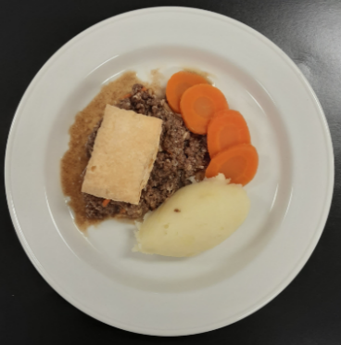 | 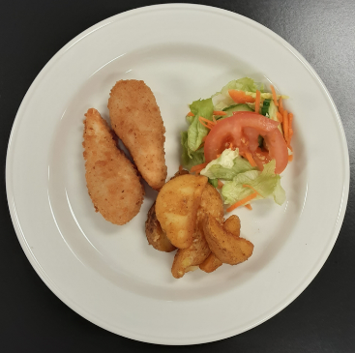 | 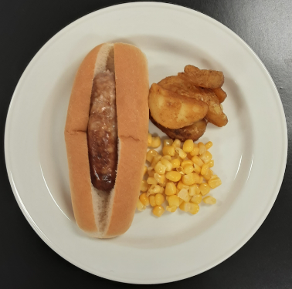 | 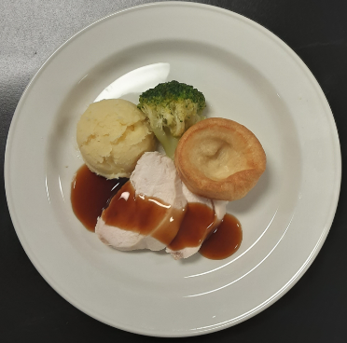 | 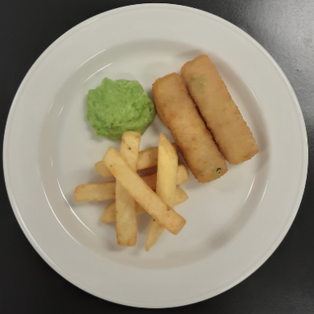
Steak mince pie, mashed potato & carrots | Chicken goujons, potato wedges & mixed salad | Hotdog, potato wedges & sweetcorn | Roast chicken, Yorkshire pudding, mashed potato & broccoli | Salmon fish fingers, chips & mushy peas

