Early Years Menu 2023/24 – Week 2
Monday | Tuesday | Wednesday | Thursday | Friday
LUNCH | LUNCH | LUNCH | LUNCH | LUNCH
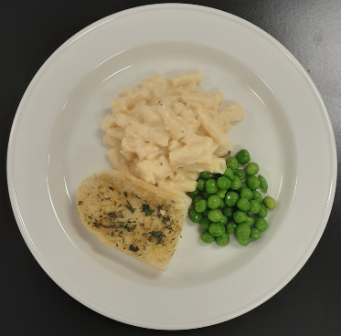 | 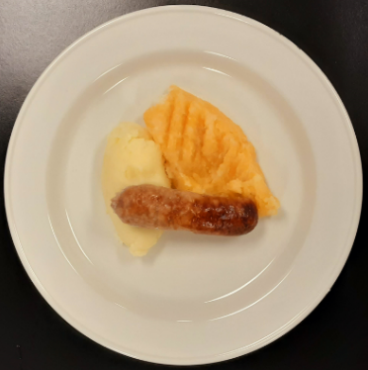 | 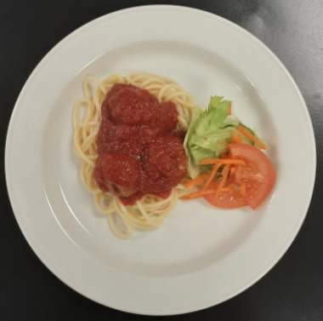 | 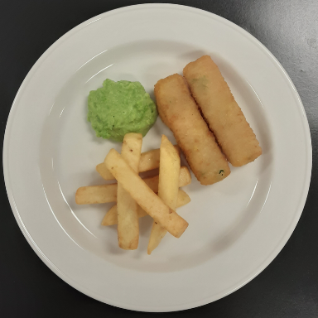 | 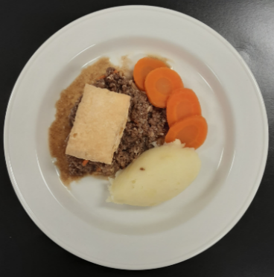
Macaroni, garlic bread & peas(V) | Pork sausage, mashed potato & turnip | Chicken meatballs in tomato sauce, spaghetti & mixed salad | Salmon fish fingers, chips & mushy peas | Steak pie, mashed potato & broccoli/cauliflower
DINNER | DINNER | DINNER | DINNER | DINNER
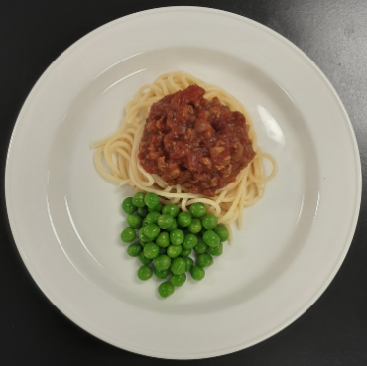 | 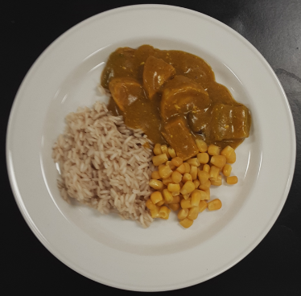 | 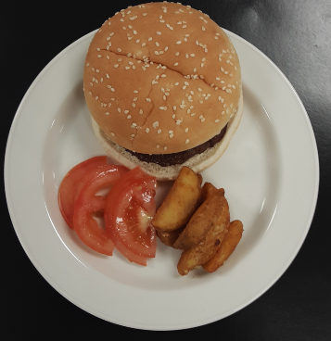 | 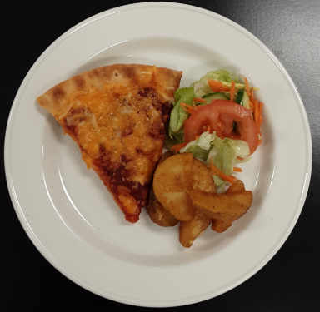 | 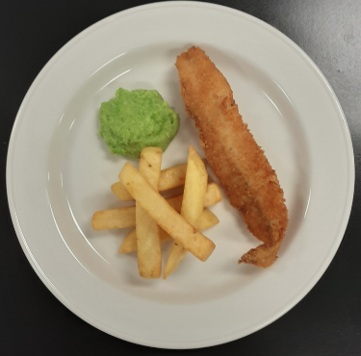
Spaghetti Bolognese & peas | Chicken curry, rice & sweetcorn | Beefburger in a bun, potato wedges & sliced tomatoes | Homemade cheese & tomato  Pizza, potato wedges & mixed salad | Fish, chips & mushy peas

