Early Years Menu 2023/24 – Week 1
Monday | Tuesday | Wednesday | Thursday | Friday
LUNCH | LUNCH | LUNCH | LUNCH | LUNCH
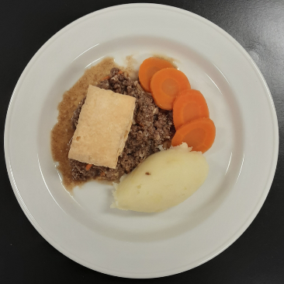 | 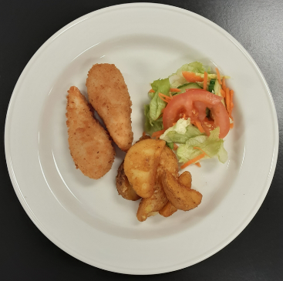 | 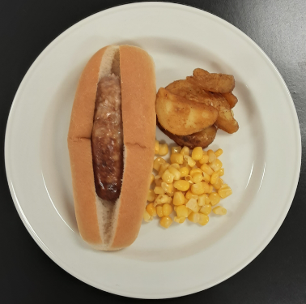 | 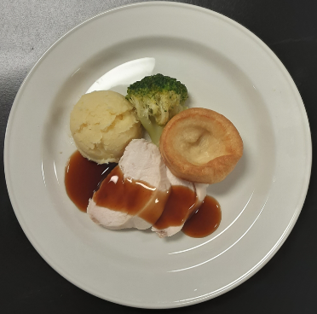 | 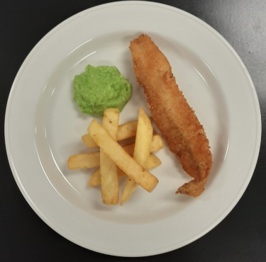
Steak mince pie, mashed potato & carrots | Chicken goujons, potato wedges & mixed salad | Hotdog, potato wedges & sweetcorn | Roast chicken, Yorkshire pudding, mashed potato & broccoli | Fish, chips & mushy peas
DINNER | DINNER | DINNER | DINNER | DINNER
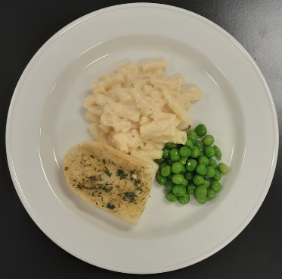 | 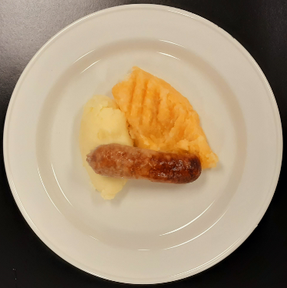 | 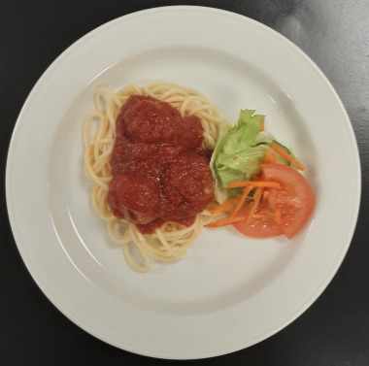 |  | 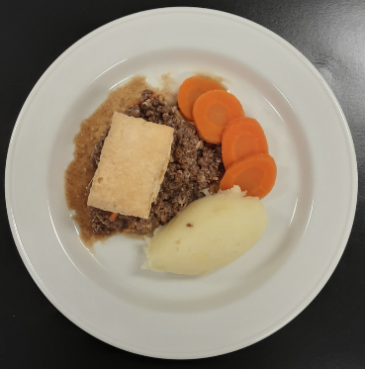
Macaroni, garlic bread & peas (V) | Pork sausage, mashed potato & turnip | Chicken meatballs in tomato sauce, spaghetti & mixed salad | Fish, chips & mushy peas | Steak pie, mashed potato & broccoli/cauliflower

