Permission and information for ECC Summer Trip to
Dean Castle Country Park

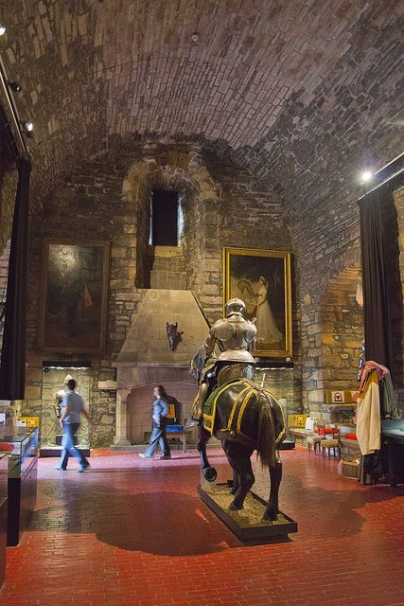
Last year we had the best trip ever!!!! And this year we are aiming to make it even better
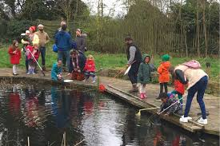
We have teamed up with Dean Park Rangers to offer a fun filled day out for YOU AND YOUR FAMILY to enjoy and make memories, so get your singing voices at the ready for the bus trip there and back
With two buses booked, there is a seat set aside for 1 parent/carer with every child. On the slip of paper attached, please state the name of the adult accompanying your child and return this along with the EV5 form and sponsor sheet. If other family members/younger siblings wish to attend, they are more than welcome to drive/car share and meet us there.
An action packed itinerary will be sent out soon.
Don’t forget to keep counting up your child and adult steps. Once all sponsor sheets have been handed back in on or before Friday 2nd June we will calculate all of our steps and find out if we have hit our target of a MASSIVE 4 MILLION STEPS.
Staff are clocking up their steps in support too so best of luck to everyone

Please note any additional money raised will go towards end of year celebrations for all children.

Thank you for your continued support and we look forward to spending the day with you on Tuesday 20th June from 9am – 2.30pm

