TERM 2 Newsletter
What has happened since our Term 1 newsletter?
IT HAS BEEN ANOTHER BUSY FEW WEEKS:-
- We have welcomed 11 new children and their families into our centre who are settling in well.
- Our Peer Massage programme finished and we offered it out to our parent/carers for our final session. Dougie Mirfin led this very relaxing experience to which 7 parent/carers attended. Feedback was very positive for this and we hope that the techniques you learned will help to promote positive interactions and mindfulness at home.
- A 4-week block of PEEP sessions were advertised and attended by nine families. Again, feedback sheets to our Community Practitioners were very positive and we hope to offer this again next year to allow other families the opportunity to engage also.
- Our parent appointments for all of our children have now taken place – thank you to everyone that attended this or took the appointment over the phone if this was your preferred option due to work commitments. (Appointments for our November starts will take place in December - dates TBC)
- During our In-service day on 24th October, we worked alongside the school to review and update our PS and ECC Curriculum Rationale. We will soon be looking for parent/carer input to this to allow us to complete this.
- Carrie and Tammie have a super expressive arts home link programme up and running and look forward to seeing all of your super creations.
- Our Halloween Party was a hit by all with super pictures on Learning Journals.
- Tempest Photography took the most beautiful photographs of the children that can be ordered online in time for Christmas if you are fast.
- And last but not least, the children have spent the last 2 weeks celebrating Science and Nursery Rhyme Week. Both had stimulating experiences on offer that were well planned by our champions, Sherrie (STEM – Science Week), Julie (Communication) and Leoni (Literacy) Nursery Rhyme Week.
Dates for your diary
Monday 21st November | Fluoride Varnishing
Wednesday 30th November | St. Andrews Day – children can come to the ECC wearing something tartan or Scottish if they wish
05.12.22 – 09.12.22 | Raffle tickets & Lucky Squares will be available
Monday 5th December | Welcoming 5 new children to the centre
Thursday 8th December | Christmas themed Stay and Play with Bookbug session
12.12.22 – 16.12.22 | Enterprise projects by the children will be available
Friday 16th December | Christmas lunch – children can come wearing a Christmas jumper if they wish to – please do not go to any extra expense for this if they do not have 1 – if you speak with a member of staff we can give him/her tinsel or paint a tree etc on their face instead
Monday 19th December | Carol singing in the Square 2pm (parents welcome)  Raffle and staff donated hamper will be drawn
Thursday 22nd December | Christmas Party with Ashley from Party Sensory
Friday 23rd December | School and ECC closes at 2.30pm for Christmas
Monday 9th January | Children return to the ECC for Term 3

Film Stars of Catrine
As you are aware, due to permissions that were required, we were approached by Scottish Government last month relating to our excellent practice in how we plan and support communication within our setting. This was a huge compliment to the staff here at Catrine ECC and we are very proud to have been filmed showcasing just some of the strategies we use. This was then presented at the Children and Young People Improvement Collaborative (CYPIC) conference on Tuesday 15th November to over 500 people in Glasgow. You can watch the video by following the link below I am sure you will agree the children were absolutely fantastic and took it all in their stride.
https://vimeo.com/channels/1821612
Events outwith the ECC you may be interested in
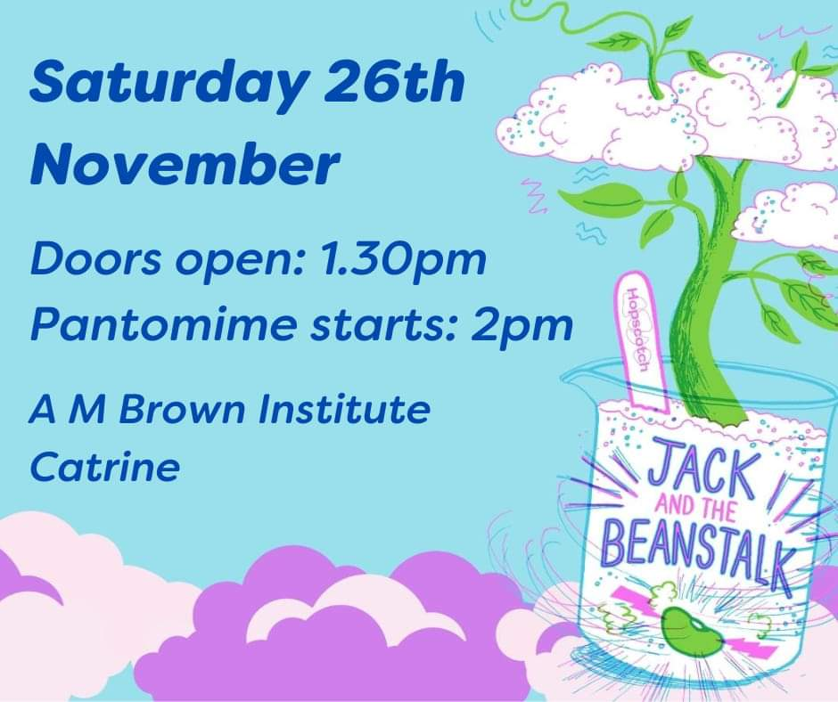
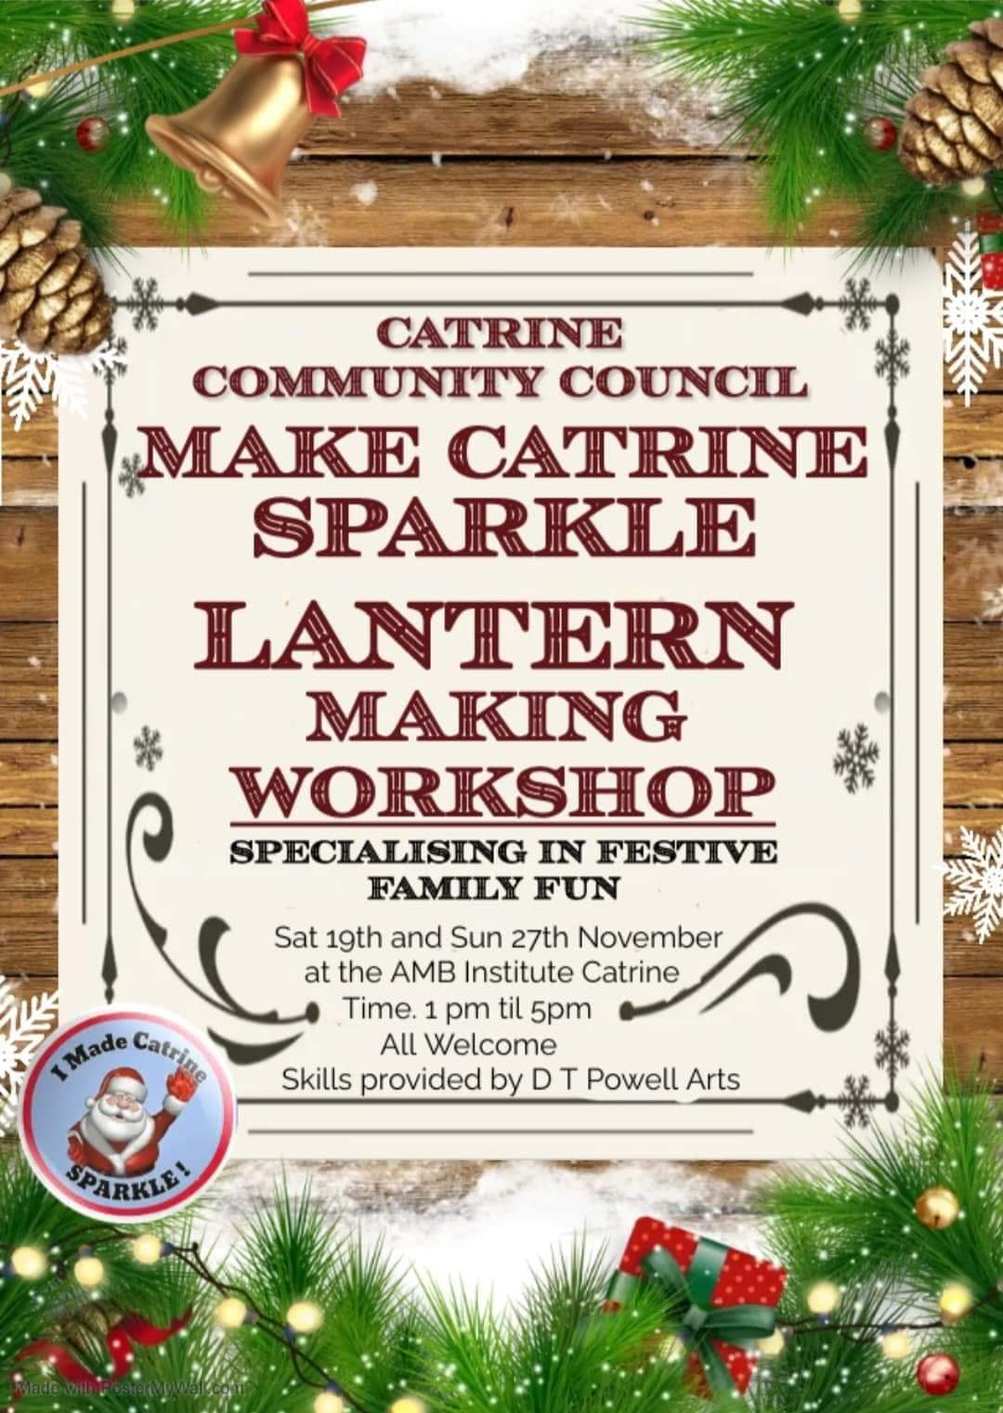

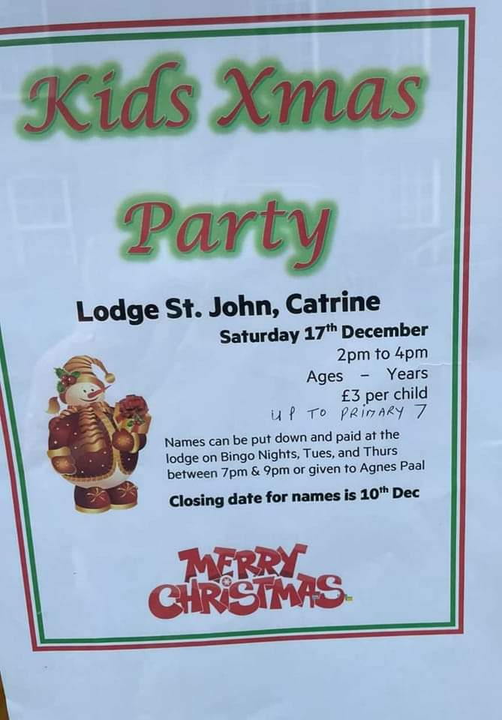

Newton Street ECC
Our original ECC at Newton Street is looking superb both indoors and out with the new roof at the back now complete. Phone lines are being hooked back up, our fab East Ayrshire I.T team are in setting up our technology and Blaze our famous horse is due to be placed back down in the corridor where he belongs. As soon as we have any further information in relation to a confirmed move date we will let all parent/carers know.

