

**February Newsletter**

Big News this month – the ECC will reopen on Monday 22nd February

Reminder of new bubbles

**The Magnificent Mini beasts Bubble consists of:-**

**Carrie's Caterpillars**

**Sherrie's Bumblebees and**

**Rena's Butterflies**

**Drop off time - 8.35am on the rainbows, pick up time - 2.35pm (with the option to collect at 12.15pm after lunch if you choose to use only half days)**

**The Spectacular Sea Creatures consists of:-**

**Michelle's Sharks**

**Julie's Jellyfish**

**Jan's Dolphins and**

**Leoni's Starfish**

**Drop off time - 8.45am on the sunshines, pick up time - 2.45pm (with the option to collect at 12.20pm after lunch if you choose to use only half days)**

We ask that you continue to support us in providing a safe provision for our children by observing current social distancing guidelines:

* always wearing a face covering at both drop off and pick up times unless you are exempt for medical reasons
* ensuring that you maintain a 2 metre distance between yourself and all other adults, including staff
* carrying out handwashing and sanitising before and after ECC pick-ups and drop offs.

[](https://www.google.co.uk/url?sa=i&url=https%3A%2F%2Fcallie.holliefindlaymusic.com%2Fdolphin-clipart-jpg.html&psig=AOvVaw0559vfYK0mGt7m_WWcULfu&ust=1607012012939000&source=images&cd=vfe&ved=0CAIQjRxqFwoTCOjdrsjYr-0CFQAAAAAdAAAAABAJ)Staffing Update

Amanda will be covering Jan’s Dolphin group upon our return. Amanda has been in the ECC during our in-service days helping the team to get the centre ready for Monday and is very excited to meet everyone ☺

Thank you

16 parent/carers responded to our online survey on our APP and GLOW and we are delighted with the positive comments and feedback from each of them. I have highlighted a few points and comments below. Thank you for your time.

**“A good variety of activities have been provided. It’s good that we are able to complete them at any time. No pressure to do it that day…..We have enjoyed seeing some of the staff on the screen.”**

**“Targets are clear and easy to understand.”**

**“Supportive phone call to ensure I understood the targets and how best to support my child meeting these.”**

**“Thank you for all staff commitment. We feel that regardless of changes and uncertainty staff have remained positive and supportive ensuring the wellbeing of our children is embedded in all posts.”**

**“Well done Team Catrine. Tricky times for us all but you brighten our days and weekends with your activities and posts.”**



ONE PARENT COMMENT FOR DEVELOPMENT WAS…..

“We try to do everything, only suggestion would be to get info the day before to get stuff.”

This will be taken on board, fingers crossed not for anymore Lockdown situations, but for future home link initiatives we send out to parents. Thank you for your honestly and your suggestion.



ONLINE REGISTRATION

Our GLOW blog and APP has information relating to online registration for the new 21/22 term. Please make use of both forms of communication if you require any further details in relation to this or access the East Ayrshire Council website.

A VERY SPECIAL VISITOR

Your child will come home with a very important letter requiring you to give/or not to give consent to. May we ask that you look out for this exciting letter and return your permission as soon as possible please. If you would like any further information or Risk Assessments when you receive your letter please phone into the centre.

NEW RESOURCES

Whilst staff have been providing critical childcare in the centre, one of the other tasks they have been undertaking is auditing current resources for our ever developing curriculum. With exciting experiences and opportunities in mind that we endeavour to offer to the children, we have ordered lots of new resources for the children returning. We will be sure to post plenty of pictures of the children exploring with them in the coming weeks.

WORLD BOOK DAY

To celebrate World Book Day on Thursday 4th March Julie our Communication Champion and Leoni our Literacy Champion have been busy planning some super fun activities for you to participate in. Look out for more information about this later in the week.

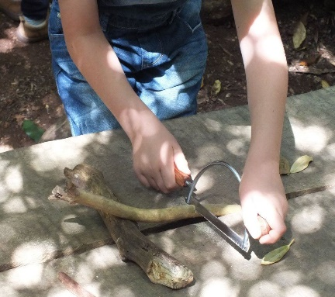STEM PROJECTS

Both before and during lockdown Sherrie has been working hard to develop our STEM (Science, Technology, Engineering and Maths) experiences we can offer to the children. We will be continuing to promote the use of our new workbench and real tools upon our return as well as reintroducing our outdoor loose parts into both garden areas. Look out for an update soon on our progress and journey in this particular area of the curriculum.

SUPPORT SESSIONS

Our Communication, Literacy and Maths and Numeracy Champions will continue to provide groups within the ECC. These groups are designed to raise attainment levels within the centre through focused play based sessions offering support and reinforcement of skills.

IN-SERVICE TRAINING

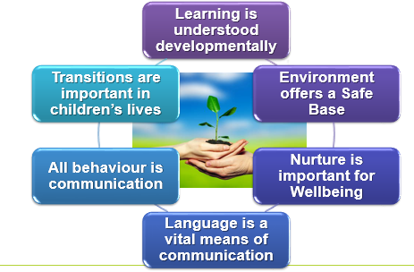During one of our recent in-service days here at Catrine ECC Alana carried out a Nurture training session for the team. There are 6 Nurture Principles that we ensure here at Catrine ECC we promote daily.

This term we are looking in particular at **Nurture Principle 2 – The Environment offers a Safe Base.** This has given us a basis to develop each of our 4 playrooms and 2 outdoor areas into a way that can continue to improve and promote some of the following,

* Clear routine and predictability to enable security for the children’s mental wellbeing
* Ensuring a nurturing, safe space is readily available in both bubbles to support any child wanted or needing a quiet time on their own when feeling overwhelmed
* A rich environment to support the ability to develop quality interactions and positive relationships between staff and children in our centre, and
* Play spaces both indoors and out are places where children can feel valued, respected, listened to and challenged.



As always please do not hesitate to get in touch with any comments, questions or ideas –

Email address [alana.speirs@eastayrshire.org.uk](mailto:alana.speirs@eastayrshire.org.uk)

Phone 01290 551233