The Catrine Village Halloween Pumpkin Hunt 2020
The children have been busy decorating a pumpkin during group time this week.
They each went on secret walks to hide their pumpkins within the local community for you to find on your way home or over the Halloween weekend. If you are going out at night don’t forget to take a spooky torch with you or use your mobile phone.
Take a selfie with one of the pumpkins and send it into the ECC.
jan.wardrop@eastayrshire.org.uk
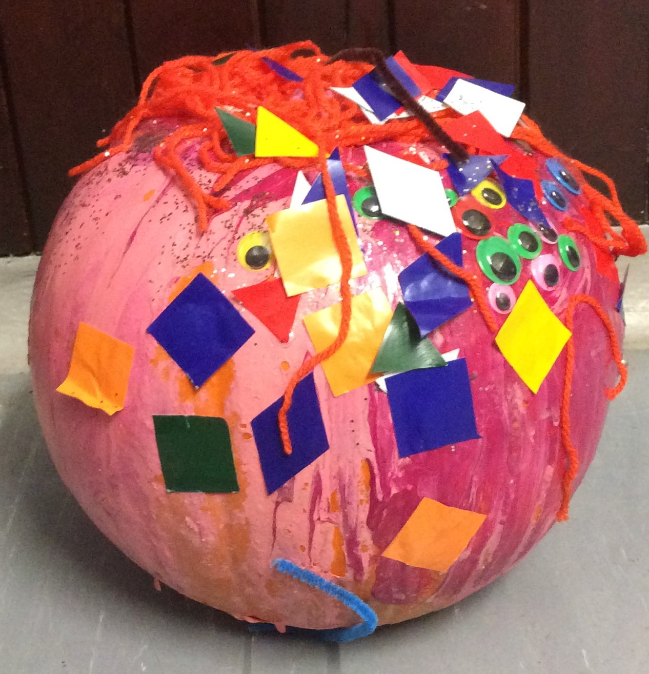
Here are some clues:-
- As you leave the ECC take some time and look for me……
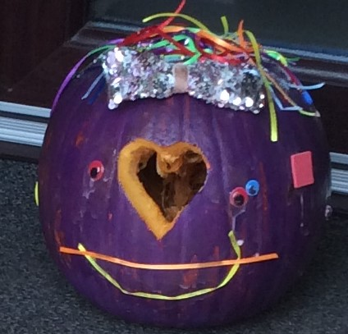

- Along Newton Street we go, where does Janet stay, do you know?

- We have lots of steps to climb, I don’t know how many, can you count
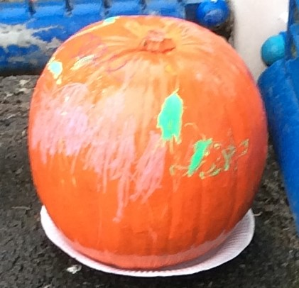

them?
Past the games hall we shall go, what can you see in the cage below??
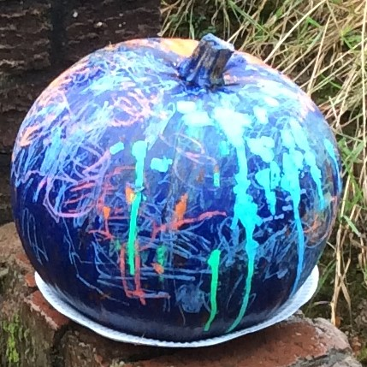

- Oh no!!! The school bell – we don’t want to be late
I wonder who that can be sat by the gate???

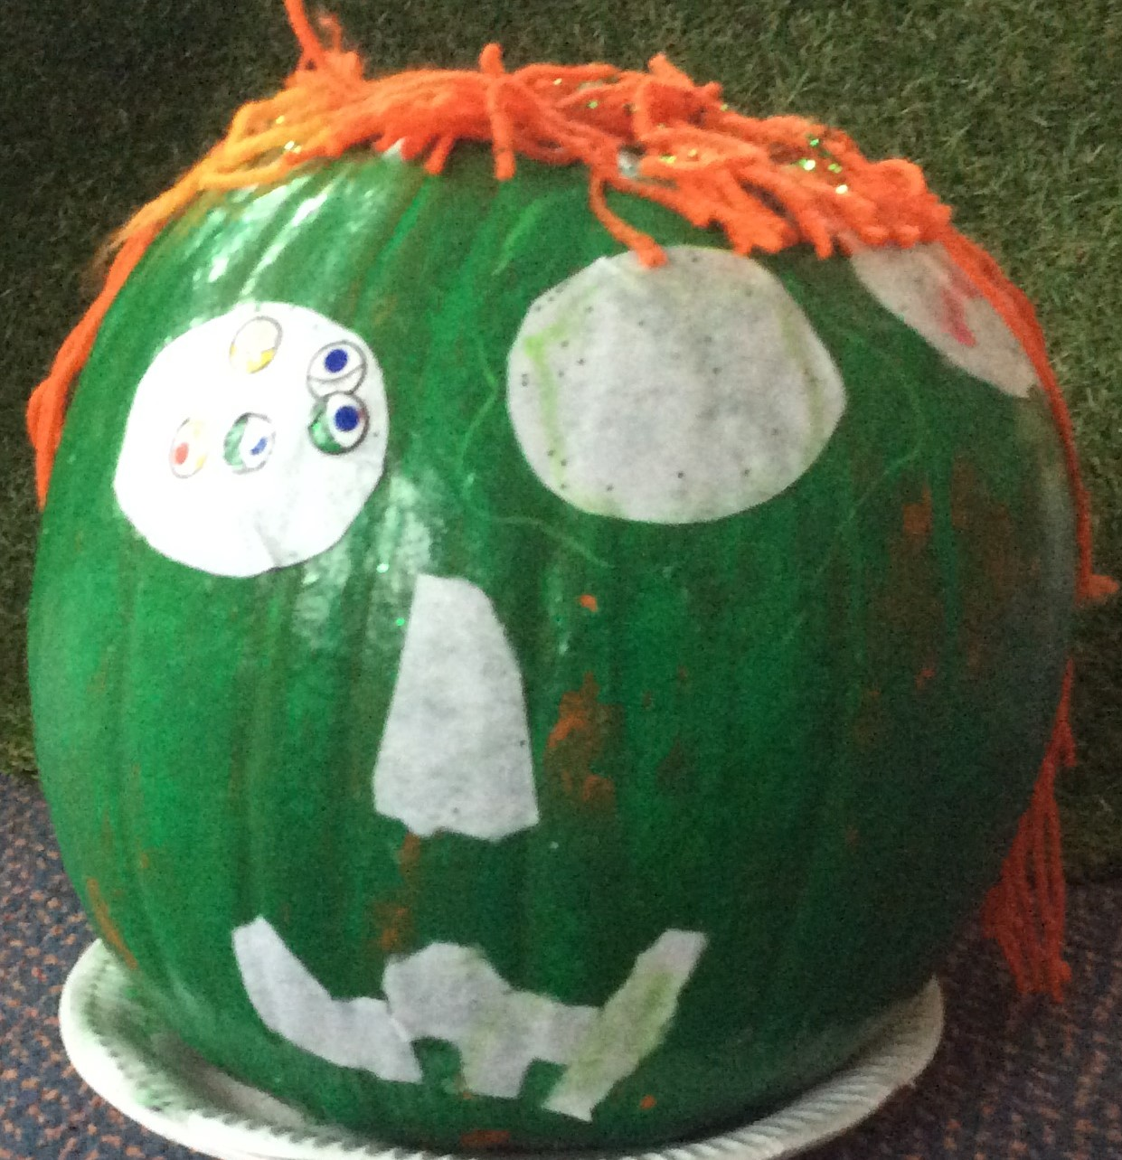
- Just 2 more to find, let’s head back to the square,
Have a look in shop windows - what can you find and where???
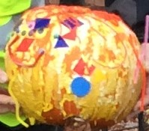

- The pumpkin patch is where we end
Feel free to pass this Halloween Hunt onto a friend

We hope you have enjoyed this adventure as much as the children have preparing for it. Please remember to social distance at all times.

Happy Halloween Everyone love from
Catrine ECC

