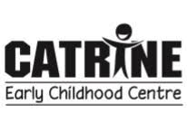
September Newsletter
What has happened since we reopened in August?
LOTS
- Staff have welcomed in a total of 40 children with the majority of them very settled and confident now with all new routines and extra hygiene procedures in place with regards to COVID-19. Both bubbles consist of 20 children with 5 Early Learning & Childcare Practitioners (ELCPs) in the morning and 4 ELCPs in the afternoon.
- We have also welcomed 3 new practitioners to our team on a temporary basis until permanent positions are filled –
  - Lauren Griffiths – 8.40am – 12.40pm
  - Sandra Cairns – 8.40am – 12.40pm
  - Nicola Angus – 11am – 3pm
They have already proved to be a super addition to our team and have settled in as well as the children
- We have moved from our initial 2.5 day provision due to COVID restrictions and back into our extended 1140 hour service. We are delighted to say that this has been a smooth transition for us all.
- We have continued to review practice over the past few weeks in order to improve our day to day routines ensuring best outcomes for everyone.
Thank you
We would like to take this opportunity to say thank you for returning Annual Data forms and EV5s. These forms allow us to take the children out and about in the community providing various experiences for exploration and learning. On that note we ask that you remember to send your child appropriately dressed for all weathers as they will be accessing outdoors EVERY DAY.
A huge thank you also for those of you that took time to complete our online survey via GLOW - comments were extremely positive and staff were delighted with your continued support.

Here is our responses to the improvement ideas suggested by parent/carers
“X can be reluctant to tell us what she has been doing so some photos/blog updates on what’s been happening would be really helpful to try and encourage her to tell us more. However, we are completely happy with the service you are providing and X is always happy at nursery.”
“Maybe more pictures of what they are doing during the day, especially pictures of how they are staying safe. Hand cleaning stations etc.”
Starting after the September weekend each keyworker will upload individual photos of their keyworker children onto GLOW, if permission has been given. This will begin to show progression and showcase interests and learning during their time here. These posts will be uploaded into their group folder so remember to check regularly.
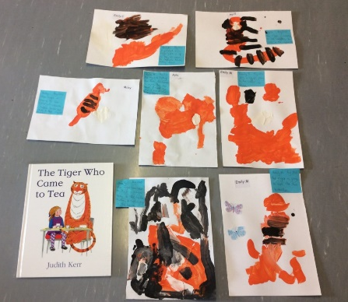
SMT will also continue to upload day to day learning experiences and WOW moments both onto GLOW and TWITTER so remember to follow us @CatrineECC.
Children have started recording their learning onto their own individual Learning Journals in floor book format. We use this form of recording to allow the children ownership of their books and to develop children’s love for reading and literacy.
Although we encourage and promote the use of technology through digital cameras, tools, electrical and battery operated appliances we do support No Screen Time days in partnership with Speech and Language Therapists.

Saying “Hi” again to familiar faces
For the remainder of the month we plan to have each staff member out at drop off/pick up. We feel this will help you to put faces to names and say hi again to staff who your child or yourself may have been close to last year. We obviously ask you to be mindful of social distancing at this time.
Date | Staff member |  | Date | Staff member
Tues 15th | Carrie |  | Fri 25th | Rena
Wed 16th | Julie |  | Mon 28th | Sandra(AM) Nicola(PM)
Thurs 17 – Mon 21st | HOLIDAY |  | Tues 29th | Leoni
Tues 22nd | Sherrie |  | Wed 30th | Jan
Wed 23rd | Lauren
Thurs 24th | Courtney

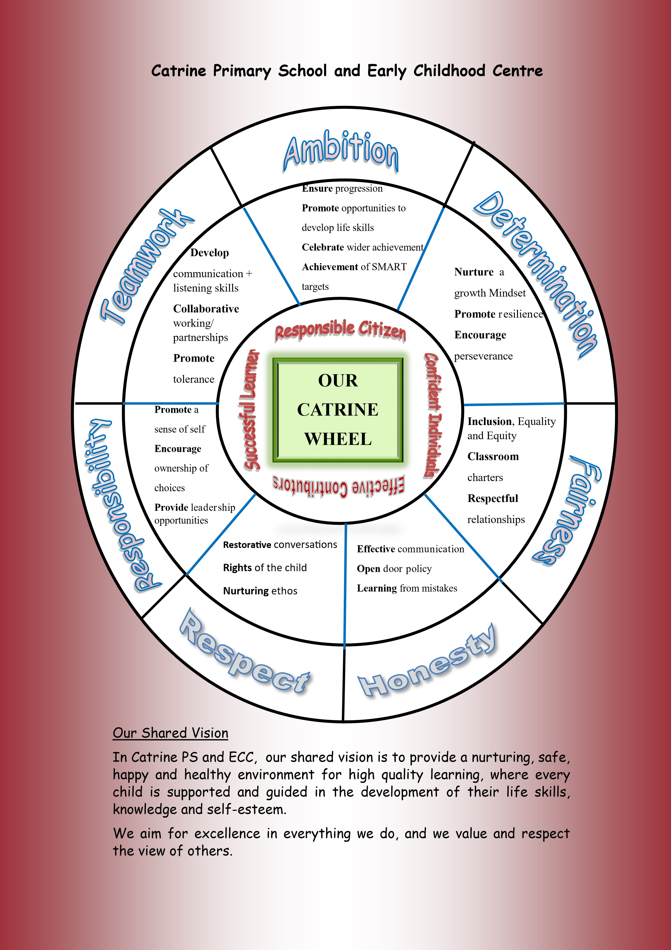
Golden Rules
During your child’s time here at Catrine ECC you may hear them talking about our Golden Rules. Our rules have been developed for health and safety reasons as well as to promote positive friendships and a foundation for teaching respect and care. It is always helpful when parent/carers reinforce these rules at home.
- To have super kind hands at all times
- To always have a Kind heart with others
- To remember to have walking feet indoors
- To have a quiet voice when inside
- To demonstrate fabulous listening ears to friends and staff

COVID-19
Personal hygiene has always been a priority in early year’s settings however with extra measures in place due to COVID-19 it has never been as important as it is just now.
We ask that you spend time at home practicing handwashing techniques and reminding the children of when this should be carried out. The video link below might help make this fun.
https://www.youtube.com/watch?v=S9VjeIWLnEg

HOLIDAY Reminder
Finally, we would like to remind all parent and carers that both the school and ECC will close at 3pm on Wednesday 16th September for the holiday weekend and will reopen again to staff and children on Tuesday 22nd September.
A full list of East Ayrshire Council school holidays for 20/21 can be found in the link below.
https://www.east-ayrshire.gov.uk/educationandlearning/schoolholidays.aspx

HAVE A GREAT SEPTEMBER WEEKEND FROM EVERYONE AT CATRINE ECC

