Kids 7 minute HIIT work out for self-regulation

Frog Jumps; Hop, Hop back and forth like a frog 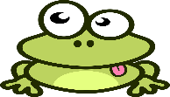
Bear Walk; Hands and feet on the floor, hips high – walk left and right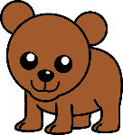
Gorilla Shuffle; Sink into a low sumo squat, hands on the floor and shuffle 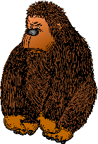
Starfish Jumps; Jumping jacks as fast as you can, arms and legs spread wide
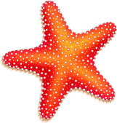
Cheetah Run; Run as fast as you can like the fastest animal in the Sahara
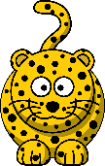
Crab Crawl; Sit, place hands behind hips on floor lift bottom off floor and crawl
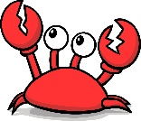
Elephant Stomps; March in place, lift legs as high as you can and stomp!

