Catrine Early Childhood Centre
Home Learning Timetable Ideas - Tuesday 31st March 2020

No times today – just tick off your tasks as you complete them everyone
And a huge well done to everybody who participated yesterday.
Wake up – Eat breakfast  Brush teeth, get dressed | Sport and exercise activities  Remember Jumpstart Jonny is LIVE at 9am online if you are looking for a structured workout
2 x Staff challenges  10am (Jan – Outdoors)  2pm (Alana – Literacy) | Imaginative Play  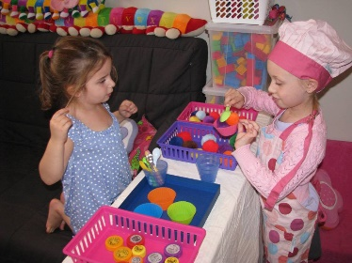
Enjoy a story together | Online learning – todays suggestion is  Kids Learning Box: Preschool (APP)

