Literacy/English | 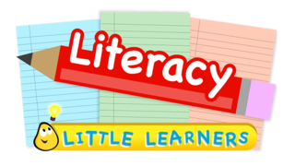  Fun English games for 3 – 5 years - https://www.topmarks.co.uk/english-games/3-5-years/letters-and-sounds  Short vowel word machines (4 – 7 years)  https://www.starfall.com/h/word-machines/  Hairy McClary from Donaldson’s Dairy story (4-7 years)  https://www.booktrust.org.uk/books-and-reading/have-some-fun/storybooks-and-games/hairy-maclary/  There’s a hole in the bottom of the Sea story (4-7 years)  https://www.booktrust.org.uk/books-and-reading/have-some-fun/storybooks-and-games/A-hole-in-the-bottom-of-the-sea/  Preschool books/activities – https://www.notimeforflashcards.com/2015/04/literacy-activities-for-free-choice-time-at-pre-school.html  Preschool books/activities - https://www.notimeforflashcards.com/2015/04/literacy-activities-for-free-choice-time-at-pre-school.html  Free literacy resources – https://www.literacytrust.org.uk/free-resources/  Cbeebies Literacy – https://www.bbc.co.uk/cbeebies/topics  Bookbug APP
Numeracy/maths | BBC Bitesize Maths – KS1 - Early/First Level: https://www.bbc.co.uk/bitesize/subjects/zjxhfg8  BBC Bitesize Maths – KS2 - First/Second Level:  https://www.bbc.co.uk/bitesize/subjects/z826n39  Fun maths games for 3-5 years - https://www.topmarks.co.uk/maths-games/3-5-years/counting  Math Visuals – Visuals to support understanding in maths: https://mathvisuals.wordpress.com/  Nrich – Mathematical Tasks and activities: https://nrich.maths.org/  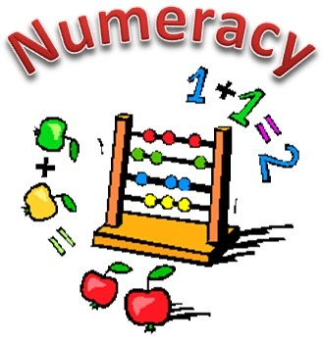  Early Years Activities: https://nrich.maths.org/13371  Oxford Owl – Maths Games and Activities: https://www.oxfordowl.co.uk/for-home/kids-activities/fun-maths-games-and-activities/  Maths is Fun: https://www.mathsisfun.com/
Science | Pairing for Early Science (4 –6 years) https://stormedapps.co.uk/pairing/pairing.html  Smudge’s early Science (4-7 years) https://stormeducational.co.uk/prev/science/  Some free games (although some ask for subscription)  ABCya.com
HWB | Food and farming videos (5 – 11years)  https://www.foodafactoflife.org.uk/5-7-years/where-food-comes-from/videos/  The great grub club (5-11 years)  http://www.greatgrubclub.com/play-it#.XmrEaGxvI2w  Learn with stories (5-7 years):  https://www.foodafactoflife.org.uk/5-7-years/activity-packs/learn-with-stories/  Twinkl.co.uk (offer code) UK TWINKL HELPS  Nature detectives - Woodlandtrust.org.uk  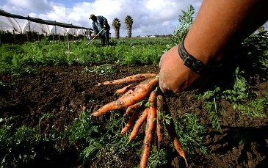  https://www.fun-non-screen-activities-that-children-can-do-at-home-115543cb3b9c  Yoga - Kiddingaroundyoga.com  You tube - Dance and beats
Music & Movement | BBc teach – nursery rhymes  https://www.youtube.com/watch?v=F9AxMQibZGA  Classics for kids (5-14 years)  https://www.classicsforkids.com/  Fun and games with music (5-11 years) http://www.sfskids.org/  Youtube  - Cosmic Kids  - Sticky Kids  - Kids Zumba

Range of Subjects | Elmo’s world games (3-5 years) https://pbskids.org/sesame/games/elmos-world-games/  BBC Online games - https://www.bbc.co.uk/bitesize/collections/primary-games/1  BBC Bitesize (Lots of information and video for all areas and topics) - https://www.bbc.co.uk/bitesize/primary  Cbeebies https://www.bbc.co.uk/cbeebies/games  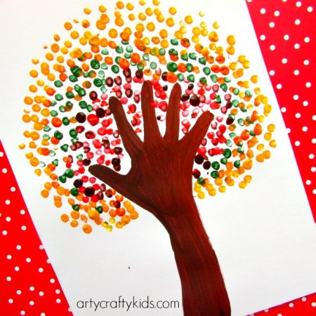  Disneyjunior.com  Milkshake.tv  Learning4kids.net  Pintrest.com  Nypost.com  Redtedart.com (arts and crafts)  Covid-19 daily schedule  https://www.mommyhood101.com/dailyschedule

