Cairns Early Childhood Centre
Parent/Carers Newsletter January 2023
Welcome to a new year 2023!!
We would like to introduce some new members of staff to Team Cairns.
3-5 Playroom
Natalie has joined our Team
Key worker Hippo Group

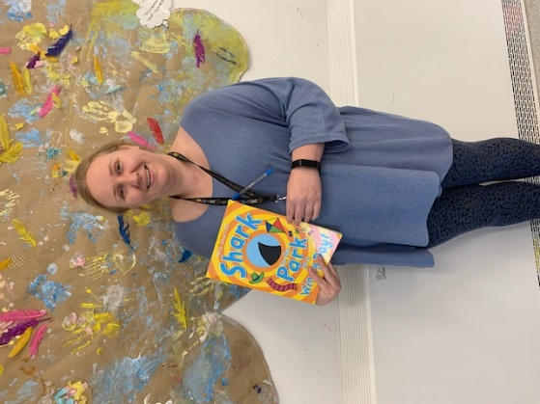

Amanda has joined the 3-5 Playroom

Staff moving within the Centre
Margo has moved to the Ocean playroom 2 -3 keyworker to the Turtles Group
Joanne has moved to the Jungle playroom 3-5 full time supporting the Tigers Group.
Leadership Team Update
Our Senior Tammy stops for maternity leave on 10th March and we wish her and her family well with their exciting times ahead! Update on our Senior cover to follow.
Sharlene’s temporary post as Senior ends 20th February and Taylor will return to her full-time hours. Sharlene will return to her full time practitioner post.
Abby our temporary Senior contract also ends 20th February.
We thank all and returning Seniors for their contribution to the leadership team and support for all our children and families over their time at Cairns and wish them well for the future.

Loose Parts Play – Improving our Playrooms with a focus on children’s ‘Creativity skills’
This Photo by Unknown Author is licensed under CC BY

We would love your help in resourcing our playrooms this year focusing on a key area within children’s learning of being ‘creative’. In supporting our children in their learning within literacy, numeracy and health and wellbeing loose parts resources can impact positively in promoting learning sparking a child’s imagination.
We are looking for any donations of the following:
Acorns, Bamboo, Earth, Feathers, Leaves, Pinecones, Pebbles, Sand, Shells, Sticks, Stones, Tree stumps, Twigs, Spoons, Drift wood, Beads, Buttons, Bottles, Cardboard boxes, Cotton wool, Corks, Glass stones, Cards, Paint and brushes, Pipe cleaners, Sponges, Wrapping paper, Yoghurt pots, Dolly pegs, Pastry brush, Baking trays, Bottles tops, CD’s, Cooking utensils, Muffin tins, Baskets, Blankets, Buckets, Ice cube trays, Tarpaulin, Tyres, Netting, Ribbon, Silk, Tin foil, Velcro/rollers, Chalk, Wall paper etc.

Children’s work: the importance of play and what we have been learning through play in January
Farm (0-2)
Our children in the 0-2 room have been busy developing a variety of skills through play. They have enjoyed making marks on the chalk board developing their fine motor writing skills. We also got a new sequence sensory board which the children have explored with their hands further developing their fine motor skills and exploring different textures. Some of the children have shown an interest in looking at the story books, developing their vocabulary as staff model language.
Ocean (2-3)
The children in the Ocean playroom have been exploring a variety of sensory experiences through art this month. We celebrated Chinese New Year with fortune cookies, painting with chopsticks and making beautiful creations with glitter paint. The staff have created a new and improved construction area for the children and the children have been challenged developing their gross motor skills on the tricky walkway. A few of the children have been taking part in transitions to the 3-5 playroom as they prepare to move in February.
Jungle (3-5)
The children in the Jungle room have been settling back into the nursery routine well and building on existing relationships with other children and staff. In the creative area the children have been exploring their senses. Experiences such as playdough with spices added, fruit in the water tray and different textured resources were added to the sand tray. In the imaginative area, the children have been exploring real food and household items within the role-play area and small world resources have been added. Outdoors we have enjoyed sledging when we had the icy weather and have been practicing road safety skills on the bikes. Within the construction area, the children have been using graph paper, pens and rulers to design their own creations and then using these plans to build using the blocks.

Social Stories

We have a variety of social stories that we can now share with you to take home which helps us to work in partnership with you and your child.
A social story is a visual story to use to chat about new situations or events. Social stories can help children understand what to expect in unfamiliar situations. The benefits can support emotions, transitions, social skills, interactions, routines and behaviours. Please ask a member of staff if you would like any social stories and we can print or e-mail to you a copy. We have topics like toilet training, biting, feeling sad etc.

Vision, Values and Aims for Cairns ECC
Update – We have displayed in our hallway a QR code that you can use to link to a very short questionnaire on what you feel our Values should be at Cairns as we continue collating everyone’s views. Please do take time to complete this for us. Your ideas, comments and views are vital in us together devising what the best vision is for our children and families.

Care Inspectorate Report
The final draft of our inspection report will be posted online soon and we will share this with you on our app when it goes live! Thank you very much to everyone who shared their views for our inspection and contributed to the report. We found it a positive experience in continuing our drive for improvement for Cairns children and families focusing on the quality of care, support and learning each child is provided with within our Centre.

Dates for your diary – January – March 2023
Tuesday 7th -13th February – Children’s Mental Health week: activities throughout the playrooms
21st February 2023 – Shrove Tuesday – We will enjoy pancake day
Thursday 2nd March 2023 – World Book Day – Children are welcome to come dressed as their favourite character.
Bookbug Session for 0-3 parents/carers – Wednesday 1st March 2023 @ 9.30a.m.
3-5 parents/carers – Thursday 2nd March 2023 @ 9.30a.m.
Tuesday 21st March – World Down syndrome day; activities throughout the playroom
Easter Events and Stay and Play events to follow soon.
Term Time Holiday Dates
Thursday 9th February, Friday 10th and Monday 13th February – Children who attend 8.40 – 2.40 / 9-3 are on holiday.
Centre Closed – Tuesday 14th and Wednesday 15th February 2023 for In-Service staff training.

Donations
Thank you to all who have donated wipes already to the Centre. This is very much appreciated. Any donations of wipes, tissues or kitchen roll is welcome. Please do keep providing a pack of wipes and nappies in your child’s bag each day.

Parent/Carer Committee
Our parent/carer committee next meeting date is Friday 17th February 2023 @ 9a.m. We would love to see as many parents/carers to come along. The agenda will focus on ideas for Easter activities/events and fundraising suggestions. We are actively looking for a parents committee which would entail someone being the Chair of the committee this would allow us to access more funding and parent/carers taking a lead role on events for our Centre. Information will be shared at the meeting. If anyone is interested please do not hesitate to speak to Lisa regarding this involvement.
Warmest regards

Lisa Rattray and Team Cairns

