Cairns Early Childhood Centre
Parent/Carers Newsletter Autumn 2022

What the children have been learning this month
Farm (0-2)

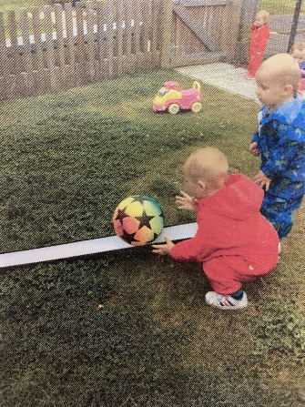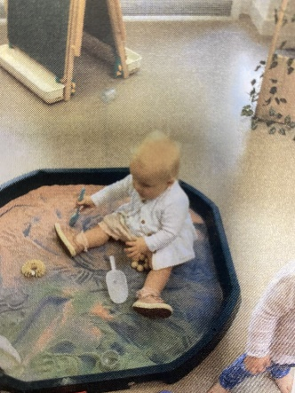
Since returning in August the children in the 0-2's have been very busy. They have spent a lot of time outdoors where they have been developing their gross motor skills through using the walkers, kicking, throwing, and rolling the balls and running and walking up and down the grassy hill. They have also been developing their fine motor skills as they have been exploring loose parts and a range of different wet and dry sensory resources."
Parent/Carer and child Sessions for Families with children aged 0-2
We will be commencing parent and carer sessions on a Wednesday morning with our families who attend the Farm Playroom. We will share with you our programme for the upcoming sessions this coming week.

Ocean (2-3)
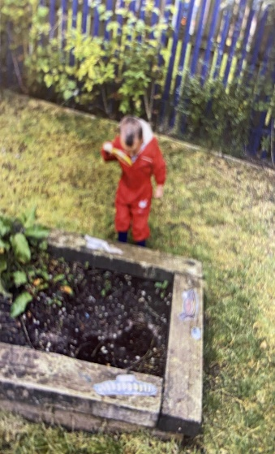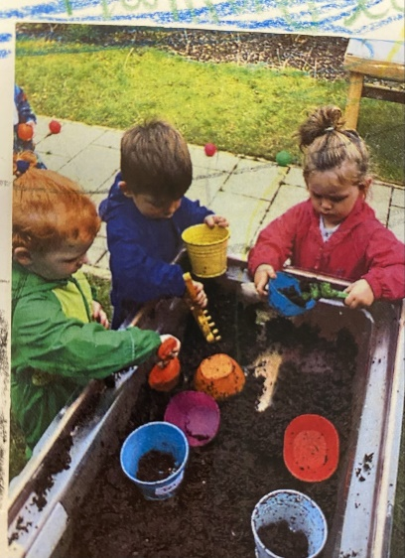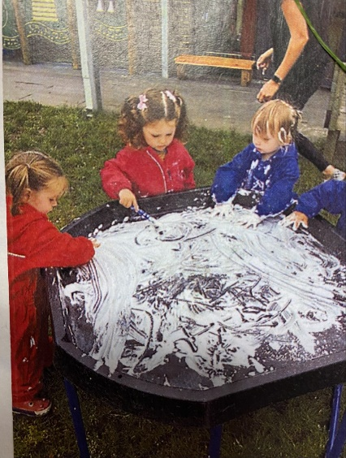

Since returning in August the children in the 2-3's have been really busy and have all settled really well. They have been exploring outdoors every day - digging in the mud, looking for bugs and getting messy exploring different sensory resources. The children have also been very good at developing their independence skills at snack time as they have been learning to collect their own plate and cup before sitting at the table.
Jungle (3-5)
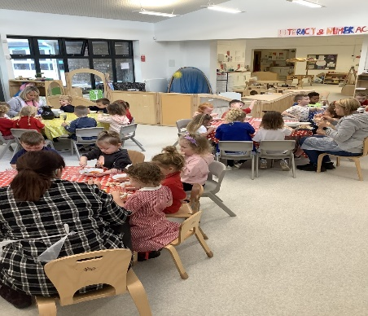
The children in the Jungle room have been focusing on settling into the nursery routine. The children have been using hi-vis vests outside to keep themselves safe, learning to put an apron on for painting and developing their understanding of handwashing before snack and lunch. All children have settled in well to the lunch routine and are having good interactions with their peers during mealtimes.

Wonderland
Routines and relationships have been a real focus. The children have been spending time in the area learning what their new routines are and getting to know their special staff and friends. As some of our children have completely different communication styles the staff have been developing the visuals within the area to support their learning and help all the children feel valued. Together, we are learning how to name and use our body parts to follow the golden rules and to keep us and our friends safe and happy in our new play space.
Lunch and snack time is becoming more settled and nurturing and the children are benefiting from the predictable routines, some children are even exploring and tasting food for the first time!!!
Stories and songs have been a huge favourite with the children participating in these as a group and/or on their own at times too. It is amazing to see how much their familiar stories or favoured songs help keep the children calm and engaged and building on their interactions with others.
We have been using familiar stories such as Going on a Bear Hunt to recall, predict and sequence whilst acting it both out indoors and out in the garden with our own selves or using small role play characters. This is helping us understand the meaning of words such as in, under and on, first, next, and of course we know our favourite line so well… IT’s A BEAR!

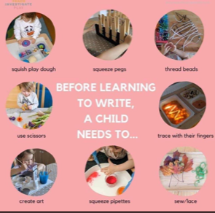

Vision, Values and Aims for Cairns ECC
Our vision, values and aims currently are:
To provide a safe, caring, happy environment where children are given the opportunity to develop to their fullest potential.
To work in close partnerships with parents, children, and the wider community, providing the time and space to deal with private matters.
To provide a stimulating and well-balanced curriculum which provides appropriate learning experiences for all through play and encourages the children to take the lead in their learning.
To be responsive to each child’s individual needs and treat each child with dignity and respect.
To promote caring for others, positive attitudes, and equal opportunities for lifelong learning.
To ensure the pace and balance of the day meets the needs of the children who attend the nursery.
We would like to revisit our vision, values, and aims as a whole community approach in getting it right for our children and families and wider Cairns community. In revisiting our values, we are hoping to achieve a relevant vision reflecting current values and times as we move into whatever our ‘normal’ after restrictions from the pandemic. Have your needs for your child changed? Have priorities within your family/home life altered? What do you feel our values should reflect for your child?
Over the coming weeks we will ask you for your thoughts and ideas on what our values should be. We will leave a board at the main entrance for you to share these ideas. We would love as many parents/carers/family members to all contribute to this and we will collate your responses. Your ideas will be valued and appreciated.
Dates for your diary
Week Commencing 3rd October 2022 onwards – Parent and Carer Stay and Play Sessions
Wk Com 17th October 2022 – School holidays for children who attend term time 9a.m. – 3p.m.
In-Service – Staff Training Monday 24th October 2022 – Centre is closed.
Week Commencing 24th October 2022 Halloween Dress-up week across the Centre
Pre-School children - Thursday 27th October 2022 4.45 – 5.30p.m. Hillhead Primary Halloween Party
Wednesday 9th November 2022 – Parent/Carer Event with Occupational Health – Session on Feelings and behaviours
Wednesday 23rd November 2022 at 9a.m. Parent/Carer Committee Meeting
Monday 21st November 2022 onwards – Parents/Carers Meetings – dates to be confirmed
December / Christmas events to follow soon.
Parent Stay and Play Sessions
You should have received an invite to your child’s day and time for a stay and play session. We welcome this as our first session post covid restrictions. Our team are looking forward to welcoming you all back into the playroom to share within your child’s learning and development and have the opportunity to speak to your child’s keyworker or colleagues.

Halloween Dress-Up Week
As we have children attending on differing days we will have a Halloween dress-up week across each playroom. It is you and your child’s choice if you wish to take part in this. There will be Halloween snacks and activities across the week.
Change of Clothes
Could we please ask that you bring with your child a bag with a change of clothes including underwear and socks. If your child is in nappies, please provide nappies in their bag along with a pack of wipes. As we are moving into the Autumn if your child has waterproof suits and wellies for outdoor learning, please bring this to the Centre as this is helpful to provide all children with outdoor wear to access our gardens when they choose. Please do make sure you label your children’s clothes from home to ensure they are returned to the correct child.
We are again running low in changes of clothes especially in the age 2-3 range. If your child has grown out of any clothes, please feel free to donate to us. This would be much appreciated.
Thank you
A huge thank you for the parents and carers who came along to our first open morning coffee/tea and chat session. It was lovely to get to know and hear about your children at home. These relationships are important to us to enable us to work in partnership with you and provide the best support and learning experiences for your children in helping them to progress throughout all their age ranges.
Developing our Parent/Carer Committee
Our parent/carer committee meeting took place in September 2022. The next meeting date will be Wednesday 23rd November 2022 at 9a.m. As the parent/carer drop-in session was successful at 9a.m. we thought it may suit better to hold this meeting at 9a.m when you are dropping your child off at the Centre. If you could spare half an hour to join that would be great. This meeting will involve discussions on December events and your input would be valuable in making arrangements in making Christmas activities special for your wee ones!
As always please know Team Cairns is here to support you and your family and we are always here to listen.
Warmest regards

Lisa Rattray and Team Cairns

