Cairns Early Childhood Centre
Parent/Carers Newsletter January 2022

Welcome from the new Head of Centre

I would like to take this opportunity to introduce myself to you as the new Head of Centre, Lisa Rattray. I am excited to join and be a part of a wonderful team here at Cairns ECC and develop meaningful relationships with children, families, and staff. I look forward to getting to know you all and supporting your children through their earliest years of learning and development, as they progress in their education and transition to Primary school.

What the children have been learning this month

Farm (0-2)
In the 0-2 playroom we have been very busy throughout January. We have been developing our fine motor skills and hand eye coordination through different activities - mark making, gluing, and sticking, construction activities and pouring and filling with different resources. We have also enjoyed playing outside throwing balls and developing our gross motor skills using our ride on cars and walkers. In the home corner we have been role playing, cooking with our pretend food, putting clothes in the washing machine and sleeping.
We celebrated Robert Burns Day and had a special visitor Courtney showing us Highland dancing and tried some shortbread as a lovely treat!
Have a look at what we are achieving in the baby playroom!
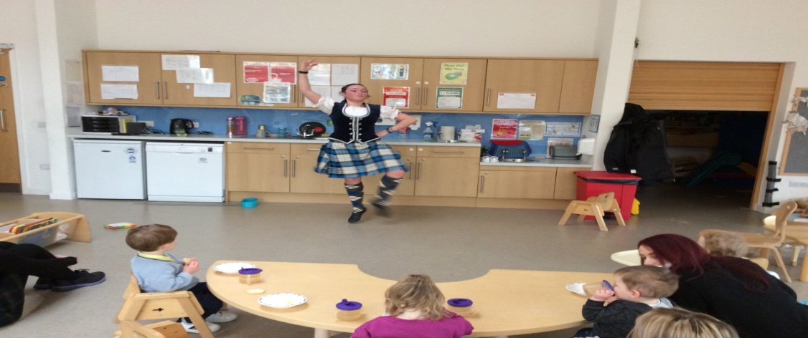
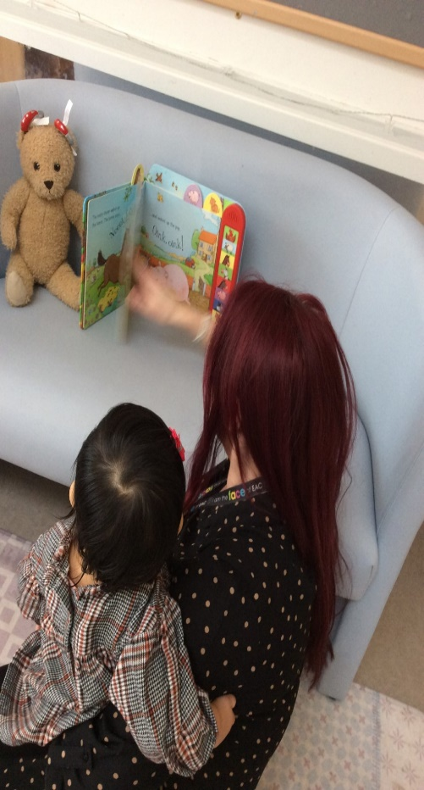
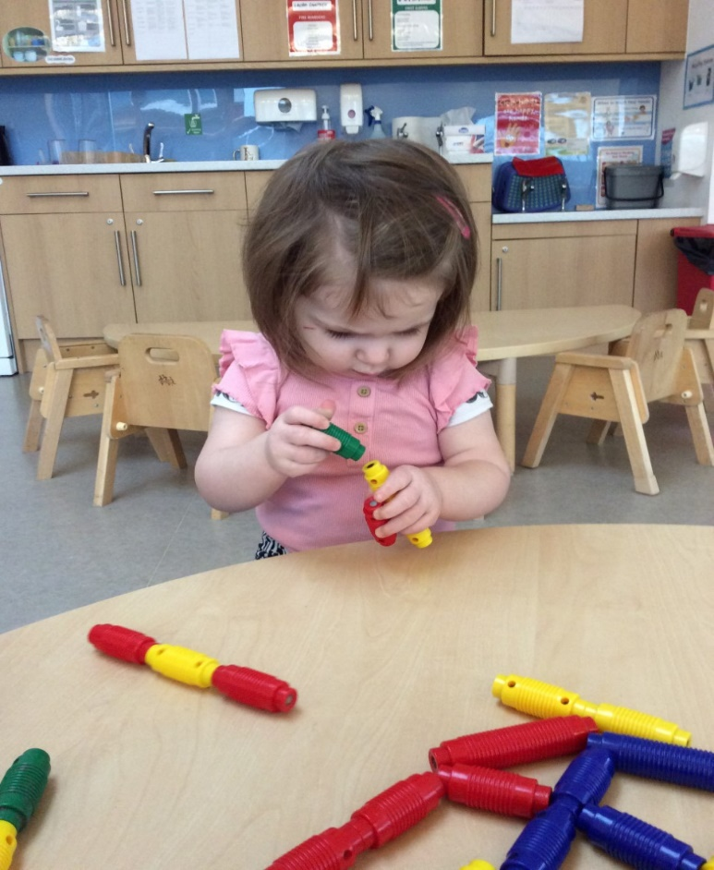
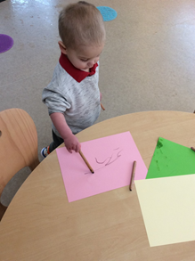

Ocean (2-3)
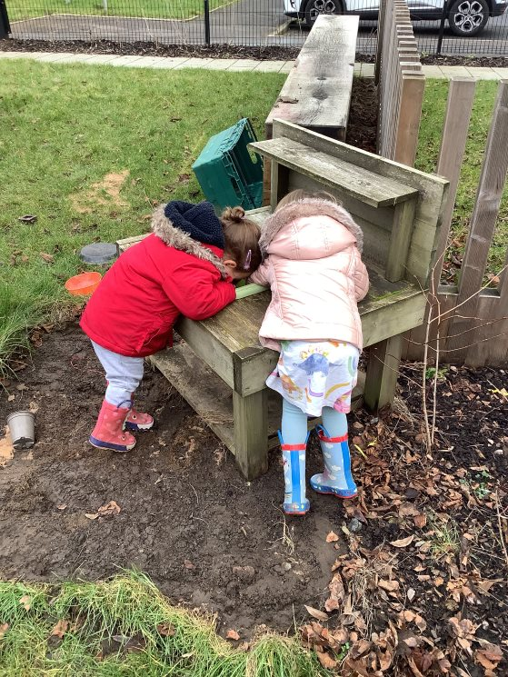
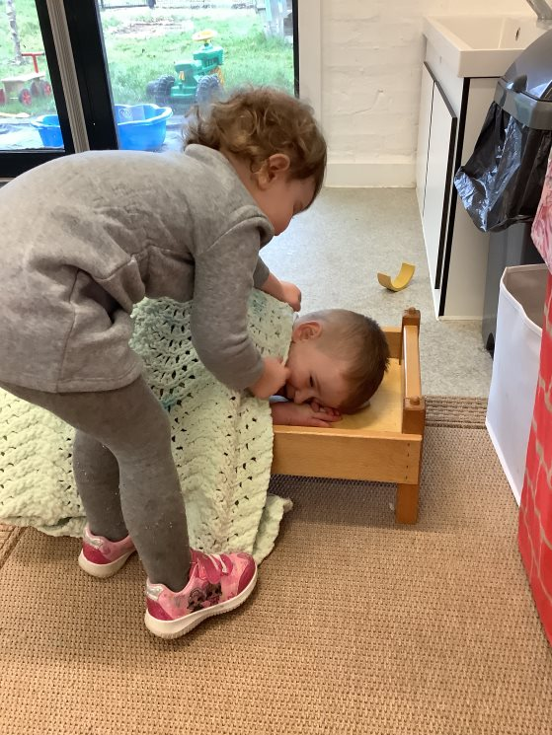
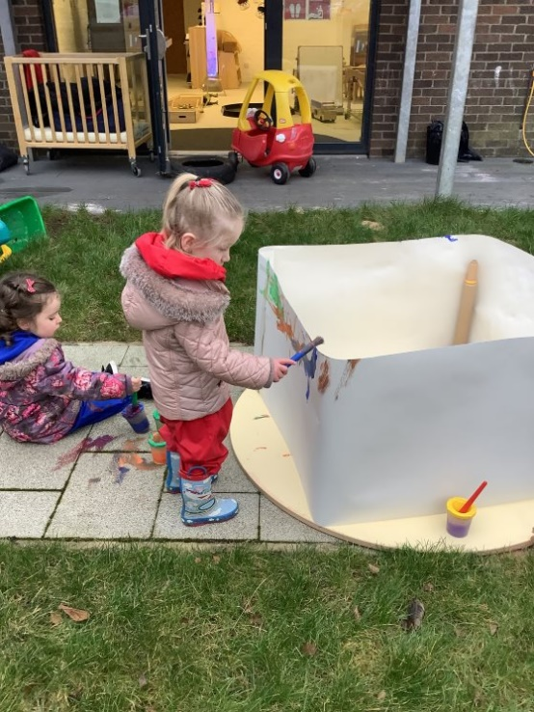
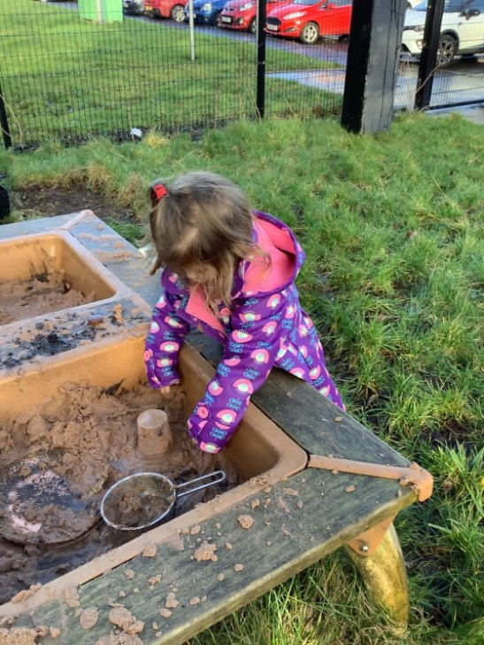
This month in the 2-3 playroom we have been giving our garden a makeover and accessing outdoors in all weathers. We love to get messy outdoors playing in the mud kitchen and in the sand, we empty and fill containers, role play using pots, pans, and other kitchen utensils as well as transport these materials. Mark making is another messy favourite, we have been using paints and chalks outdoors creating beautiful artwork.
We have also been forming positive relationships with each other, staff and new friends who have joined us throughout the month.

Treetops and Waterfalls (3-5)
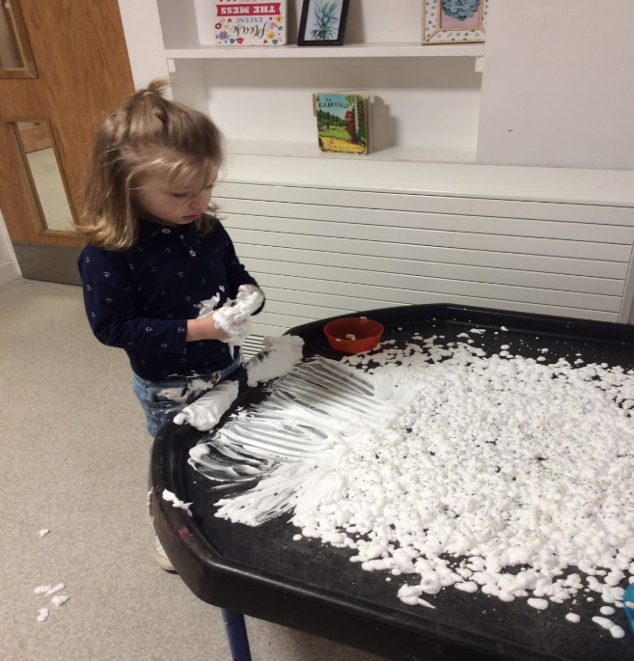
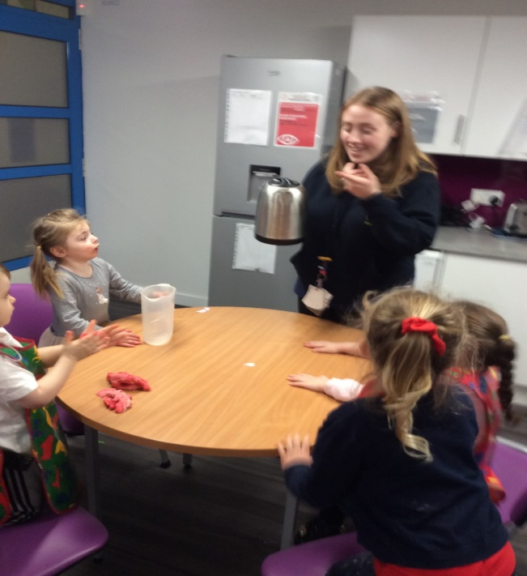
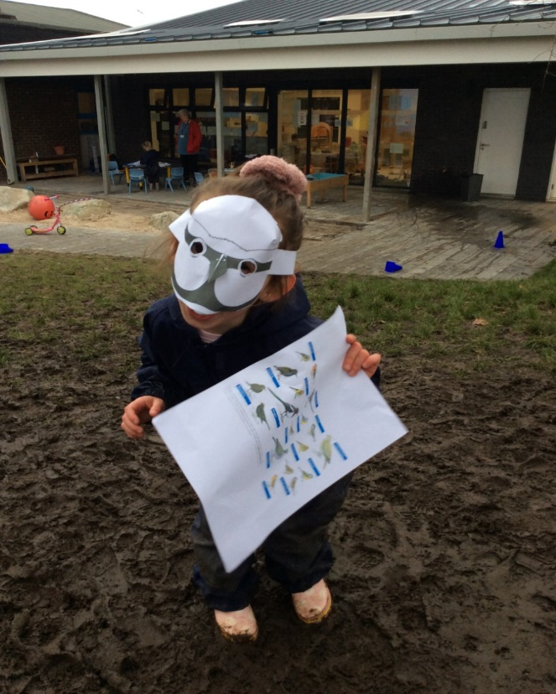
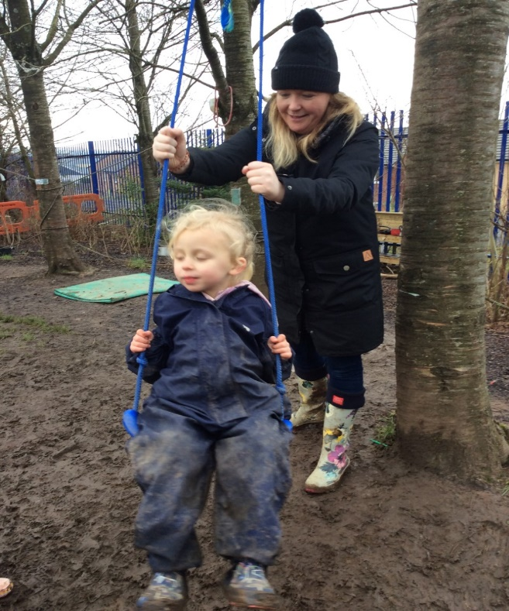
It has been a busy month in both bubbles in the 3-5 playroom. We have been exploring our creative skills throughout the month making our own playdough and using our imaginative skills to design wonderful creations and variations of the hungry caterpillar, developing our own ideas and theories. We have explored sensory play with gloop, jelly and shaving foam in the water tray. We have shown an interest in all things ‘dinosaur’ and this has led to us using rich language and extending our vocabulary describing what they look like and asking questions to build on our knowledge about how they lived.
Outdoor play has been a popular choice and we have participated in the RSPB Big Garden Birdwatch where we learned more about different specifies of birds and went on a bird hunt! We have been busy developing our gross motor skills and building our confidence sharing these experiences with our friends.

COVID Guidance and Update
In January the government updated guidance on testing and self-isolation advice. As you will be aware if your child has a positive LFT result they no longer need a PCR to confirm this. You should then follow the advice from health on self-isolation for yourself and any household members. Please upload all your LFT results online and please e-mail the Centre a photo of your child’s result. This will aid us in the management of general coughs and colds especially at this time of the year. Thank you for your continued support and co-operation with this.

February Term Time Holiday
Friday 11th and Monday 14th February 2022 are holidays for term time children.
We are closed on Wednesday 15th February 2022 for In-Service Day training.
We re-open for all of our children on Thursday 16th February 2022.

Children’s Scrap Books / Online Learning Journals
We have begun our journey moving from documenting children’s individual learning within children’s scrap books to online learning journals. We are going to complete children’s scrap books from now until Easter and then prepare to move all children’s learning online. We will advise closer to the Easter holidays when this will happen and please let us know if you would like any help accessing these online which we can discuss with you.

Change of Clothes
Could we please ask that you bring with your child a bag with a change of clothes including underwear and socks. We thank parents/carers for their kind donations this month and welcome any donations of spare clothes.

Developing our Parent/Carer Committee
Please let us know if this is something you would be interested in taking part in. We would love to gain your views, ideas and hear about your thoughts on what would be beneficial for your children and fully involve yourselves in the life of the Centre. This would include being part of fundraising events, activities for the children and being part of improvement projects for the ECC. We are a welcoming team and value your views as we work together as a Cairns community in meeting the needs of your children and families.

Thank you
Thank you for your continued support to Cairns ECC and please do not hesitate to get in touch if you have any questions or queries for us. We are always here to help and support you all.

Warmest regards

Lisa Rattray and Team Cairns

