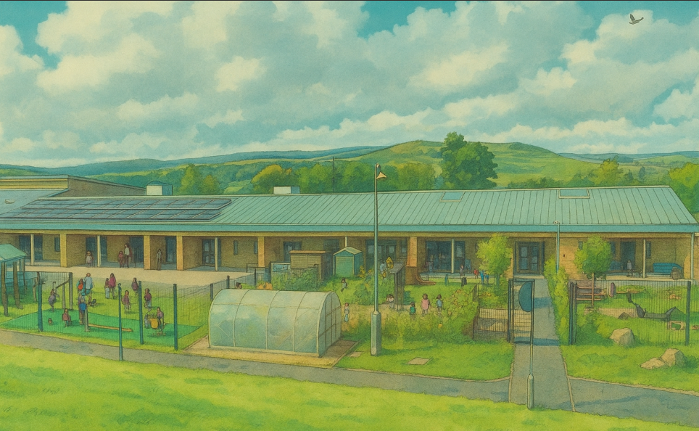


Bellsbank Primary School and Early Childhood Centre
Craiglea Crescent,
Bellsbank,
Dalmellington
KA6 7UA
School Telephone No: 01292 550305 | ECC Telephone Number 01292 551195
Email: | eabellsbank.ps@eastayrshire.org.uk
School blog | https://blogs.glowscotland.org.uk/ea/bellsbankpsecc2017/
School App: Available on appropriate mobile devices | Safer Schools Scotland app
Denominational Status (if any): | The school is non-denominational and co-educational and provides a 2 -12 education within the Early Childhood Centre and Primary School.
Role: | School: 102 ECC: 53
Further information: | www.east-ayrshire.gov.uk/schoolhandbooks

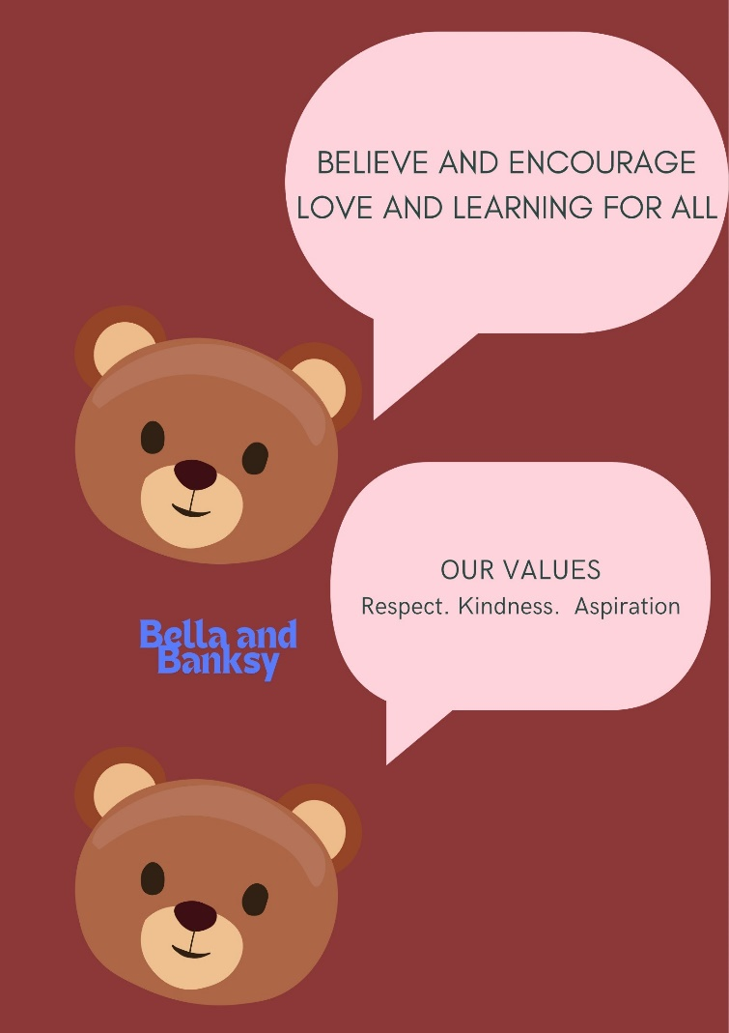
On behalf of all the pupils and staff at Bellsbank Primary School and Early Childhood Centre I would like to warmly welcome you and your child/children to our school community.
We are very proud of our school and the community in which we serve. Our School Vision is ‘Believe and Encourage Love and Learning for All’. This is important to us because as well as a 2-12 Education establishment, the building is also home to the Bellsbank project where learning takes place from birth to beyond school age.
We aim to work in partnership with parents and the local community to ensure that our children are successful in reaching their potential. If you have any questions or wish to discuss anything further please do not hesitate to contact me.

Fiona Greig

Our School and ECC values are:
- Respect
- Kindness
- Aspiration
We promote these school values throughout the curriculum and ethos and life of the school. Our school mascots Bella and Banksy help us promote our school values.

Our School and ECC aims are:
- Provide challenging and inspiring opportunities that enable our children to maximise their potential in life.
- Provide a safe, secure and nurturing learning environment.
- Provide high quality learning experiences that engage children fully in their learning.
- Provide a well-planned and progressive curriculum that meets the needs of all children.
- Value and develop strong trusting relationships with parents from an early stage.
- Develop a sense of pride which has a positive impact on our community.
With a focus on high quality learning experiences, we aim to raise attainment. By providing a variety of opportunities in school and out with, our children can achieve. Our staff team know our children and families well and aim to identify any barriers to attainment and achievement. East Ayrshire Relationships Framework underpins our work as we strive to ensure all children are safe, healthy, achieving, nurtured, active, respected, responsible and included.
We promote improvements and wider achievements. Children are awarded certificates if they demonstrate the school values or that they are a successful learner, confident individual, effective contributor or responsible citizen.
Communication
- Our main method of communication is through our school app which we use to share information, links to useful websites, photos and recordings. Scan the QR code to download the app.
- We share our achievements and successes on Learning Journals.
- We also have our school blog where we share the work in the classes.
- Within our school blog, there is a link to a blog for the ECC.
The school SEEMIS messaging system holds one main contact and will send attendance notifications to the main contact only. It is not possible to generate the automated message necessary to inform all parents/carers. However, should a parent/carer have a significant concern that the main contact is not sharing key information regarding attendance, they should contact Bellsbank PS to discuss possible alternative solutions.

Parental Engagement
In the ECC, we have termly Stay and Play/Read events for parents and carers to attend. Once a term, we have a parents’ coffee morning. This is an opportunity to discuss the children’s experiences and work together to make them the best they possibly can be. There is an active ECC Parent Council.
In the Primary School, we have regular family learning tasks, Stay and Play afternoons, curriculum workshops, events and assemblies.
Parents as Partners
We have an active School Parent Council who support the school in improvements and who give up their time to give our children a variety of experiences. At present, our Parent Council Meetings are a mixture of in person and online. All parents/carers are welcome to attend.
Chairperson | Mrs Arlene McKelvie
Secretary | Mrs Kerry Whitelaw

For more information on parental involvement or to find out about parents as partners in their child’s learning, please contact the school directly or visit the Parentzone website at www.parentzonescotland.gov.uk.

SECTION 2
Transitions
Throughout the session we offer many informal transition opportunities for children moving from Pre-school to P1, as well as formal transition opportunities and meetings in the summer term. Our children in P1 transition from Bellsbank Family Centre.

- Building relationships in the preschool year.
The P6 buddies are trained in communication friendly strategies and visit the preschool children from January to Easter along with school support staff. In the summer term preschool children attend the school once a week to get used to being in the P1 classroom
- ECC ASN Early Transition meetings for Pre-school children.

- Induction events for all families and children joining Primary 1.
There is an event in the summer term for all new P1s and their families to attend. To have a tour of the school and ask any questions. This is followed by a session early in the autumn term to discuss the P1 curriculum.
- ‘Move-up Day’ events for all children moving stage within the Primary School, and include new children joining the school at these events.

- P6 ASN Early Transition meetings for S1.
This will involve staff from the secondary school.
- P7-S1 Transition Events.
Our associated Secondary School is Doon Academy which is part of our school campus. Throughout the session we participate in events with children from other Primary Schools in our Education Group. STEM Transition Days are held in the spring term and formal Bump Up days in the summer term.
- P7 ASN Enhanced Transition events take place during the summer term.
Doon Academy Head Teacher (Acting): Martin Robertson
Address: Ayr Road, Dalmellington, KA6 7RW
Telephone No.: 01292 550521
Email: martin.robertson@eastayrshire.org.uk

Support for children and young people and parents/carers
Fiona Greig (Head Teacher)
fiona.greig@eastayrshire.org.uk
01292 550305

Ashley McLurkin (Depute Head Teacher) School
Ashley.mclurkin@eastayrshire.org.uk
01292 550305
Denise McCaffrey (Depute Manager) ECC
Denise.mccaffrey@eastayrshire.org.uk
01292 551195
Dianne Miller (Depute Manager) ECC
Dianne.miller@eastayrshire.org.uk
01292 551195
Parents/Carers are encouraged to contact the Head Teacher or Depute Head Teacher (school) or Head Teacher or Depute Managers (ECC) if there are any concerns. The Head Teacher is the Child Protection Officer for the School and Denise McCaffrey is the Child Protection Officer for the ECC and any concerns involving a child’s wellbeing should be shared with Mrs Greig or Ms McCaffrey immediately.
Support for Children
‘The Children and Young People (Scotland) Act 2014’ introduces an approach for all children’s services to work together to meet children’s needs. At Bellsbank Primary School and Early Childhood Centre we follow this approach as well as the ‘GIRFEC Practice Model’ which is a framework that centres on the individual and their specific needs. Every child under the age of 18 is entitled to have a Named Person who is available to help and support the child and do whatever is necessary to promote the child’s wellbeing. Mrs Greig is the Named Person for all children in the Primary School. The Health Visitor is the Named Person for all children in the Early Childhood Centre.
Additional Support Needs
Our approach is in line with the guidelines of ‘Getting It Right For Every Child’ (GIRFEC) and is underpinned by the ‘Education (Additional Support for Learning) (Scotland) Act 2009’ and a ‘Curriculum for Excellence’. All children and young people may need some additional support at some point to help them develop to their full potential during their education journey. Most children are supported within their own class with class teachers using appropriate strategies and supports. If a child needs more help than the class teacher can provide, we begin assessing the child holistically in order to identify the necessary additional support required. This is called a staged intervention approach as there are many levels of support available, ranging from in class support, in school support, or specialist support from services such as; psychological services, speech and language therapy, occupational therapy etc.
My Plans
A My Plan is created for any child who requires extra support to address their needs. Plans are developed in partnership with the pupil, their parents/carers and any services involved. On most occasions, it will be written and regularly reviewed by the class teacher. Plans are monitored and progress is discussed during regular TAC (team around the child) meetings. Views of pupils, as well as parents/carers, should be incorporated into the plan as per the UNCRC to ensure that views are taken seriously. Where more targeted, individual support is required within school or from a multiagency team to allow a pupil to access the curriculum, an Individual Learning Plan (ILP) will be written and included as part of the Child’s Plan.

Additional and more specific information on Additional Support Needs can be found on the East Ayrshire Council website:
https://www.east-ayrshire.gov.uk/EducationAndLearning/SupportForPupils/AdditionalSupportforLearning.aspx

Staff
Senior Early Learning & Childcare Practitioner | Kaz Higgins
Senior Early Learning & Childcare Practitioner | Marcia Thomson
Excellence and Equity Lead | Linda Kerr
Early Learning & Childcare Practitioner | Mary Brown
Early Learning & Childcare Practitioner | Robyn Dixon
Early Learning & Childcare Practitioner | Julie Ewan
Early Learning & Childcare Practitioner | Shane Flynn
Early Learning & Childcare Practitioner | Alison Hutton
Early Learning & Childcare Practitioner | Lauren Kennedy
Early Learning & Childcare Practitioner | Siobhan Kennedy
Early Learning & Childcare Practitioner | Megan Kirkpatrick
Early Learning & Childcare Practitioner | Paige McWilliams
Early Learning & Childcare Practitioner | Shirley Morrison
Early Learning & Childcare Practitioner | Gillian Slater
Early Learning & Childcare Practitioner | Ashley Thomson
ECC Clerical | Stacey Collins
ECC Clerical | Lauren Forbes
P1/2 Class Teacher | Mrs Russell
P2/3 Class Teacher | Mrs Leitch
P4/5 Class Teacher | Mrs Boyle
P5/6 Class Teacher | Miss McArdle
P6/7 Class Teacher | Mrs Waddell
NCCT and Support for Learning | Mrs Droy and Mrs Ferguson
Pupil Support Assistant | Miss Downie (Mon-Fri)
Pupil Support Assistant | Miss Greig (Mon, Wed, Thurs)
Classroom Assistant | Vacancy (Mon- Fri)
Classroom Assistant | Miss Rowan (Wed – Fri)
Classroom Assistant | Mrs Kudajeck (Tue, Fri)
Senior Clerical Assistant | Mrs Whiteford
Janitor | Mr Hunter
Pupil Support Teacher | Mrs Shepherd
Active School Co-ordinator | Ross Stormonth
Campus Police Officer | PC Shirkie

SECTION 3
Our school day is from
9am-10:30 am
Morning Interval (10:30am-10:45am) P1-3 (10.45am-11am) P4-7
11am-12.15pm
Lunch (12.15pm-1.00pm)
1.00pm - 3.00pm
Our ECC session is from:
Term Time 9 - 3 All children are signed in by their parent or carer.
52 week am session
52 week pm sessions

School Holidays and in-service days
Our school holidays are in line with East Ayrshire Council’s school holidays 2024/25.
https://www.east-ayrshire.gov.uk/Resources/PDF/S/school-holidays-2024-25.pdf

Attendance and Timekeeping
Section 30 of the Education (Scotland) Act 1980, lays a duty on every parent of a school age child to "provide efficient education for him/her suitable to his/her age, ability and aptitude, either by causing him/her to attend a public (local authority) school, or by other 8 means". Most parents choose to meet this duty by enrolling their children at local authority schools and therefore must ensure that their children attend school regularly.
We take attendance at Bellsbank Primary School seriously and follow up on unauthorised absences, or continued absence from school, involving other partners if necessary. Regular and punctual attendance is linked closely to achievement and we will work with parents/carers to ensure that children can achieve their full potential.
The law requires that educational establishments maintain an accurate record of attendance and absence of each pupil. Parents are requested to assist in this process by informing the school if children are to be absent for any reason.
Where your child’s absence is approved, for example a medical appointment or the school is notified of a sickness absence, it is marked as an authorised absence.
Where an absence is unexplained by the parent the absence is marked as unauthorised.
If your child is not going to be attending school, please telephone to let us know by 9.15 am on the first day of absence, explaining the reason. If no contact is made, the school will send a text message as a reminder, followed up by a telephone call if no response.
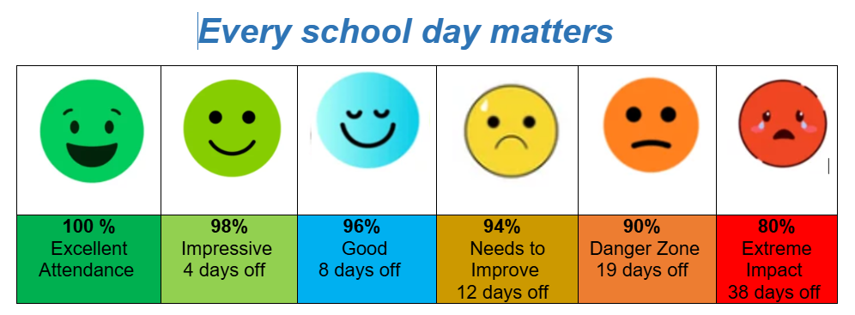
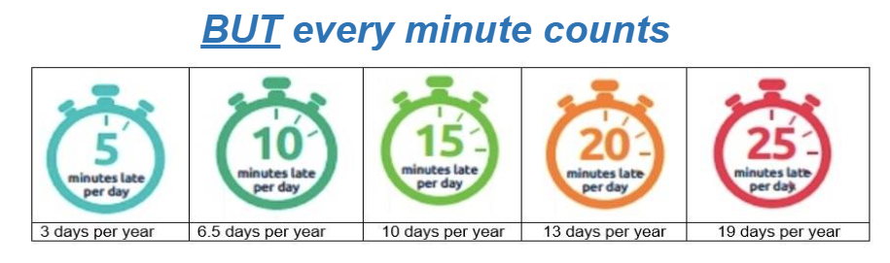

Behaviour and Anti-Bullying
We are committed to providing a safe and caring learning environment for all children and follow East Ayrshire Council’s Respectful Relationships Policy. Bullying is hurtful and never acceptable. Everyone has the right to be treated with respect and live a life free from bullying and harassment. It should be emphasised that there is a difference between one-off incidents amongst peers in the classroom/playground and the systematic and ongoing targeting of a pupil or group.
Our shared definition of bullying is to hurt someone physically and/or emotionally, on purpose, resulting in them feeling scared, sad or weak. Children accused of bullying may need support as much as those being bullied. We always take bullying seriously and will endeavour to investigate fully, supporting all children involved, consulting parents/carers, implementing appropriate strategies for support and recording details using appropriate systems. Our Leadership Team have undertaken training with ‘Respect Me’, Scotland’s anti-bullying Service. We have developed our relationships policy, which you will find on the school website.

Dress Code
Our school uniform comprises of:
- Grey/black school trousers/skirt
- Pale blue polo shirt and burgundy sweatshirts (
School uniform with logos can be ordered from https://www.donsport.co.uk/schoolwear/primary-schools but polo shirts and sweatshirts without the school badge can be worn too.
Security and Visitors
All visitors should report to the main office where they will be requested to show ID and sign in on arrival. There is a secure door to the school corridor. Visitors will be provided with a visitor badge which should be returned when signing out and leaving the building.

Homework and Study
We encourage children to take responsibility for their own learning. In line with Curriculum for Excellence it is our aim to make homework more active, manageable and enjoyable for the children. Homework should enable children to consolidate learning, take responsibility for their learning, promote independent working and demonstrate to parents the type of learning they are doing at school.
This session we are using several online platforms such as Sumdog to reinforce learning in numeracy and Giglets for literacy tasks. Homework will be shared with parents through Learning Journals.

School Meals
‘The Schools (Health Promotion and Nutrition) Act 2007’ sets out in detail the National Nutritional Food Standards. School Meals in East Ayrshire offer nutritionally balanced food each day. All pupils in P1-3 are now entitled to a free school meal. All other pupils can either purchase a school lunch or bring a healthy packed lunch. Children from P4-7 entitled to a school meal can apply for this from the local authority.
Cashless Catering - We operate a cashless catering system called ParentPay. ParentPay accounts can be topped up online or via PayPoint stores.
Lunches should be ordered through https://www.parentpay.com/
Menus and other information can be found at:
www.east-ayrshire.gov.uk/EducationAndLearning/Schools-Catering/SchoolLunchMenus.aspx

Complaints Handling
We encourage Parents/Carers to speak directly to the Head Teacher, Mrs Greig, if they have any complaints about any element of the services we provide. We aim to resolve complaints at school level. However, if you have made the school aware of your complaint and you are unhappy with our response, you can make a formal complaint to East Ayrshire Council.
Please see the link below for more details. East Ayrshire Council: https://www.east-ayrshire.gov.uk/CouncilAndGovernment/Contactus/ComplaintsProcedure/Howtomakeacomplaint

Emergency Procedures/Medical Matters
In the event of an emergency affecting Bellsbank Primary School and Early Childhood Centre, we have well established procedures in place to cope with almost all situations:
Group Texts are sent out to parents/carers to advise of an emergency. Parents/carers should provide the Head of Establishment or school/centre office with an up to date mobile phone number to enable automatic contact via text messaging.
In the event of an emergency, the Council’s Communications Team work quickly to update the Council website, Facebook and Twitter with the latest developments and advice on what to do.
The team also work closely with Westsound Radio (DAB 11B, MW 1035) and West FM (96.7, 97.5 and 106.7) and statements and updates are issued frequently.
We understand an emergency can be a very stressful time and phone lines are often used by emergency services, so it is important that we try and keep lines clear.
As parents, you are advised that before telephoning your child’s educational establishment, you should first check the Council webpage, for news and announcements: www.east-ayrshire.gov.uk
You can also check the Facebook page: www.facebook.com/eastayrshire/ or, Twitter: East Ayrshire Twitter/ or check our School App

Data Protection
East Ayrshire Council creates, collects and processes personal information about children and we are bound by the terms of the Data Protection Act 1998.
We collect information from children, their parents and guardians and we may also receive information from other sources, such as previous schools.
All information is stored securely and we do not share it apart from the circumstances described below, or where the law requires us to do so.
Under the Act, we are known as the Data Controller and the information we collect is needed for a number of reasons which include, but is not limited to:
- Monitoring and reporting on absence.
- Supporting teaching and learning.
- Monitoring and reporting on your child’s progress.
- Providing appropriate care.
- Assessing how well your child’s school/centre is doing.
The information we collect will also include details such as contact address or phone numbers and data such as ethnic group, additional support needs and any relevant medical information. Occasionally, we may make information available to other organisations, for example:
- To other schools/centres if you move away.
- To the Scottish Qualifications Authority for examination entries.
- To the Scottish Government and its agencies.
You can see the personal information we hold about you by making a Subject Access Request. A parent or guardian may make a request on behalf of children under 12.
To do this, please contact the Council’s Freedom of Information Officer on 01563 576094, or email: Freedom Of Information@east-ayrshire.gov.uk A fee may be charged for this service.

SECTION 4
Bellsbank’s Curriculum
Curriculum for Excellence is the education system in Scotland. It aims to provide young people with the skills, knowledge and attributes they will need for learning, life and work. The Curriculum for Excellence identifies SEVEN PRINCIPLES for curriculum design, and we aim to ensure our learning, teaching and planning has:
- Challenge and enjoyment
- Breadth
- Progression
- Depth
- Personalisation and choice
- Coherence
- Relevance

Curriculum for Excellence is divided into the following curricular areas:
- Literacy (including English and Modern Languages)
- Mathematics
- Health and Wellbeing including P.E
- Sciences
- Social Studies
- Expressive Arts
- Religious and Moral Education
- Technologies
All staff are responsible for the 3 main areas of the curriculum, which are Literacy, Numeracy and Health & Wellbeing.
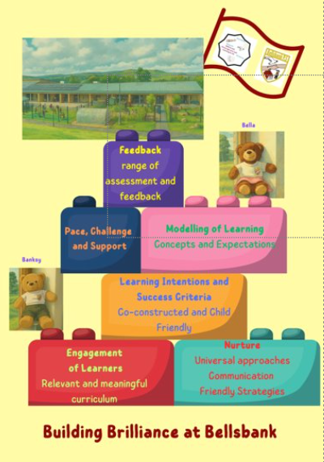
When planning, staff use East Ayrshire Progression Frameworks for all curricular areas to ensure adequate depth, breath and challenge. We have developed our Curriculum Rationale which promotes:
- Development of the four capacities: Successful learners, responsible citizens, effective contributors and confident individuals.
- Skills for learning, life and work.
As we strive to raise attainment, we must ensure the most effective methods of teaching and learning. Bellsbank Primary School and Early Childhood Centre have recently updated policies for all curricular areas. These can be found on our GLOW Website.
We have developed our ‘Excellent Lesson’ which we have called ‘ Building Brilliance at Bellsbank’. The principles of this excellent lesson are the key features of our children’s learning.
SECTION 5
Over the last 12 months we have continued our improvement journey, supported by whole school self-evaluation, with all staff participating in appropriate CLPL to make changes to improve outcomes for our children.
The following documents can be found on our school GLOW website:
- Standards and Quality Report for session 2024/25.
- School Improvement Plan for session 2025/26.

SECTION 6
Assessment is an integral part of everyday teaching and learning. Teachers gather evidence on an ongoing and informal basis. Learners themselves will be increasingly involved in this process, as they develop the skills needed to be able to make effective judgements on their own learning; skills that will be important to them throughout life. More formal testing will also continue to be part of the framework of assessment, providing additional evidence of what learners know, understand and are able to do and helping teachers plan learning experiences which are motivating and challenging.
We gather evidence in a variety of ways:
- day to day observations
- questioning
- assessing written work
- teacher devised tests
- set tasks
- formative strategies
- standardised and diagnostic testing, for example: P3 Quest and National Standardised Assessments for P1, 4 and 7.
Assessment is used to inform next steps in teaching and learning with pupils being involved in identifying their strengths and areas for development. In this way, pupils can set their own personal targets to progress with their learning.
At Bellsbank Primary School, staff meet to share children’s work and agree on attainment levels, as well as participating in termly tracking and monitoring meetings with the Head Teacher. This means that if a child is not on track to achieve expected levels, appropriate support and/or interventions can be put in place.

Reporting
This session, we will provide a report in May, as well as 2 parents’ appointments. All classes will use ‘Learning Journals’ to keep parents informed of children’s learning.
Staff in our Early Childhood Centre will meet parents/carers twice a year to complete their child’s care plan. ‘Learning Journals’ will be used as a 2-way platform to share photographs and achievements.

SECTION 7
Contact details
Telephone Number
01292 550305
- Email
eabellsbank.ps@eastayrshire.org.uk

- Website address

https://blogs.glowscotland.org.uk/ea/bellsbankpsecc2017/

