Bellsbank PS

Cost of the School Day Statement
February 2025

Our Cost of the School Day statement will be discussed with pupils, families and staff. Stakeholders will work together throughout session 24/25 to revise this statement to reflect the needs of our community. Our current approaches to support families with the Cost of the School Day are illustrated below and specific approaches outlined overleaf.

Values  - We respect each other and ourselves.  - We are kind to each other and ourselves.  - We aspire to do our very best. | Vision   | UNCRC  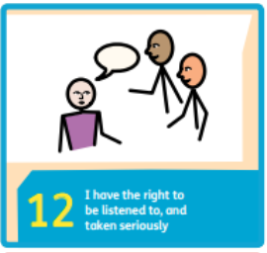
Uniform   | Travel  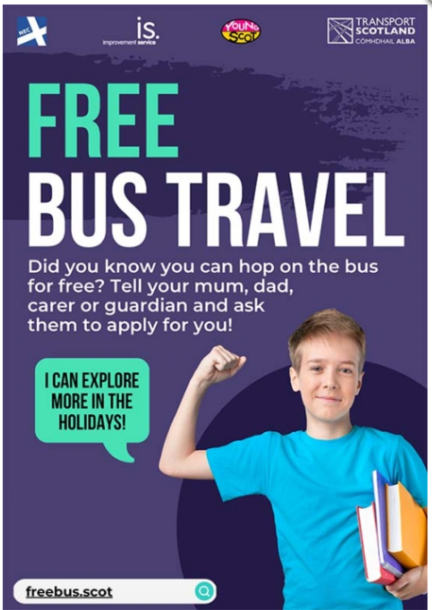 | Friendships  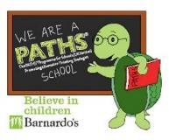
Learning and Home Learning     | Trips   | Fun Events  
Eating at School   | After School Clubs   | Outdoor Clothing  

Uniform
- Our uniform consists of pale blue polo shirts and maroon jumpers/cardigans. Whilst uniform with school badges on are available, polo shirts and jumpers/cardigans without the badge is perfectly acceptable.
- Pre-loved school uniform is donated by families as their children grow out of them. Our family room houses these clothes. Families are encouraged to take any uniform required.
- No specific PE kit is required for PE lessons. Therefore any shorts, leggings, joggers and t-shirts are acceptable for PE with the exception of football strips. We do have a small supply of shorts and trainers available for children to borrow for their PE lesson.
- Our Parent Council have subsidised P7 Leaver’s Hoodies over recent years. These are personalised and provided to all P7 pupils to form part of their uniform for the final few months of primary school.
- Families can check eligibility for school clothing grants through East Ayrshire: https://www.east-ayrshire.gov.uk/CouncilAndGovernment/Benefits/Benefits-EducationAndSchool/Clothing-grants-and-free-school-meals/Clothing-grants-and-free-school-meals.aspx

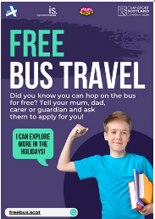
Travel
- Most pupils are able to walk to and from school from the village. Free school transport is available for pupils within our catchment area, where no safe walking route is available. Pupils living in Burnton can access the school bus and pupils from surrounding farms and houses can access school taxis. To check eligibility and apply for school transport, please visit: https://www.east-ayrshire.gov.uk/EducationAndLearning/TravellingToSchool/Schooltransport/Schooltransport.aspx
- All young people in Scotland can apply for a free bus pass from ages 5 to 21. To apply for a bus pass for your child, please visit: https://freebus.scot/how-to-apply/

Friendships
- Uniform is promoted in school to avoid any peer pressure for branded and fashion clothing. All pupils have access to digital technology in school.
- Our Health and Wellbeing Curriculum and PATHs programme promotes positive relationships and our values of aspiration, caring, happiness, achievement, respect and teamwork. All stakeholders have contributed to our ‘Respect Me’ and Relationship policies. Rights is an integral part of our approaches.

Learning
- We provide all our pupils with stationery and resources required in school. During session 23/24, our school community voted for home learning packs for all pupils funded through PEF.
- PEF money is allocated to support our pupils with their learning in class.
Home Learning
Homework and all resources required are shared weekly with children, in line with our Homework Policy. Homework is also shared through Learning Journals by class teachers. Families are encouraged to discuss queries with staff as required.

Trips
- We plan our trips to compliment in class learning. We strive to ensure these are at minimal cost to families. Doon Education Group are allocated funding from East Ayrshire Council to ensure our pupils can access opportunities available to all pupils within the authority. Shared activities and events allow us to share the cost of transports with other schools within our Education Group.
- If a cost is required, this is reduced as far as possible. Families have the option to pay in instalments via Parent Pay, over a period of time.
- Our School Fund is used to support in reducing the cost of trips to families.
- Our active Parent Council support with the cost of trips across the ECC and school, often providing funding for transport.
- P7 Residential trips to Inverclyde have been fully funded with community grants applied for and awarded to the Parent Council. Funding is a regular feature on our Parent Council meeting agendas.
- School and Parent Council are proactive in sourcing grants and funding to enable all our pupils to experience a range of opportunities to enhance their learning.

Fun Events
- Fun events are organised throughout the school and ECC, with a focus on keeping the cost at a minimum. These are planned to ensure there are periods of time between events.
- During fundraising events, a small donation is suggested for those who are able to contribute. There is no expectation for a set or minimum amount to be fundraised or donated.
- Our Eco Committee offer a Halloween and Christmas Jumper swap shop at the relevant time of year to ensure all pupils are able to participate in specific events.

Eating at School
- All pupils have access to free buttered toast every morning, provided by our kitchen. This is often still available at break time as well as fruit. Staff check in with pupils to ensure they have all had breakfast and are ready to learn.
- All pupils from P1-7 can access free school meals. To check eligibility and apply for free school meals, please access: https://www.east-ayrshire.gov.uk/CouncilAndGovernment/Benefits/Benefits-EducationAndSchool/Clothing-grants-and-free-school-meals/Clothing-grants-and-free-school-meals.aspx
- We offer a cashless catering system, ParentPay, to reduce the requirement and stigma around cash.

After School Clubs
- We offer after school clubs in school for all stages at different times throughout the school year, at no cost to families.
- Our pupils can access ‘The Hut’ provided by the Zone after school every day for a small fee. Parents can book this directly with ‘The Hut’ who collect children from school at 3pm and transport the children by bus up to Bellsbank. To book your child, please access: ****

Financial Support
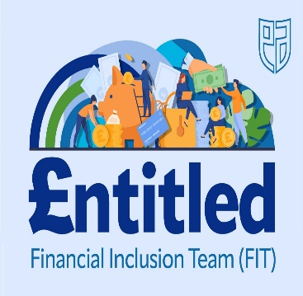
- Financial support can be provided to any family and any time by our Financial Inclusion Assistant, Kirsty McMonagle. Information regarding financial supports are shard through our school app. If you wish to speak with Kirsty, please contact the school.

