 Bellsbank Primary School
Inclusion and Positive Relationships Policy
Our Values and Our Vision
RESPECT KINDNESS ASPIRATION
RESPECT KINDNESS ASPIRATION

Bellsbank Primary School is committed to meeting the needs of all our learners.​ As a school we create a safe and nurturing environment through a consistent whole school approach to wellbeing which is supported through high quality learning experiences and ongoing assessment of needs. ​Every pupil feels they are valued and included allowing them to reach their full potential. We remove barriers to learning through an inclusive approach underpinned by positive relationships and a relentless drive to get it right for every child in our care.​

At Bellsbank Primary School we encourage every pupil to show:
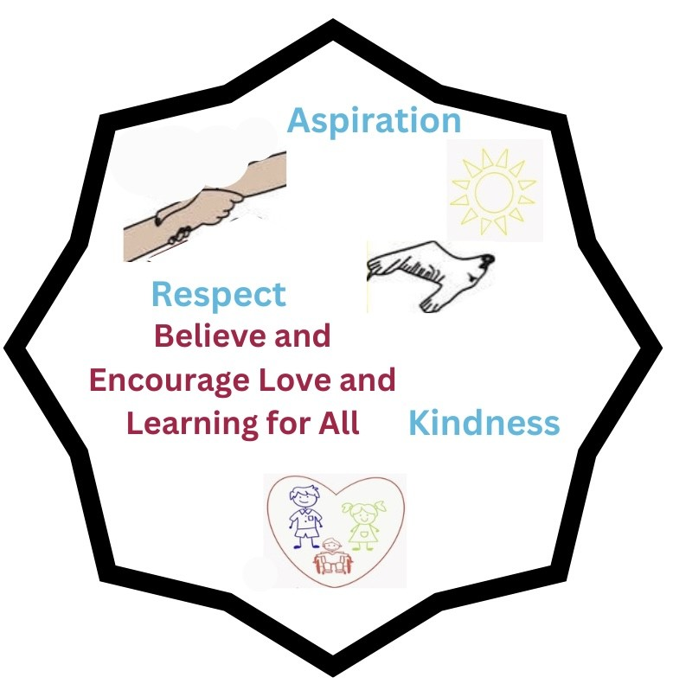

We will: | Because we want to:
- Show Kindness  - Show Good Manners to everyone within our school community by showing respect and looking after each other  - Show responsibility through working hard and doing our best. | - Feel safe, healthy and nurtured.  - Feel responsible and proud of our school.  - Our school to be a place where everyone feels respected, happy and included.  - Be active in our learning through achievement and attainment
Bellsbank Primary School
Relationships and Behaviour Policy
What matters to us is: | We know we won’t get if right all of the time:
Our Rights  Our Achievements  Our Behaviour | - We might say or do something hurtful  - We might cause damage  - We might be disrespectful  - We might be unsafe  - We might disrupt learning
However, when this happens together we have agreed to:
- Focus on repairing what has happened through restorative conversations
- Take responsibility for ourselves, for our actions and for making things right
- Take time to regulate our emotions
- Accept that we may need help from someone else to do this (peer, adult or parent)
- Accept that there may be consequences for my actions (beyond a restorative conversation) however these will always be specific to the situation and the individual needs of everyone involved.
We make our policy work by:
Knowing our Rights | All our classes have a Class Charter linked to the Rights of the Child and we know we have a responsibility to respect others’ rights. We are working towards our Bronze Rights Respecting Schools Award. Our Pupil Voice Assemblies allow us to have our voice listened to.
Being Respectful | Our school ensures everyone is included and we follow the Respect Me Anti Bullying Policy.
Being Restorative | We take time to repair relationships through restorative conversations. We all know how to behave responsibly and can discuss our thoughts and feelings around this.
Understanding our wellbeing | All our classes explore the GIRFEC SHANARRI (safe, healthy, active, nurtured, achieving, respected, responsible and included) indicators and PATHS lessons and know how to use these everyday within the school.
Being a Communication Friendly School | We make sure everyone feels included by supporting and developing our classroom environments to support the learning of all. Using the Circle Framework and Communication Friendly strategies and supports we ensure all resources and learning aids are accessible for all our pupils.
Being nurturing | Our Learning Lab is a safe space for pupils at break and lunch times as well as during learning time. This means we have space to access if we need to regulate our emotions and have wellbeing support.
Being supportive | Our B's Buddies support us in the playground. We can access other groups to support our wellbeing such as wellbeing groups and After School Clubs.

We can learn about and get help with our relationships and behaviour through:
Pupils | Health and Wellbeing/  PATHS Lessons | Soft Start /breakfast club /quiet lunch | Assemblies | Talking to an adult | Talking to a friend/  Wellbeing Champion | Pupil Voice  Assemblies
Parents | School Blog /Learning Journals | Parents Evenings | Information Leaflets | Speaking to staff | NEST – Online resource | Parent Council
Staff | Colleagues | SLT | Professional Learning | Occupational Health | Supervision Spaces | Online Resources

