
Bellsbank Primary School
Attendance Policy March 2025
How we achieve this
Values  - Respect – we see the good in other people and ourselves​  - Kindness – we are caring and help people and ourselves​  - Aspiration – we aim to do our very best; we have dreams and work hard to achieve them​ | Vision   | UNCRC  Young People’s Views are reflected in supporting attendance and engagement  Bellsbank PS is an accredited Rights Respecting School. This means children’s rights are learned, understood and lived in our school and ECC. Children’s views around attendance are sought, listened to and acted upon.  
Getting It Right For Every Child  - Supporting individuals and families  - Nurture Groups  - prioritising social and emotional support  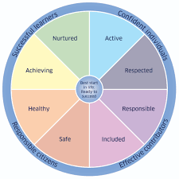  - providing flexibility in learning and teaching, environment, and curriculum  - families referred to low income supports  - high quality teaching and learning that promotes personalisation and choice  - targeting underlying causes such as child health and wellbeing and additional support for learning needs | Home and School Communication  Information around the promoting of attendance and reducing absence shared regularly and support for promoting attendance is also signposted.  - App  - Parent Council meetings  - Displayed in school  - Regular updates from school about all children’s attendance and latecomings  Effective communication about absence and the reasons between home and school. | Staged Intervention Process  When attendance falls below 90%, a phone call will be made to alert parents to the absence rate and to offer support. This will take place throughout the process.  Attendance will be monitored on a weekly basis for improvement.  Further assessment may be required to identify barriers to attendance.  Within school supports may be implemented.  Referral to partners may be required e.g. Scottish Children Reporter Administration
Understanding the barriers and challenges  These may be: -  - Individual  - Peer  - Family  - School | Tracking and Monitoring of Attendance  Monitoring of GMWP assessment  - Affiliation  - Autonomy  - Agency  Whole school attendance monitoring every 6 weeks  Update to parents 3 times per year  Identified children attendance monitoring weekly | Parental Engagement  Working with our parents to ensure the best support is given at all times.  - Regular communication  - Informal drop ins  - Family Learning Sessions  - Team with the Family meetings

Bellsbank Primary School and ECC
Attendance Policy

Rationale:
In Bellsbank Primary School and ECC we are committed to supporting children and their families to ensure attendance and engagement in school. We believe that this can be best achieved through building positive relationships across the school community, embedding nurture principles in our daily practice and ensuring a focus on social and emotional wellbeing and an ethos of community, mutual respect and trust.
“For every child or young person to achieve their potential, all schools should consider each pupil’s positive engagement with learning and their level of involvement in the school community. Attendance at school should be clearly linked to school’s overall approaches to promoting positive relationships and behaviour. Staged intervention structures and school’s ethos, cultures and values are fundamental to promoting positive relationships and behaviour.” Included, Engaged and Involved Part 1: A Positive Approach to the Promotion and Management of Attendance in Scottish School (2007)
“All absence can affect progress. Children and young people’s progress, attainment and achievements can be impacted by any absence. Evidence suggests that attendance that falls below 90% impacts negatively on progress. The higher the absence, the greater the impact on attainment.”
Improving Attendance: Understanding the Issues (November 2023)
Guiding Principles:

- All children and young people have a right to education; and education authorities have a duty to provide education.
- All children and young people have the right to get the support they need to benefit fully from their education and fulfil their potential.
- All children and young people need to be included, engaged and involved in their learning. Children and young people should be given opportunities to fully engage and participate in the life of their school in order to encourage good attendance.
- Schools should actively engage with parents to try to ensure that any barriers to good attendance are removed.
- Schools and partners should work collaboratively to promote and support good attendance.
- The foundation for schools, learning establishments and education authorities is a focus on positive relationships and an inclusive ethos and culture that promotes good attendance. Attendance should not be considered in isolation

National Context
Scottish Ministers have set an ambition for our country: that Scotland is the best place to grow up and bring up children.
“To achieve that we require a positive culture towards children. One where children are welcomed and nurtured. One where we all are alert to their needs and look out for them. Where they are listened to – whatever their age – and where their views are heard and their rights protected. They should be respected as people in their own right. Not as economic units for the future. But as members of Scottish society now with rights to a present day life that allows them to fulfil their potential.” (Scottish Government 2014)
The Importance of Good Attendance
Research has shown that attendance levels of less than 90% can impact on young people’s attainment. Lower attendance levels can have an impact on the connections the child has within the school – impacting peer relationships and preventing supportive relationships with adults in the school.

Promoting Good Attendance
Promoting positive relationships through a positive whole school culture
- At Bellsbank Primary School, we are developing a Relationships Policy with our children, parents, carers and staff.
- This policy has Children’s Rights at the centre, based on UNCRC to ensure young people have their voice listened to and acted upon.
- We use restorative approaches to resolve problems and difficulties.
- We follow the Barnardo's PATHs programme which helps young people develop their emotional literacy to be able to articulate their thoughts and views.
- All staff have been nurture trained and nurture principles underpin our work.
- We are developing an anti-bullying policy with children, parents, carers and staff based on Respect for All.

- Parental Engagement

- Developing a positive culture for attendance by
- ensuring all stakeholders (pupils, parents, partners and the wider community) understand the importance of attendance and promote it
- equity and inclusion are embedded
- feelings of safety and belonging are prioritised
- compassionate, flexible relationships - strong connections with significant adult(s)
- families, partners, and community members are valued equally and collaborate to
- support wellbeing
- supporting families to build their confidence
- cross-sector working - avoiding a discrete problem-solving approach
- preventative (universal) and intervention (targeted) approaches are balanced

Communication
We will share universal information about attendance and the impact on children’s wellbeing and learning on the school app, school blog and during Parents' Evening and Parent Open Afternoons. Attendance will feature in updates to the school Parent Council. Communication will take place with families directly as soon as possible after a concern regarding attendance is raised. All parents will receive an update about their child’s attendance and late-coming three times a year.
Cost of the School Day
We will have a focus on minimising events and activities which may cause financial hardship to families so to reduce further barriers to attendance. We will endeavour to make use of our Pupil Equity Funding to reduce barriers to learning linked to the Cost of the School Day.
Additional Support for Learning
The Education (Additional Support for Learning) (Scotland) Act 200419 requires education authorities and other agencies to make provision for all pupils who require additional support to overcome barriers to their learning. Additional support may be required to overcome needs arising from their learning environment; disability or health; family circumstances or social and emotional factors which would include mental health concerns.
Under the Act, every looked after child is presumed to have an additional support need, unless an assessment concludes otherwise. Providing additional support may help children and young people to engage more fully with school and promote good attendance. Schools should recognise that poor attendance can often be related to, or be an indication of, an additional support need and they should use their staged intervention processes to ensure that any barriers to learning are identified and appropriate support is provided.
(Included, Engaged and Involved Part 1: A Positive Approach to the Promotion and Management of Attendance in Scottish Schools)
In Bellsbank Primary School we follow our Meeting Learners’ Needs Policy to support children’s attendance and school and reduce barriers to children’s learning.
Bellsbank Primary School Practices in supporting attendance
We will take into consideration the following when reviewing practices to support attendance:
- adopting a ‘long-term view’
- aligning to values and culture
- supporting individuals and families by getting it right for every child
- reflecting the views of the young person
- curriculum flexibility and learning pathways
- families referred to low income supports
- prioritising social and emotional support
- building connections with a key person(s) e.g., mentoring
- providing flexibility in learning and teaching, environment, and curriculum
- high quality teaching and learning that promotes personalisation and choice
- targeting underlying causes such as child health and wellbeing and additional
- support for learning needs
- addressing environmental factors
- activating children and young peoples’ motivation
We will use the Glasgow Motivation and Wellbeing Profile (2023) to explore motivation and sense of wellbeing in the learning context. In particular,
- affiliation – a sense of belonging. I belong (nurtured and included)
- autonomy – a sense of self-determination. I am allowed/trusted (responsible and respected)
- agency – a belief in your ability to achieve your goals. I can (achieving and active)
(Attendance: Understanding the Issues November 2023)
Supporting Attendance and Managing Absence
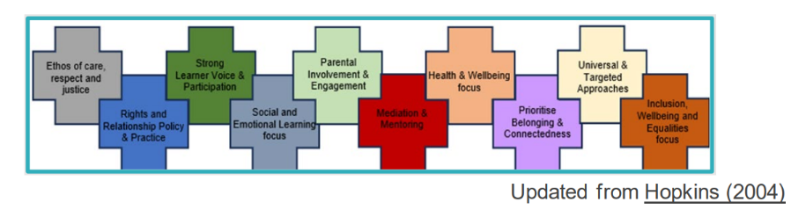
The following should be considered when reviewing systems to support attendance:
• we will use data to identify early warning signs – triggering support at an 'early' stage. Attendance data will be monitoring every six week for all.
• rigorous tracking and monitoring of all absences. Children below the threshold of 90% will be tracked weekly and patterns of absences will be explored.
• analysis of ‘actionable data’
• identify history of absence
• highlight absence through a range of lenses e.g., types of absence, trends, groups (e.g., care experienced children and young people, young carers, anxiety-based absence), ‘pedagogical truancy,’ environmental factors (including using SEEMiS coding effectively)
- systems (including attendance policies and procedures) are reviewed and implemented consistently by all team members and across sectors
- multi-dimensional, multi-tiered system (a spectrum) of support (including Scottish Children's Reporter Administration) effective partnerships
- evidence-based support approaches
The Flowchart below indicates the systems we use to work with children and families to support attendance at school.
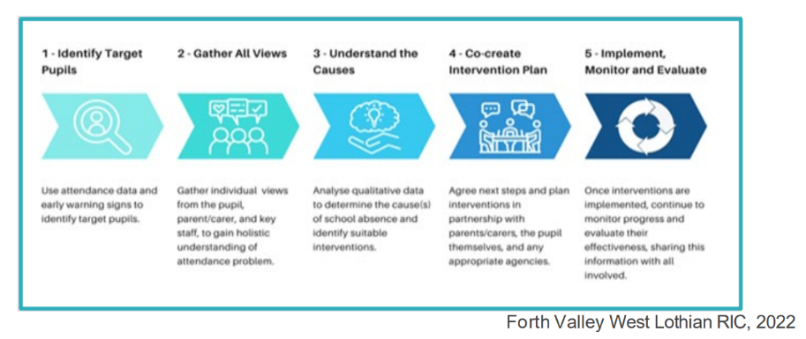
(Attendance: Understanding the Issues November 2023)

Managing authorised absence
Reasons for authorised absence are listed below
- Illness where no learning provision is made (including ongoing mental health concerns)
- Medical and dental appointments to be recorded in separate category (see Appendix 1)
- Meetings prior to, and during court appearances and other legal processes
- Attendance at, or in connection with, a Children’s Hearing or Care Review, or appointment with another service provider, e.g. social worker
- Religious observance
- Bereavement
- Weddings or funerals of close friends and family
- Arranged absence in relation to children in Gypsy/Traveller families
- Participation in non-school debates, sports, musical or drama activities agreed by the school
- Lack of transport – including due to bad weather
- Family recovery from exceptional domestic circumstances or trauma
- Period of exclusion to be recorded in a separate category
- Extended leave with parental consent including some young carer activities
- Maintain relationship and contact
In these instances, regular communication between school and the family to offer support will take place.
Managing Unauthorised Absence
Reasons for unauthorised absence are listed below
- Absence with parental awareness in specific circumstances
- Family holidays during term time
- Occasional absence without parental awareness
- Longer term absence – school related issues
- Longer term absence – home and wider community
- Absence relating to substance and alcohol misuse
Attendance and Absence data recording and management
As part of Bellsbank Primary School’s Quality Assurance Processes, attendance levels are monitored monthly to highlight any children whose attendance has dropped below 90%. This results in a phone call to parents to alert them to this level and to discuss any possible support which may be required.
Children whose attendance has dropped below 90% are tracked weekly for absences and lates to examine patterns and to continue conversations with families.
SEEMIS coding will be followed (as indicated in Appendix 1) this will allow for patterns and trends regarding authorised/unauthorised absence and lates to be monitored.

Appendix 1: SEEMIS Attendance Codes February 2024
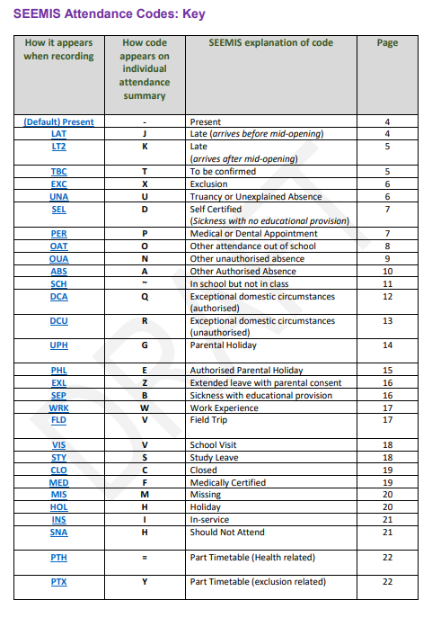


Appendix 2: Bellsbank Primary School Attendance Flowchart
Targeted Supported
- During 6 weekly attendance monitoring, pupil’s attendance is below 90%. A phone call home will be made to ask how the school can support.
5. After a further 3 weeks, if no improvement is seen in attendance, letter 4 will be sent home to invite paretns/carers to attend a Team with the Family meeting to make a plan to support attendance. This may involve the school nurse and social work if deemed necessary.
4. After 3 weeks, if no improvement, letter 3 will be sent home to invite parents/carers in for an informal meeting to discuss barriers and supports for attendance.
3. After 3 weeks if no improvement a reminder letter will be sent (letter 2) and an invitation to come into school to chat about how the school can support
- Monitor for 3 weeks. If no improvement in attendance, letter 1 is sent home with the explanation about percentages and days lost of school. This will be followed up by a phone call to offer support.
Throughout this process, the school will make use of assessment tools to help understand why children are reluctant to attend school. All children complete Wellbeing Webs and Glasgow Motivational and Wellbeing Profile throughout the session.
More bespoke assessments such as Boxalls, Pupil Assessment Profiles and School Refusal Assessment Scales may be used after discussion with parents and carers

Appendix 3 Letter 1
Name of School
Tel:
Our Ref:
Date:
Dear Lisa
Promoting and Supporting Attendance
I’m just sending a wee reminder about attendance as you may not be aware that XXXX’s (child’s name) attendance has slipped a bit and is now less than 90%. We always want our children in school as much as they possibly can be. I have included a copy of our Attendance Poster for your information. This outlines the impact of even a slight dip in attendance. I hope you and XXXXXX (child’s name) find it useful.
If I can be of any further help, please don’t hesitate to contact me at the school.
Yours sincerely

Appendix 4 Letter 2
Name of School
Tel:
Our Ref:
Date
Dear Lisa
Promoting and Supporting Attendance
I recently sent a reminder about attendance as XXXX’s (child’s name) attendance had fallen below 90%. Unfortunately there hasn’t been any improvement and their attendance is now less than 85%. You and XXXXX (child’s name) will see from our Attendance Poster the impact of this level of attendance on learning and progress. There can be many reasons for absence from school and I am keen to find out how we can help XXXXXX (child’s name) attend school as often as possible.
Please give me or …… a call and we can work together to help improve XXXXXX’s (child’s name) attendance.
Yours sincerely

Appendix 5 Letter 3
Name of School
Tel:
Our Ref:
Date:
Dear Natalie
Promoting and Supporting Attendance
I have to advise that XXXXXXX’s (Child’s name) attendance at school is less than 80%. I am very concerned as this level of attendance can have a serious adverse effect on XXXX’s (child’s name) education and progress at school. It is important that XXXXXX’s attendance improves and I am more than happy to help and support you with that.
We have spoken on the telephone a few times now, and would like to invite you in for an informal meeting to find the best way forward. To discuss how we can help and support you with supporting xxxxxx’s attendance could you please attend a meeting in school on (Day, Date) at (Time). You are welcome to bring a relative or friend to support you. Please advise me in advance of any special requirements. If this date or time is not suitable please call and we’ll arrange another time.

Yours sincerely

Appendix 6 Letter 4
Name of School
Tel:
Our Ref:
Date
Dear Paul
Attendance Monitoring
I have to advise that xxxxxx (child’s name) attendance at school is less than X%. I am very concerned as this level of attendance can have a serious adverse effect on xxx (child’s name) education and progress at school, and is causing him to miss many enjoyable and valuable school events and activities.
I am more than happy to help and support you with improving xxxxx (child’s name) attendance. We have spoken about this matter several times by telephone.
Given the level of attendance, I feel it would be helpful to discuss this together involving …………. (insert relevant agencies).
To discuss how we can help and support you with supporting xxxxxx’s attendance could you please attend a meeting in school on (Day, Date) at (Time). You are welcome to bring a relative or friend to support you. Please advise me in advance of any special requirements. If this date or time is not suitable please call and we’ll arrange another time.
At this meeting we will look at a range of possible supports and devise a Children’s Plan. This will allow us to explore all the possible reasons for non-attendance and work together to support xxxxxx (child’s name).
I have included a copy of our Attendance Poster for your information.
Yours sincerely

Appendix 7 Attendance Poster
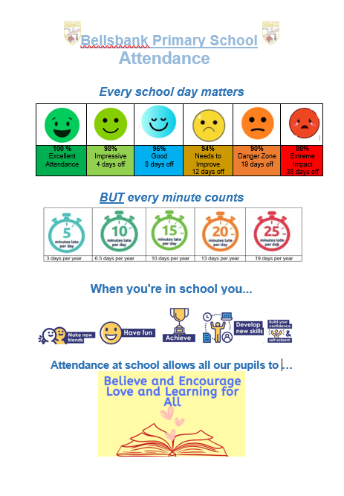

Appendix 8 Universal Support
All children’s attendance will be monitored every 6 weeks. At the end of each 12 week block, an update about attendance and late comings will be sent to all parents/carers with opportunities to discuss any concerns with the class teacher or senior leadership team,

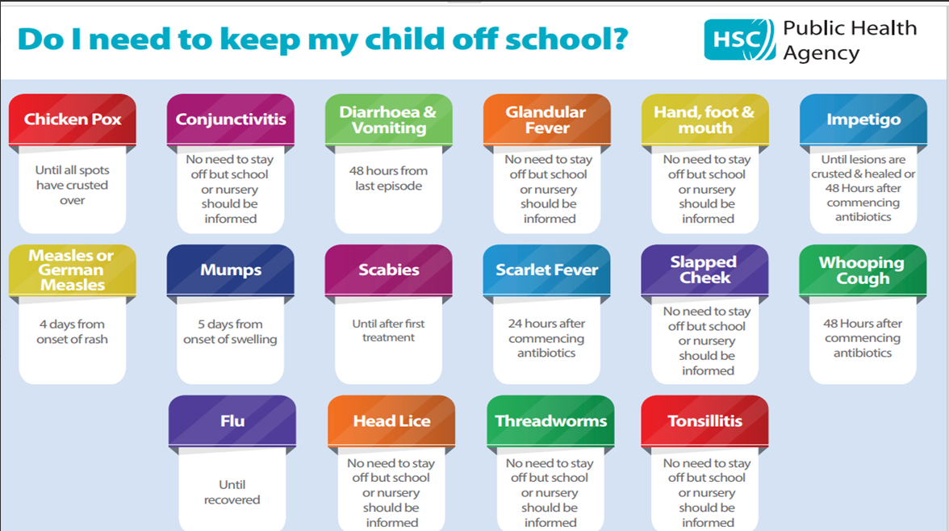

Monthly Update Shared on the School App
Attendance
As a school we are closely monitoring the attendance of our pupils across the school.
We know that pupils become ill and are unable to attend school which cannot be helped, however, we have also noticed that more of our families are taking holidays, having days off and having unexplained absences during term time which is having an impact on teaching and learning.
Our current overall school attendance average is xx%. Our aim is to raise this above 91% for the year.
Within the school we have xx% of pupils falling below 90% attendance for the month of xxxx excluding holidays and this is something we will be monitoring closely.
Files attached:
· Attendance Matters Information
· Bellsbank Attendance Protocol
· Information on Illnesses for parents.
Monitoring Attendance
At Bellsbank we ensure that attendance of pupils is monitored closely.
We aim to engage with parents/carers as early as possible to support any worries and concerns around attendance.
If a child’s attendance drops below 90%, our Senior Leadership Team will begin to monitor by doing the following:
- Look at the background of the pupil through exploring pastoral notes, discussion with teachers, discussion with pupil if appropriate, and any additional support need information.
- Where there is an area for concern, initial conversation with parent will take place over the phone and discussion of supports to eliminate any barriers to attendance. This will be monitored over 2-3 weeks.

- If attendance continues to fall, parents will be invited into the school to have an informal meeting to discuss next steps this is to support the family.

- If support from outside agencies is required for example: school nurse, or social work, a more formal Team With The Family (TWTF) will be arranged.

- Time will be given for actions to be followed from the TWTF this will be dependent on each individual situation.

- If no improvement and attendance continues to fall without due cause, there may be a need for a report to be sent to the Children’s Reporter through SCRA to support the pupils attendance as it will now be having an impact on wellbeing and learning.

Contacting the School to discuss concerns

The school is aware that issues around children’s attendance can be an indication that he child or family needs some support and we are happy to help. If you are concerned about your child’s attendance or the reasons why they don’t want to attend, you can contact the school in various ways to request a meeting with Mrs Greig, Mrs McLurkin or the class teacher.
- Learning Journals
- Emailing the school
- Phoning the school

