My name is ____________________ My teacher is _____________________
4. Swearing at people is not a good thing to do. Swearing at people will make them feel upset. I will try remember not to swear at people when I am angry. The adults at school will help me to think of better things to do when I am angry. I will try my best not to swear at people. Well done me!

2.
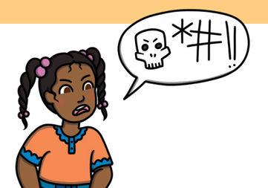
Swearing is when a person says rude or unpleasant words. When people are angry or very upset, they might swear.
Swearing is not a good thing to do. It is not ok to swear.
When I am angry or upset. I might swear at my friends, my teacher or other members of staff. This is not ok.
- Sometimes at school I get upset. I find it hard to talk when I get upset.
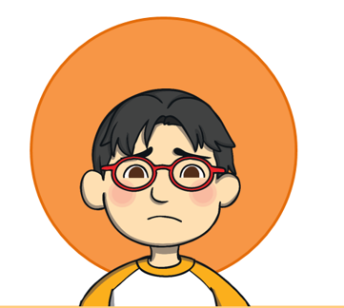
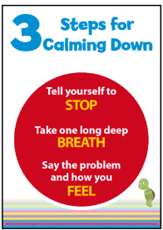
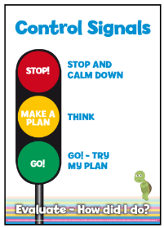
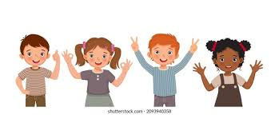
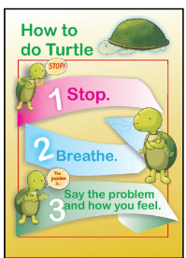
3. When I am feeling angry I can tell an adult how I am feeling, change my emotion check in to uncomfortable or use one of the posters. This will remind me to do turtle or follow the control signals to help me feel better.
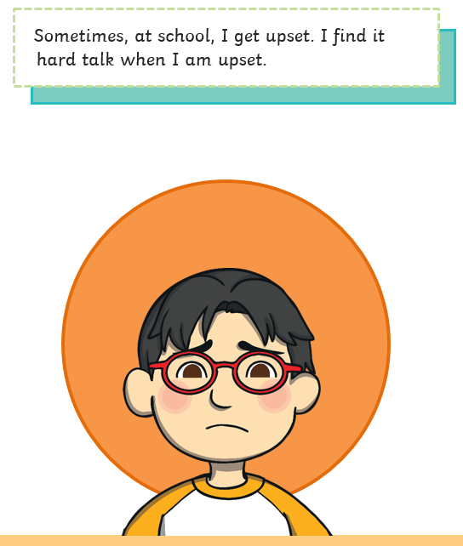
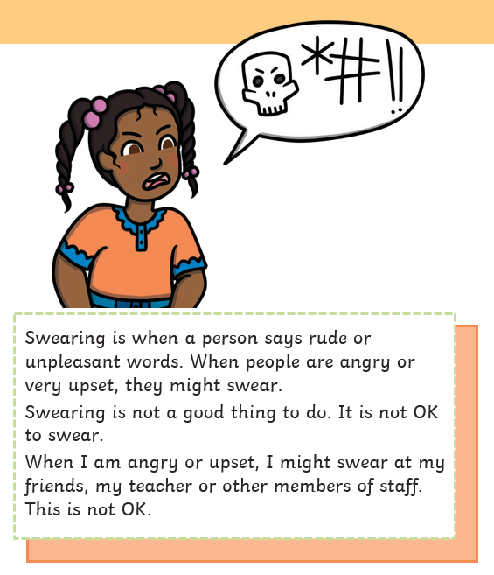
.
4. Swearing at people is not a good thing to do. Swearing at people will make them feel upset. I will try remember not to swear at people when I am angry. The adults at school will help me to think of better things to do when I am angry. I will try my best not to swear at people. Well done me!

3. When I am feeling angry I can tell an adult how I am feeling, change my emotion check in to uncomfortable or use one of the posters. This will remind me to do turtle or follow the control signals to help me feel better.
.

