
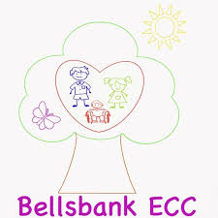
Bellsbank Primary School and Early Childhood Centre
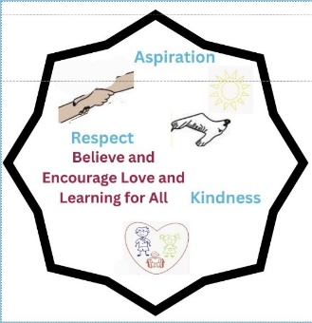

Inappropriate Language and Swearing Statement
UNCRC Rights of the Child
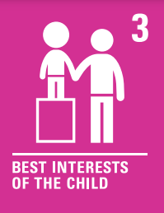
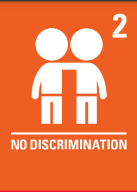
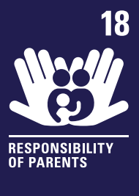

At Bellsbank Primary School and Early Childhood Centre we have a zero tolerance approach to inappropriate language and swearing towards other people. It is not acceptable behaviour and we will not tolerate this in our mannerly and friendly school.
In school, staff work with children to help them develop their emotional literacy using the PATHs programme. Lessons include helping children to develop problem solving strategies for when they feel their emotions are overwhelming. Posters to remind the children of these strategies are displayed around the school.
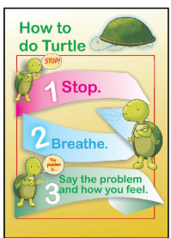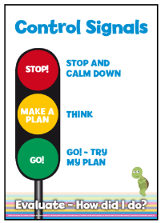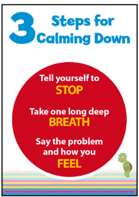
Inappropriate language and swearing towards others is offensive. It is anti-social and it upsets others. When others have inappropriate language or swearing directed towards themselves, it makes them feel distressed, intimidated, or even scared.
All members of staff will challenge children who speak in this way. Children who swear and use inappropriate language towards others are not following our school values of: Be kind, Be respectful and Be the best you can be. Everybody has a right to be spoken to in a polite and respectful manner.
The school’s response to swearing and the use of inappropriate language
Children who use inappropriate language or swear will:
• Use their next breaktime, either later that day or the following day to discuss a social story for the child to discuss their use of inappropriate language towards others.
• A letter sent home to the parent/carer stating the offensive language that has been used towards others.
If inappropriate language is used towards others whilst playing football, the child will:
• Be removed from the football game at that time and for the rest of the day
• Possibly not be able to represent the school football team (if they are a member of the team)
If children continue to use inappropriate language or swear towards others, their parents/carers will be invited into school to discuss their behaviour.
Some children with additional support needs may swear as they find it difficult to handle their emotions. The staff team will review each incidence individually and address situations accordingly.
We will not tolerate inappropriate language or swearing towards others in our friendly and mannerly school.
Written: February 2025 Review: February 2026

