Bellsbank Primary School

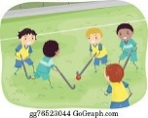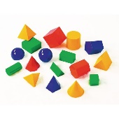Term 3

Health and Wellbeing  
**Physical:**   
East Ayrshire Sportshall Athletics Championships Gymnastics: jumping, rolling, balancing and climbing

A Healthy Lifestyle

**Social & Emotional:**   
Bounceback Programme

Responsible digital behaviour and keeping safe online

**IDL**

**Science:** Inheritance: Life Cycle of plants, inherited and non-inherited characteristics

**People, Place & Environment**: Compare and contrast my local area in Scotland with an area out-with Scotland (climate, weather and how the land is used)

**Food & the Consumer:** Food labelling and media influences

**Numeracy & Mathematics**  
**Whole Numbers:**   
Multiplication Masters

3D Shape

Symmetry

Tessellation

Fractions, Decimals & Percentages

**Expressive Arts**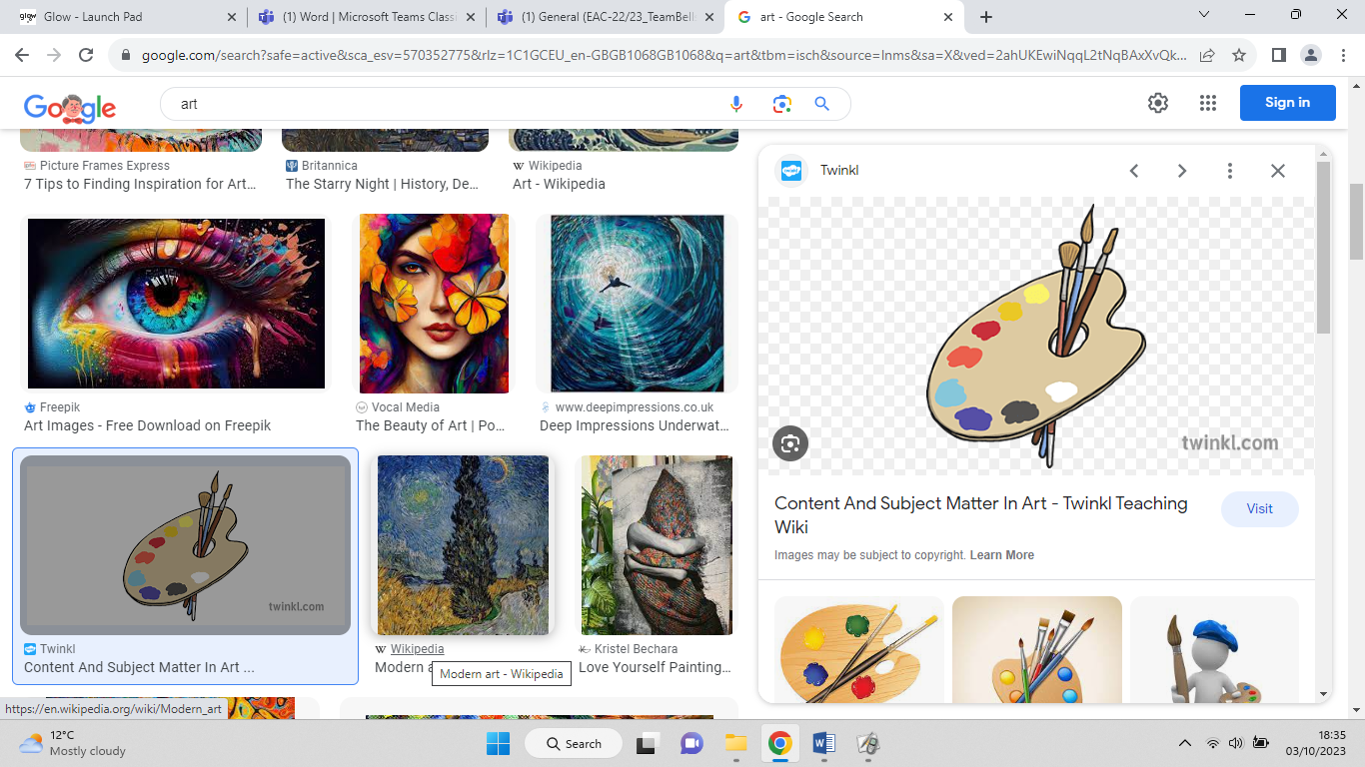

**Art:** Drawing techniques

**Music:** Strings with Miss Martin & Songs for Assemblies

**Literacy**  
**Reading:** Finish The Graveyard Book by Neil Gaiman

Literacy World Reading Stages 1 & 4

“Clockwork and All-wound Up” by Phillip Pullman

Accelerated Reading Scheme for enjoyment

Scot’s Language

**Spelling:** East Ayrshire Literacy Stage 3, 4&5, 6&7

(Common words and “s”, “o”, “m”, “n”)  
**Grammar:**   
Nouns (collective, masculine & feminine, synonyms/homonyms, antonyms, homophones, adverbs (manner, time and place)

**Writing:**   
Information Report: Using Writer’s Toolbox and including a title, subheadings, facts, table/chart/diagram and an appropriate conclusion.

**Leadership**  
P1 helpers (Lunch Time and Reading)

Recycling Monitors

Teacher: Mrs Johnstone