Our Ref:JC/Brass
Date: 11/08/2022

RE: Instrumental Music Tuition

Dear Parent/Guardian,

I am writing to let you know about an opportunity that your son/daughter is now eligible for. Your child has recently had a visit from East Ayrshire Music Service staff who provided a showcase performance on Brass instruments available through the Music Service.

If you would like your child to be tested for a Brass instrument, then please complete the Expression of Interest MS form. The link for this can be found below or can be accessed through the QR code. Although we try our best to accommodate as many pupils as possible, demand for lessons is very high. Please note that by registering your interest, this does not guarantee your child a space.

https://forms.office.com/r/nMUF1PjrwR

Should your child be successful in the trial a further registration form will be issued to allow you to register for lessons and the loan of an instrument. For your information the Terms and Conditions of the Music Service can also be found here:

https://blogs.glowscotland.org.uk/ea/eainstrumentalmusicervice2017/ims-documents/

With Thanks

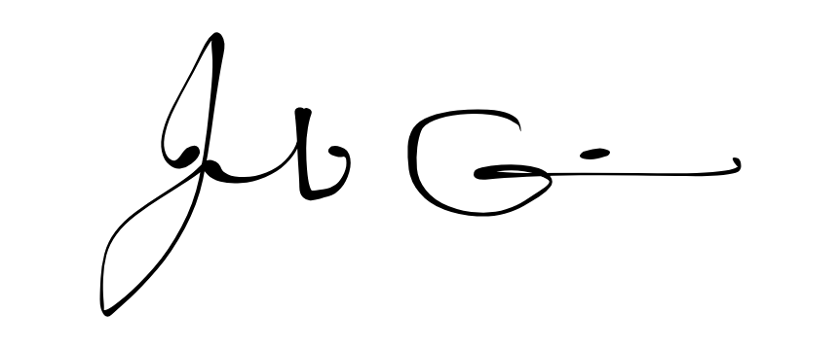
Acting Music Service Manager

