Writing - Write Memories for the Year about your friends, favourite thing you did at school outside and inside, your funniest memory, favourite trip, draw a picture of yourself and your favourite book either you have read or the teacher has read to you this year. Click link below for writing sheet.  Primary 2/3 Home Learning for week beginning 22nd June, 2020 | Have a treasure hunt in your garden. You can hide toys or anything you want as your treasure. Make up some clues on a sheet of paper and ask your family to find the treasure using the clues. You might need to ask a member of your family to help you with this. | 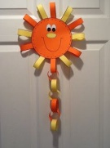  Make a countdown chain for the last week of Home Learning and hang it on your wall. You will just need to make a chain with 5 loops on it and number it 1 to 5. Each day you can score of the number.
Make a tent/den in your back garden using old sheets or blankets. Put some cushions in it as seats and invite some of your family out to play in it. Have your lunch in your new den. Take a photograph of it and keep it in a scrap book. | Make an obstacle course outside for you and your family to race on. You could use anything you have around the house and garden. Some ideas are hoops, skipping ropes, boxes, balls, paddling pool and anything you can think off. Take photographs of everyone taking a turn and keep them for memories. | Have a mini sports day in your back garden or any open space near your house. You can run races and time each other to see who is the fastest. Make up different types of races like the 3 legged race and egg and spoon race.
Take a photograph of you on your last day of Home Learning outside. | 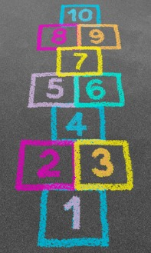  Use some chalk to make a Hopscotch Game outside. You chalk the numbers on the pavement and play the game. Ask a family member to help you with this and ask if they played it as a child. | Have a party at home in the back garden if you can to mark the end of the school year. You could make some fruit snacks for the party. Here are some ideas.

