Virtual Trip to Edinburgh Zoo.
Below is a table full of ideas that you and your family can complete so you can go on a virtual trip to Edinburgh Zoo.
First of all, have a look on the Edinburgh Zoo website.  https://www.edinburghzoo.org.uk/ | Use the website where you can watch live webcams of some of the animals in their enclosures. | 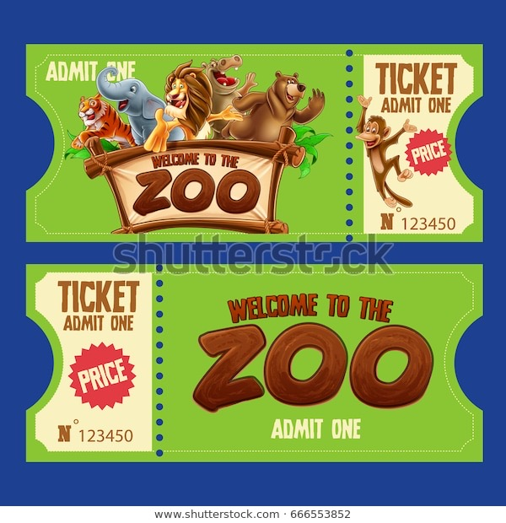  Can you design a ticket for entry to the zoo? Add the following details: Price (adult or child), Name of the zoo, Date you are visiting, Picture | Use google maps to look at a satellite view of the zoo. There are also good pictures of parts of the zoo and the animals within google maps.
What will the weather be like on your virtual trip? Research the weather for that day and make a list of things you will need to pack for your day out. Hopefully the sun will shine!!  https://www.metoffice.gov.uk/  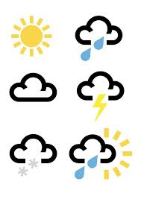 | The café is very expensive so it would be best to take a packed lunch. Can you help make a packed lunch at home that you could eat.  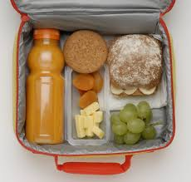 | 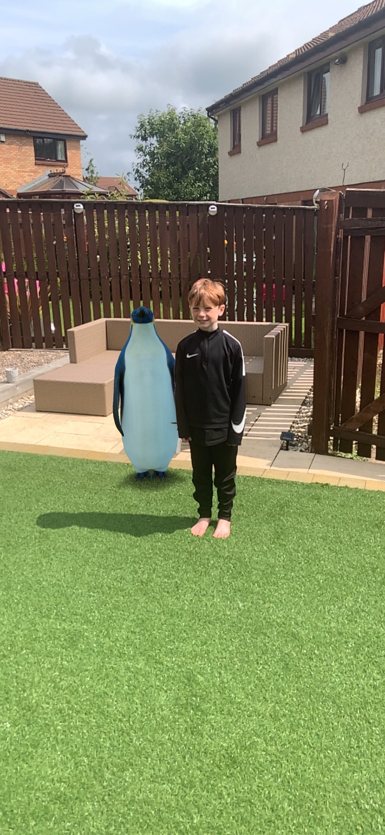  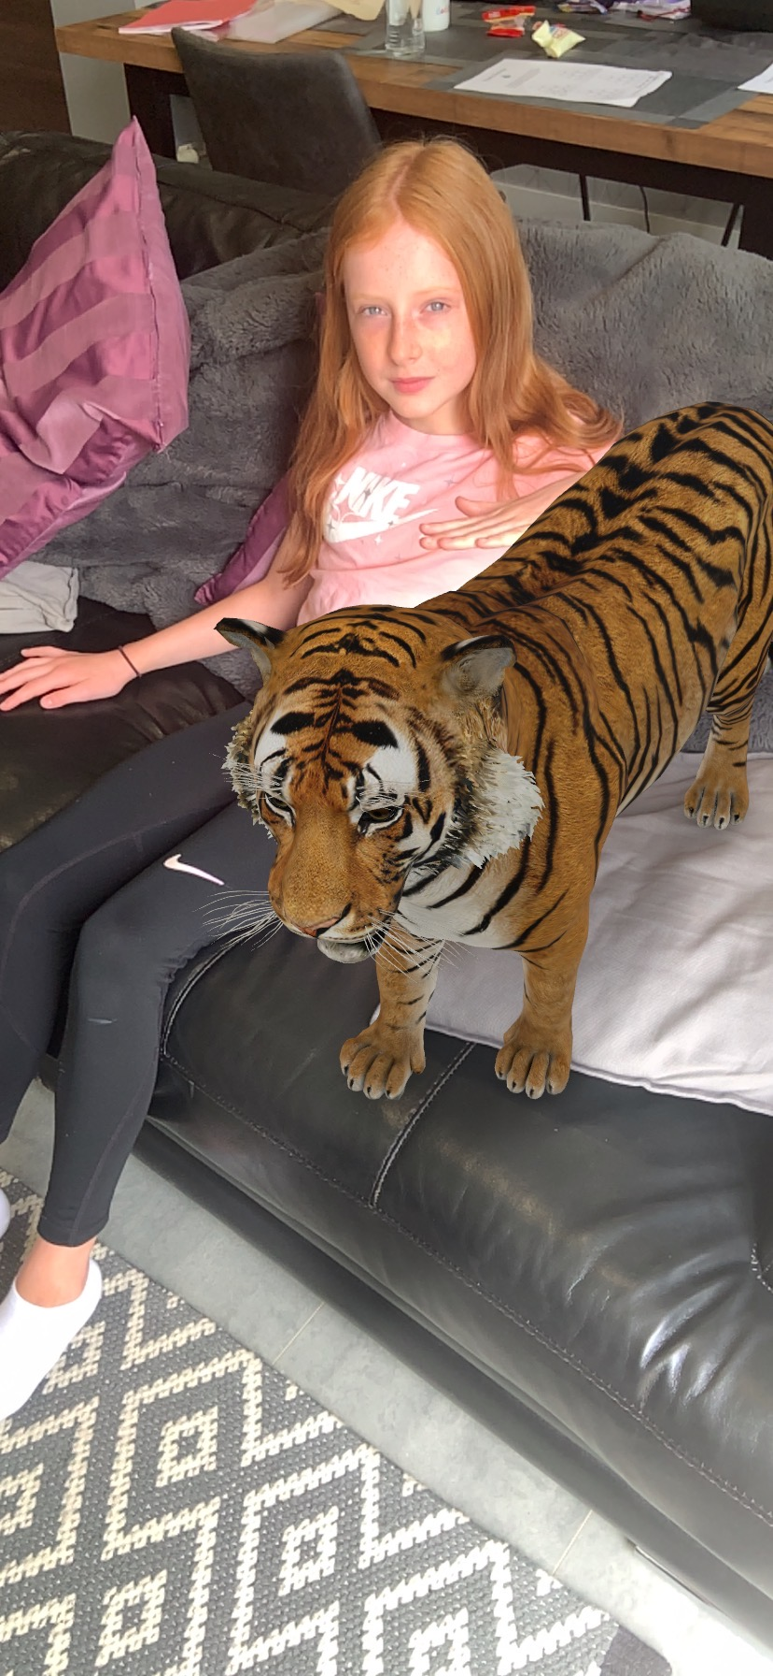  Use a phone or portable device and type an animal in to google. There is an option to view it as 3d. Have a play around with it. You might find yourself cuddling a tiger!! | The interactive map on the website has lots of links that gives you information on the different animals in the zoo. Can you draw your own map? Remember to add things like picnic spots, children’s playpark, animal enclosures, entrance and exit to the zoo.  https://www.edinburghzoo.org.uk/map/
Edinburgh Zoo is most famous for its penguins. Click on the link where you can learn to draw your own penguin.  https://www.youtube.com/watch?v=Coqgz3PttqY | Everyone loves to buy souvenirs from the shop at the end of their visit. Have a look at the online shop on the website and in the eco-friendly section.What is the price of the cheapest item? What is the most expensive? What would you buy and how much does it all cost? Can you come up with items that you would sell and include your own price? | Go back to the website and try to find the times that the zoo is open.  What time does it open? When does it close during the winter months? What day is the zoo closed? | Pick two animals that you would find in Edinburgh zoo. Can you use the internet to find out 3 amazing facts about each animal and write them down?
Sing along with these songs.  https://www.youtube.com/watch?v=e_04ZrNroTo  https://www.youtube.com/watch?v=BBF1G4EDvqA | Watch these funny video clips about animals you will find in a zoo.  https://www.bbc.co.uk/iplayer/group/b091wvg4 | Can you write down all the letters of the alphabet and write an animal that begins with each letter? | Here is a puzzle to try.

