Tasks to attempt every day… | Other tasks for the week I can attempt…
I can practice writing my name. If I am confident try my second name- this could be on paper, using technology, using chalk outside it is up to you. Please support me by letting me write over letters, copying letters or giving it a go with your guidance. | Numeracy/ Maths Additional Task: Explore capacity using a cup or a jug and some water. Use words such as ‘full’, ‘empty’, ‘almost full’ and ‘almost empty’ If the weather stays nice you can take this activity outdoors.
I can practice my sounds - all jingles are on YouTube https://www.youtube.com/watch?v=euxN7LGOolc If I am confident with sounds I can start to blend them to make short words e.g cat, sit.
I can listen to a story and talk about it- who are the main characters? Describe the characters. What happens first, next, last? | Story Additional Task: Listen to the story ‘The Tiger Who Came to Tea’ on Youtube : https://youtu.beBXgW9UCgpc8 Discuss the story:  What do you think it is about?, who are the main characters?, How do they feel? How do they feel at the end? What was your favourite part of the story??  Literacy additional. Write a shopping list of the items to buy from the shops after the tiger has visited. Don’t forget the large tin of tiger food! You can write your list or you could use magazines to cut pictures to make a list.  Talk Task: Who would you most like to have tea with when lockdown is over? What would you have at your tea party? Would you allow a tiger to have tea at your house?
I can practice reciting numbers- this could be using technology and YouTube songs, counting when playing hide and seek etc. Also, some learners have started learning counting in fives, twos and tens so we could practice these using videos online.
I can practice counting- this could be counting toys, socks, absolutely anything. Focusing on the child giving you the correct amount asked for or counting out items one by one and knowing their answer is when they run out of items to count.
I can practice recognising number- this could be online, writing numbers for kids to name, finding them on items in the home or hiding written numbers on paper around the room to play hide and seek (at school we sometimes use a torch to make it more exciting). | Art task: Can you mask model tigers using playdough or construction toys?  You could also make yourself a tiger mask. You could explore colour mixing to make orange paint and add black stripes.  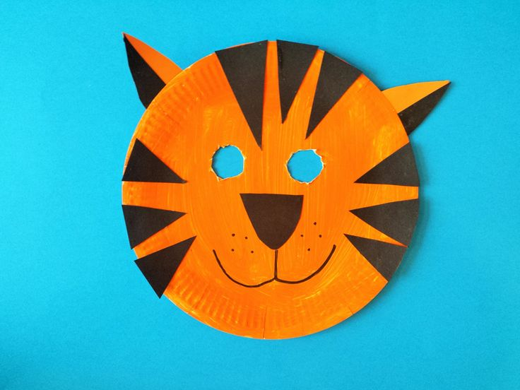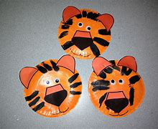
I can practice writing my numbers- this could be on paper, using technology, using chalk outside it is up to you. Please support me by letting me write over letters, copying letters or giving it a go with your guidance.
I can take part in physical activities- this could be using technology (in SLC 1 we love GoNoodle on Youtube especially The Dinosaur Stomp), Joe Wicks P.E. follow him on YouTube, a walk or play in the garden if available. | Health and Well- Being task: Have a tea party with the people you live with. Think of what foods and drinks you would like at your tea party. You could even help an adult to prepare the food. If you have a soft toy tiger (or any other soft toy animal) take it to your tea party. Remember to share some food with your animal!

Extra Challenge : Revise all of your reading words. Try saying them all in a tiger voice. Your words are a, and, he, I, in, is, it, of, that, the, to and was. Find a place to display the words. You can hang them on a washing line or stick them to your bedroom door. Practice reading the words each day. You can play games with them e.g. You could take it in turns with people in your house to hide the word and the person who finds it shouts the word, or have someone shout the word and see how quick you can splat that word with your hand. Anything goes!

