C:\Program Files (x86)\Microsoft Office\MEDIA\CAGCAT10\j0332364.wmf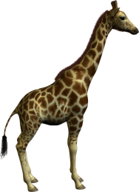My 5 Favourite Animals

My first favourite animal is a

My second favourite animal is a