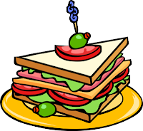
How to Make a Sandwich

1.

2.

3.

4.

5.

6.

