Addition and Subtraction Word Problems
L.I. I can solve two-step problems involving addition and subtraction.

1. Ben buys 12 pencils one week and 6 the following week. He gives 3 to his friend.
How many pencils has Ben left?

2. Jane has 15 sweets. She gives 4 to her friend Anne and 2 to her mum.
How many sweets has Jane left?

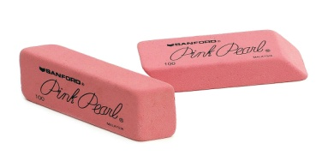
3. Freddy has a box of rubbers with 12 in the box. He drops them and looses 5 rubbers. He then buys another box of 12 rubbers.
How many rubbers does Freddy have now?

4. George has 23 water balloons. He give 6 to his sister and 7 to his brother.
How many water balloons has George left?

5. Alfie and John bring their lego men to school. Alfie brings 11 and John has 8. They give their friend Tom 4 men between them.
How many lego men have Alfie and John left altogether?

