SLC 3 – No Pens Day - Wednesday 4th October 2017
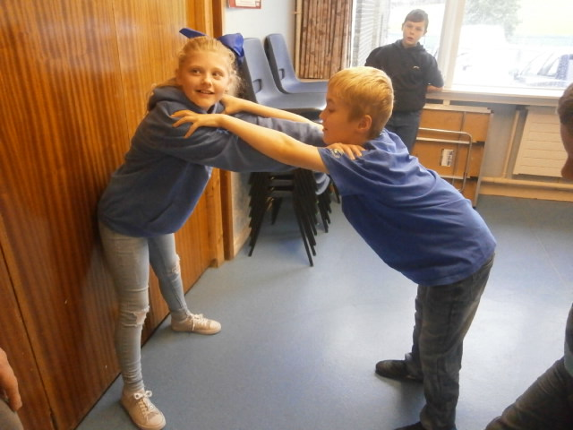
We worked with Mr Ross in the morning to explore literacy through drama. We have been learning about the story of Charlie and the Chocolate Factory. In the morning, we read about Mike Teavee being transported by a magic television in the factory. We then came up with our own ideas to bring TV adverts to life.
Here are Billiejo and Kieran being a television!

Scan the code below to watch a full video of all the TV adverts that we came up with!
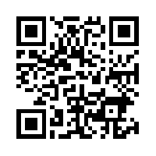

Later in the day, we practiced our spelling words using some active methods. One of our favourites was using the magnetic letters and boards.

