SLC 1 No Pens Wednesday 2017
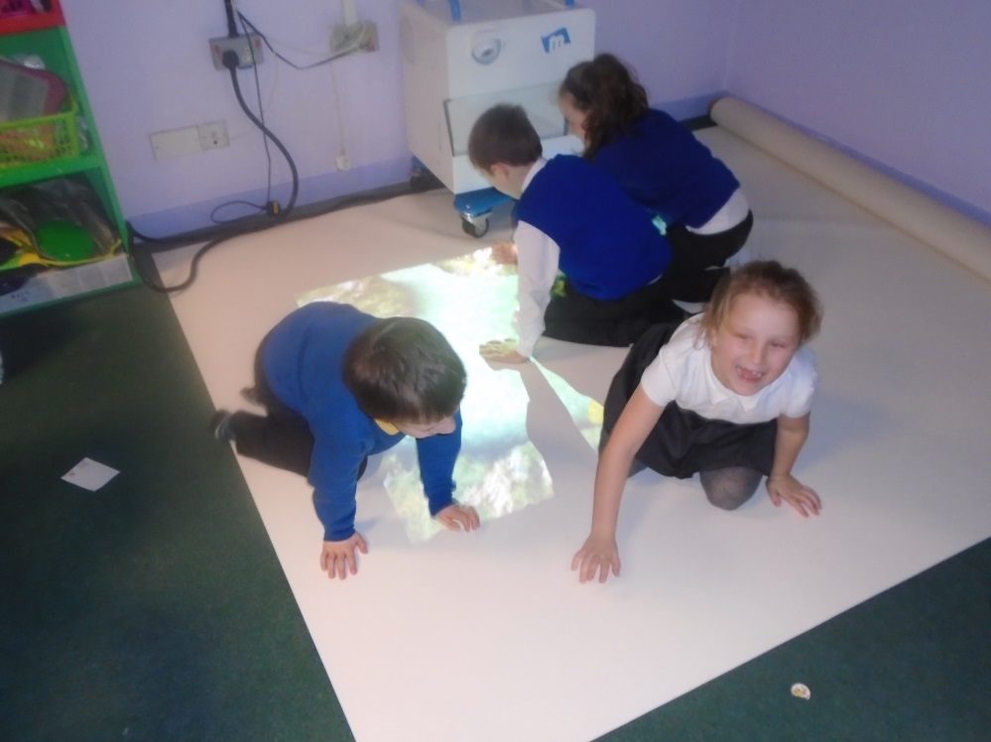
In SLC 1 we used to Magic Carpet to find and read our tricky words.

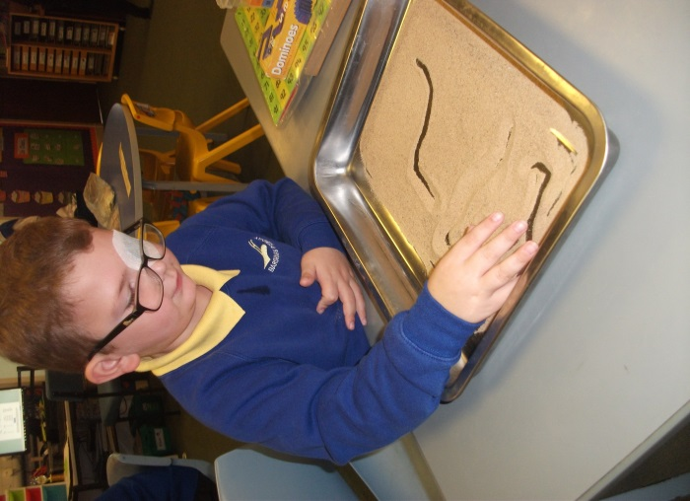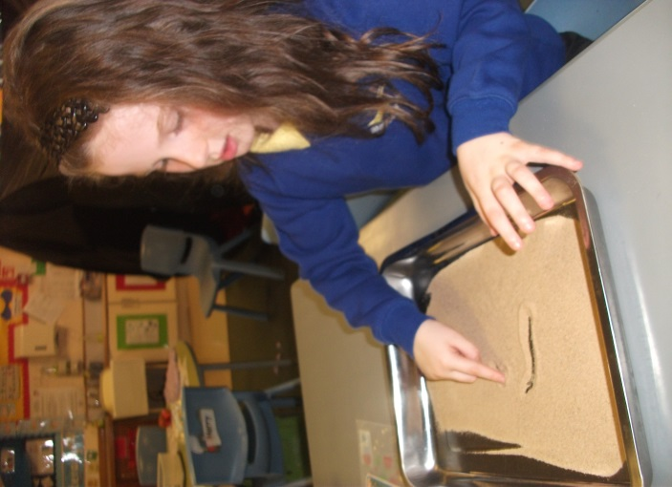
At numeracy we wrote all our answers in sand. We were making 2 and 3 digit numbers.

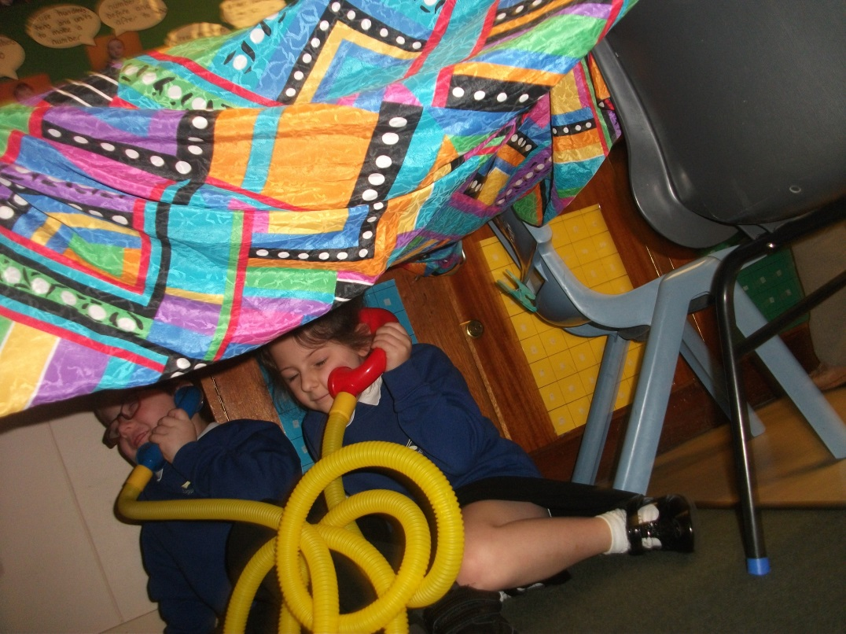
We also looked for words that began with‘t’ using a torch. Then we built a tent and went on the telephone.

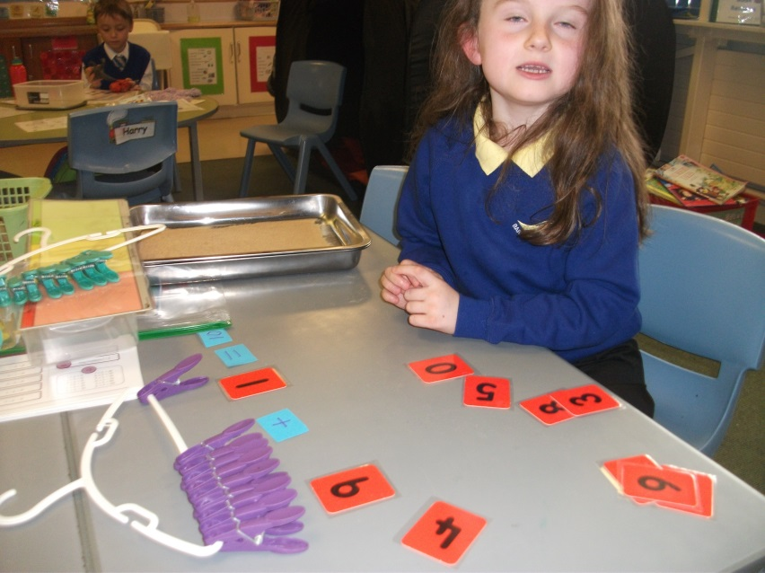
We practised our number bonds using pegs and number cards.

