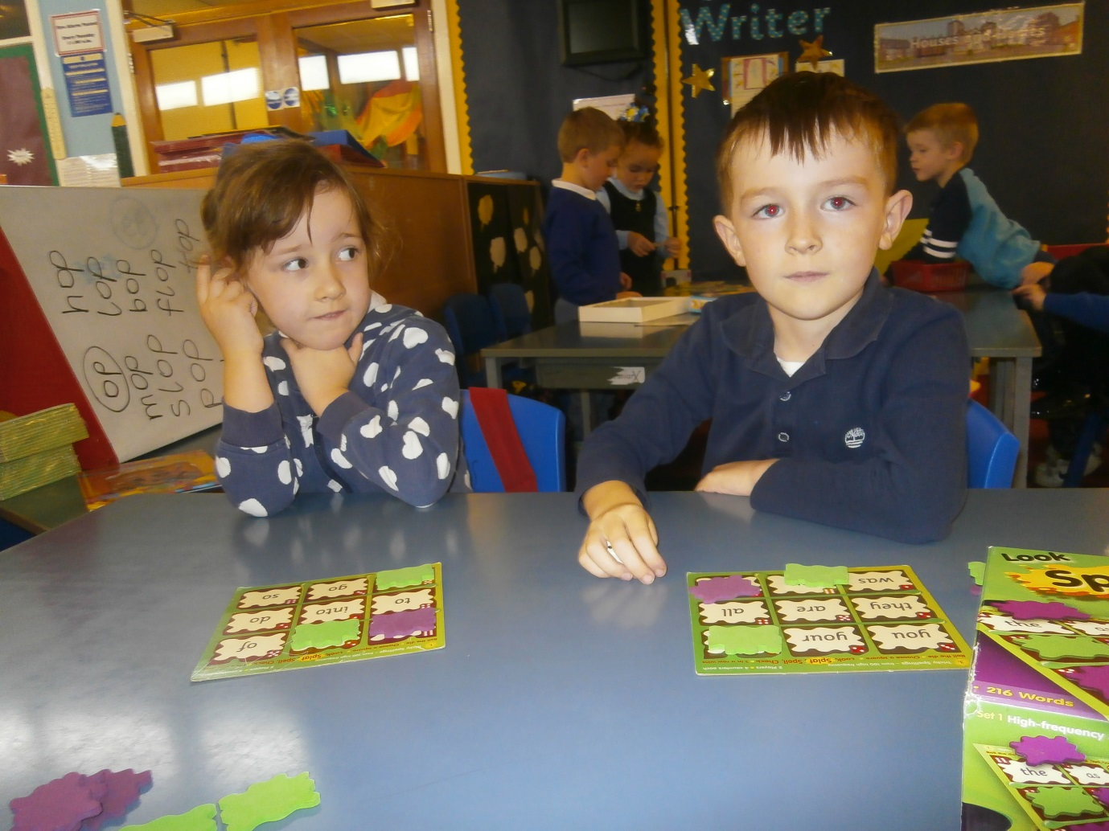

Primary 2 had fun on No Pens Wednesday playing spelling games and addition and subtraction games. Bonnie and Mason were sounding out their words.
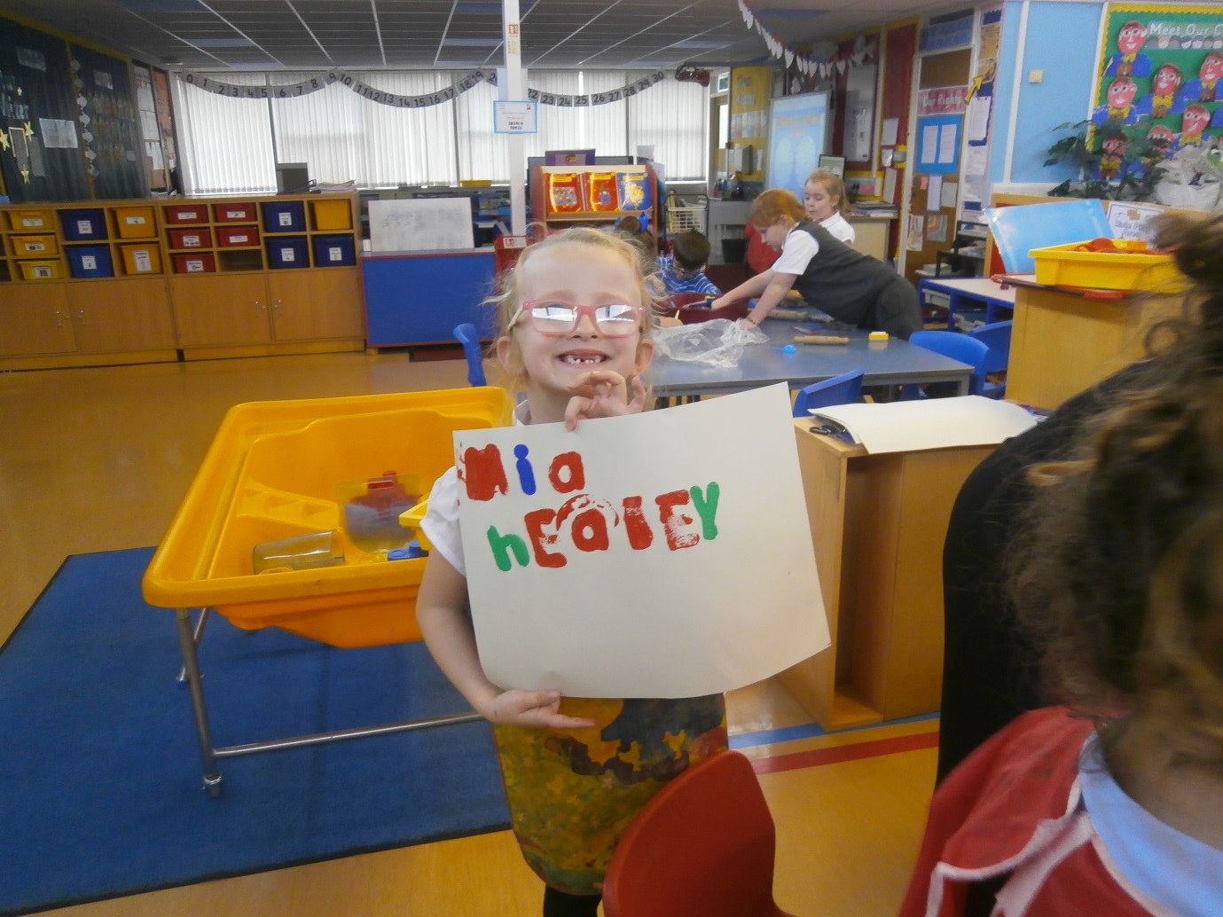
Primary 2 were using sponge paints to write their name and CVC words. All children had great fun using the paints and finding all the letters. Some children even made words for the sound that we were learning that week.
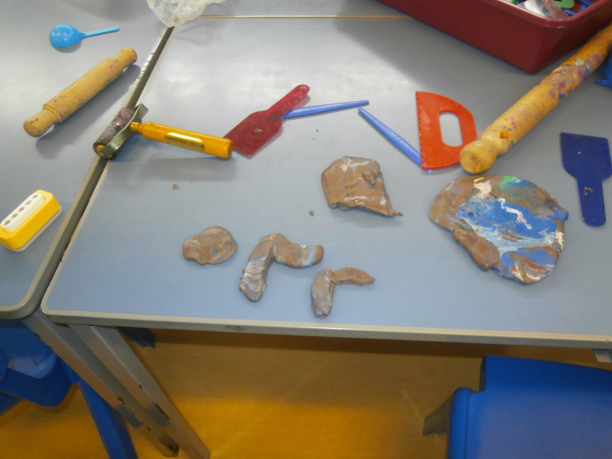

Primary 2 had fun with play dough making letters and CVC words. Some children just managed to make the letters but they did it independently which was super.
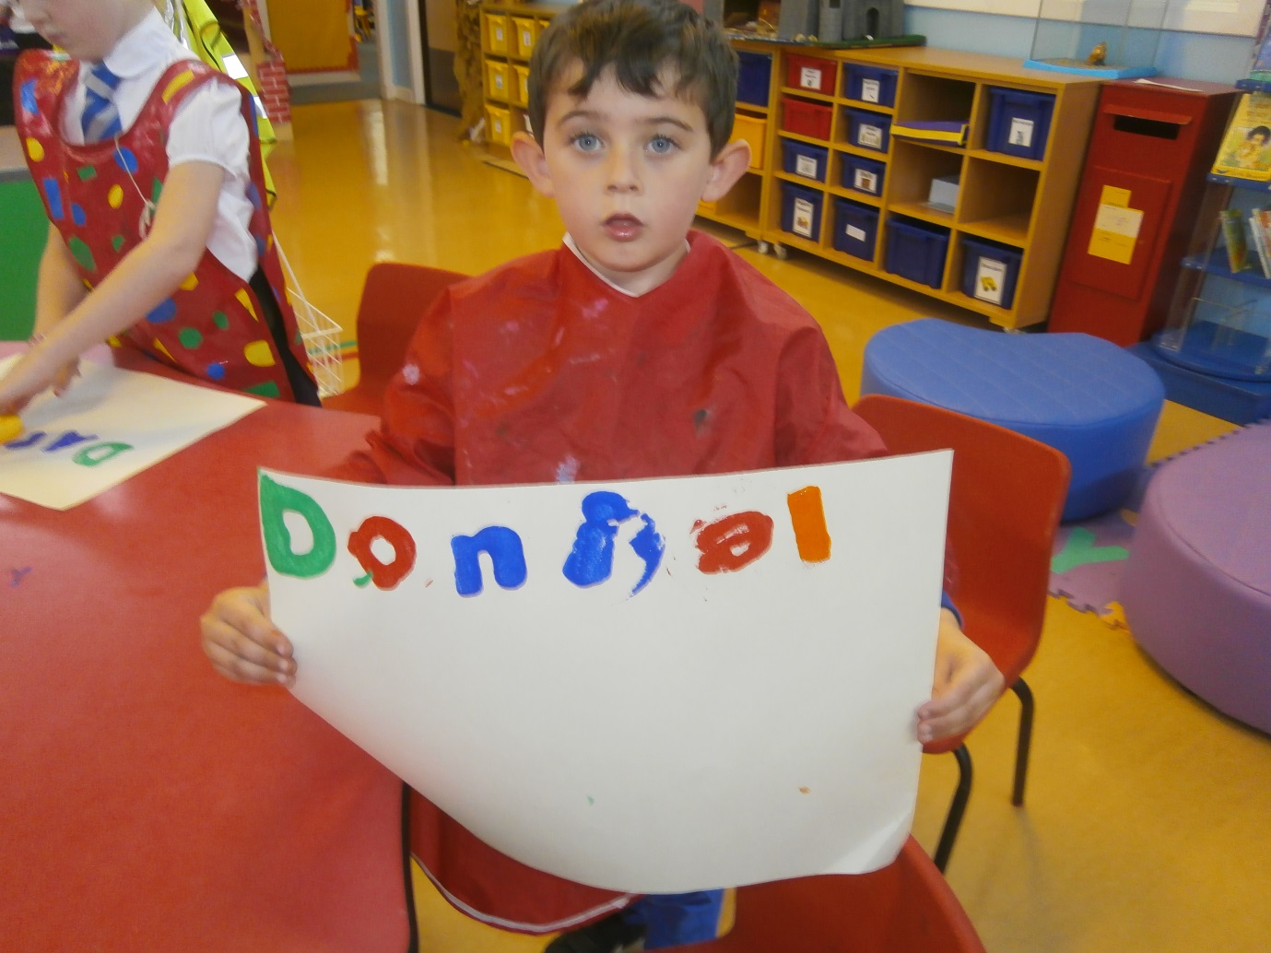
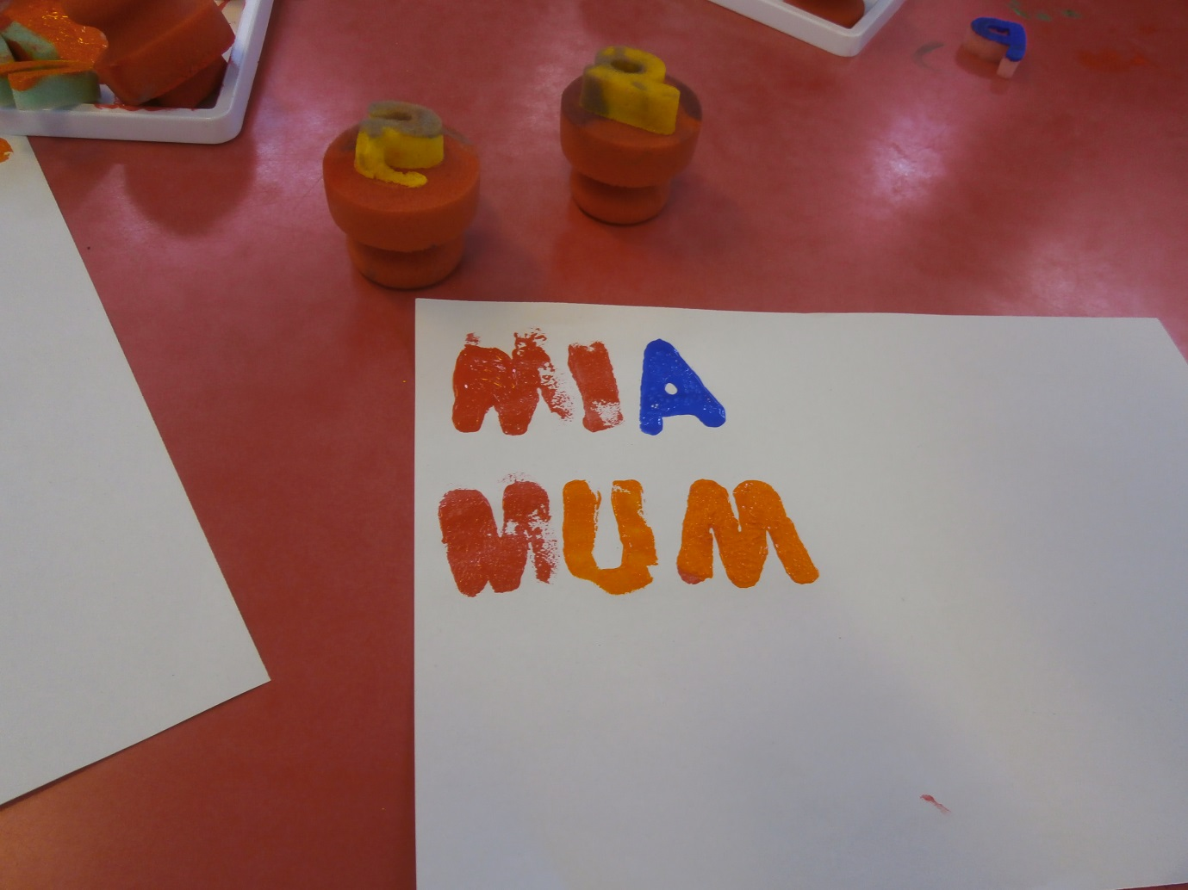

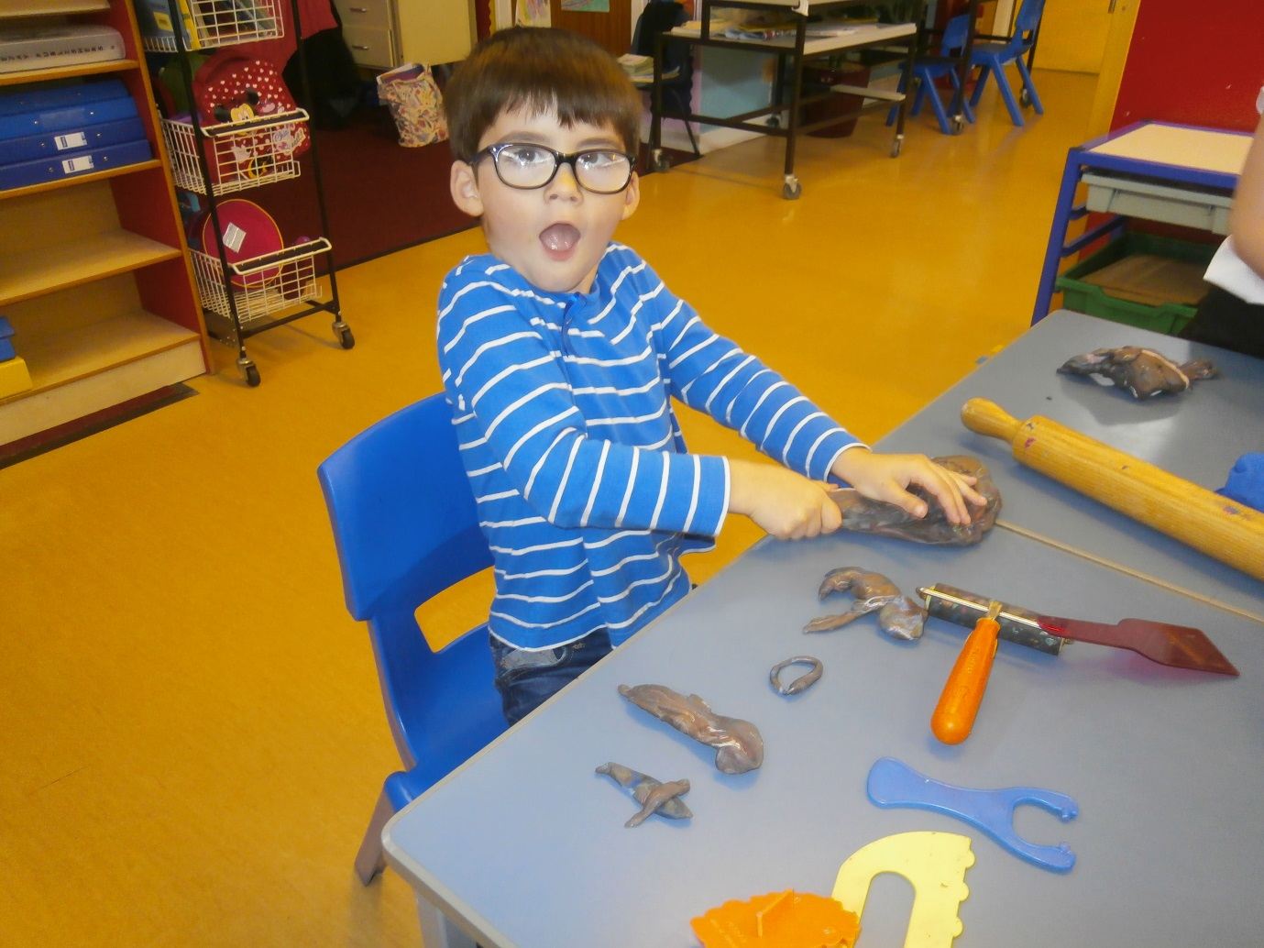

Harry had great fun making his own letters. He made a ‘k’ and a ‘t’.

