Primary 1
‘No Pens Wednesday’ – Literacy activities

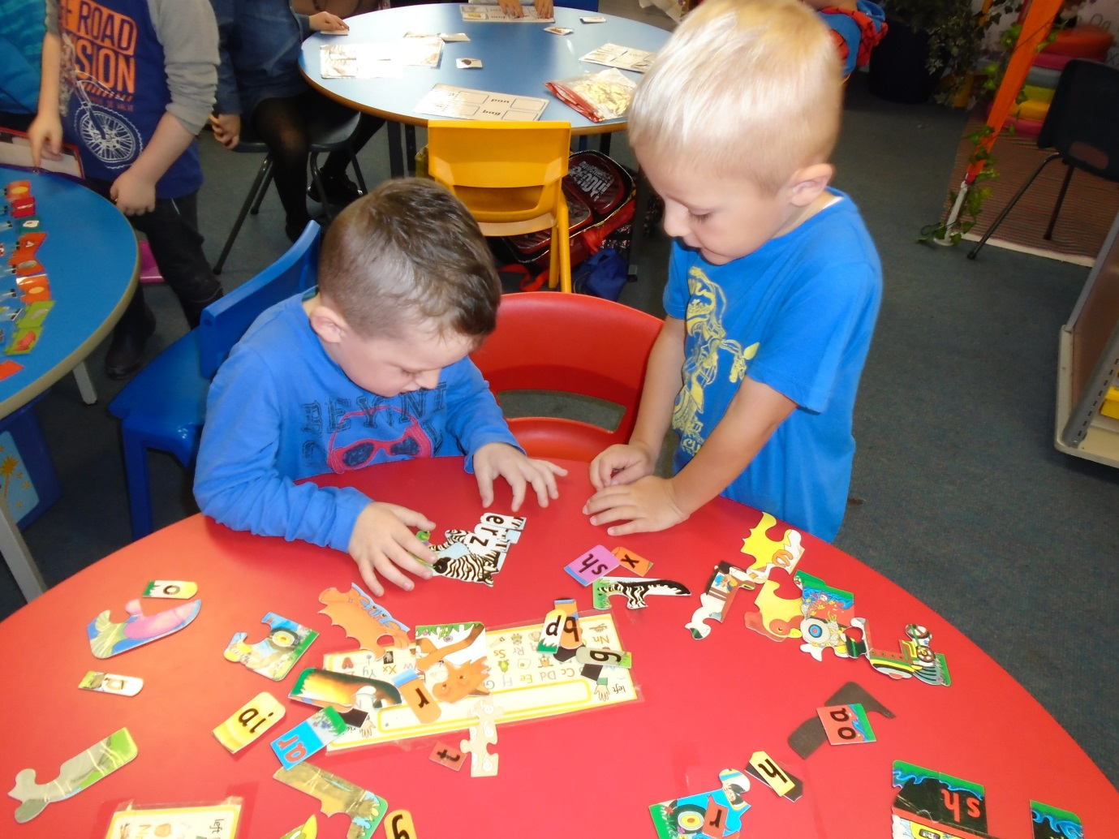
As we are now at the early stages of learning to blend in Primary 1, the pupils practised making up words using the sounds they have learned on jigsaw pieces.

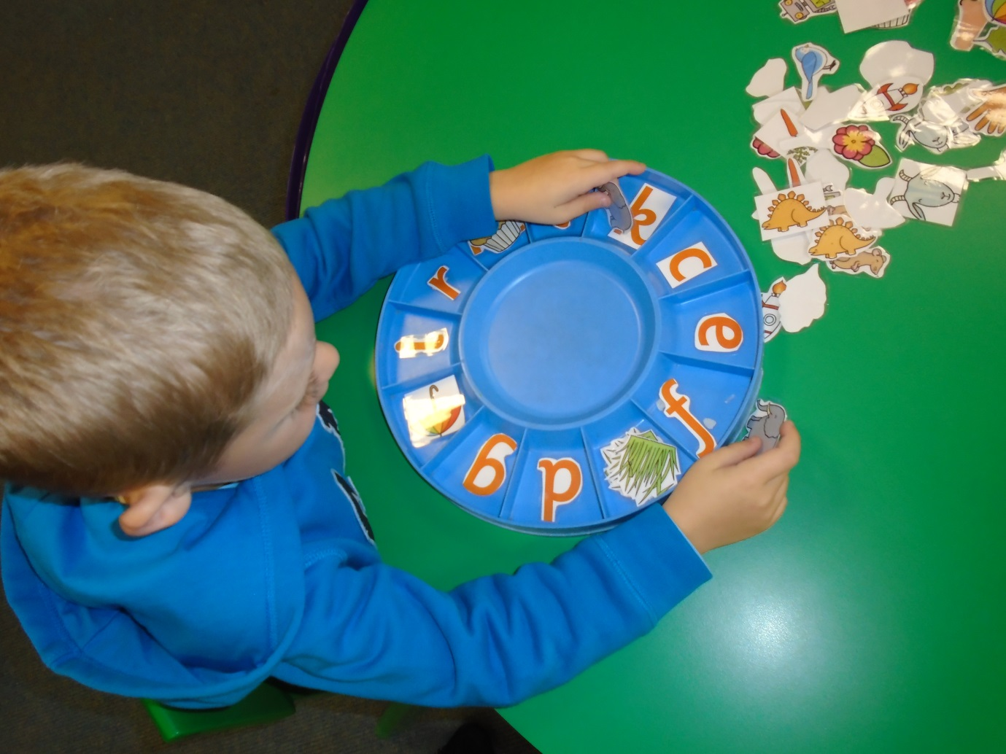
To practice identifying sounds and matching them with associated words, the children were encouraged to look at the given pictures and match them up to the correct sound in their circle.

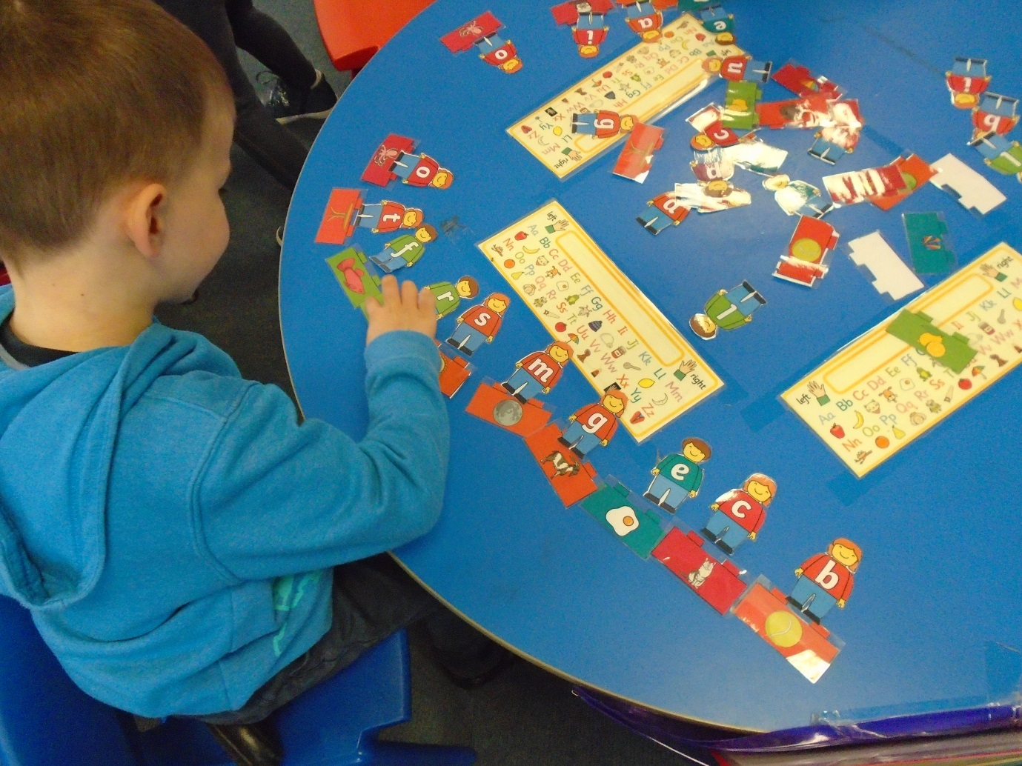
We use a variety of different games to reinforce all the initial sounds and encourage the children to identify newly learned sounds in words they know.

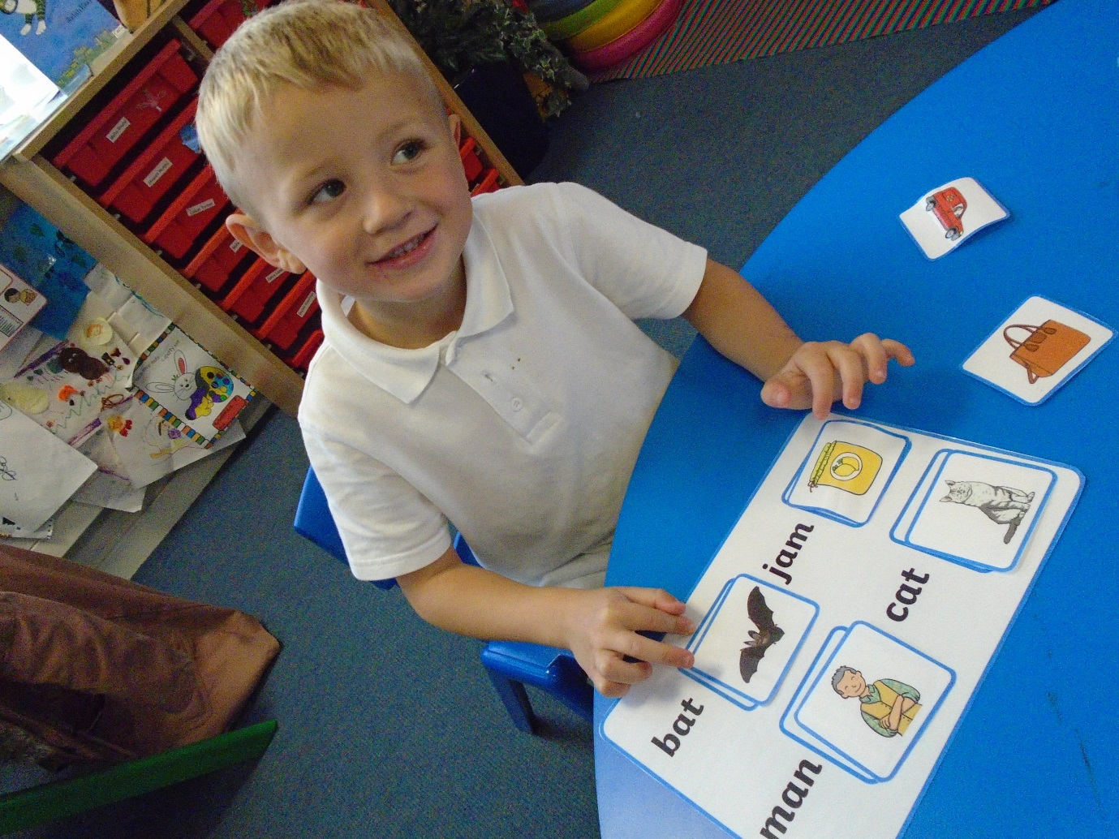
For some of our ‘more able’ learners, who are at the stage of reading cvc words independently, they matched up words with pictures using the laminated cards.

