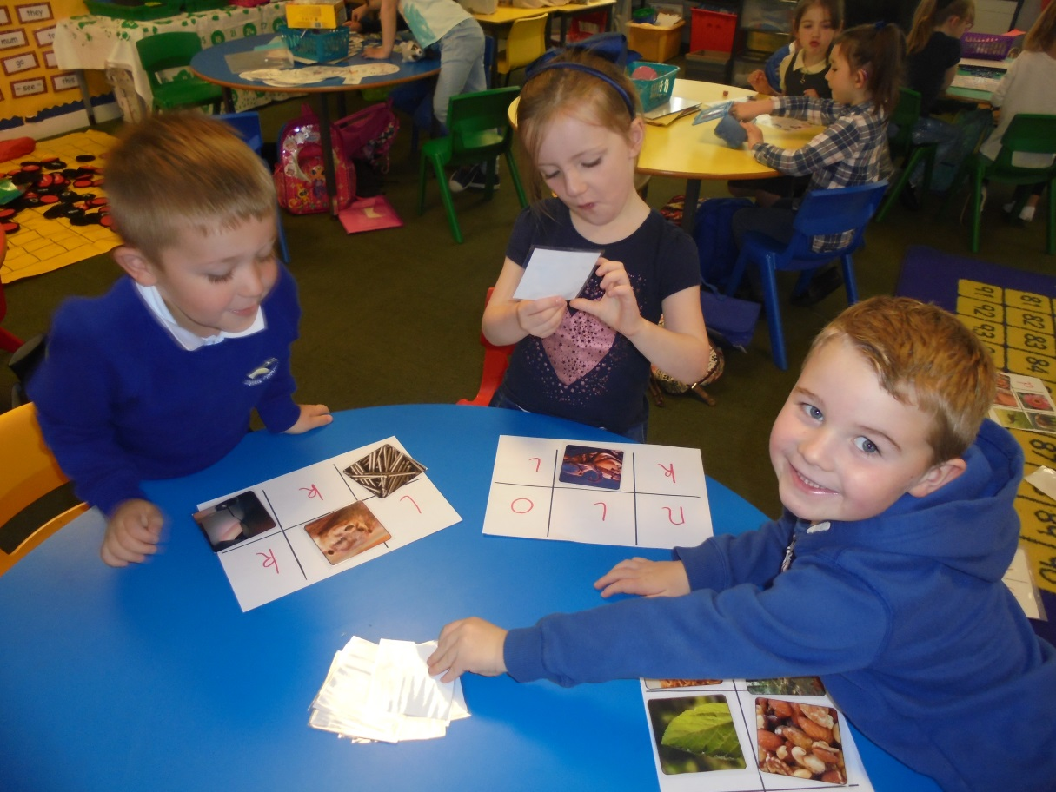
P1 identifying initial sounds through playing Bingo.
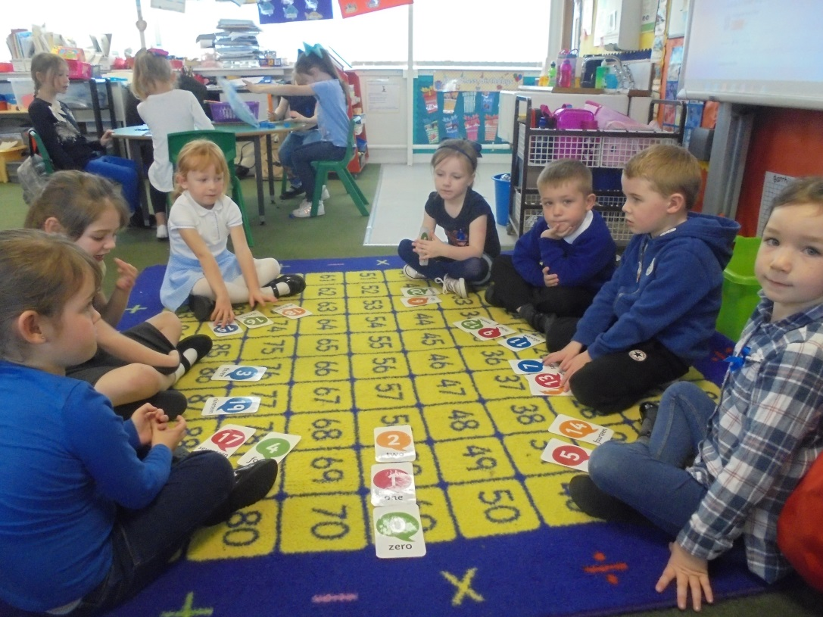
P1 identifying and ordering numbers to 20.
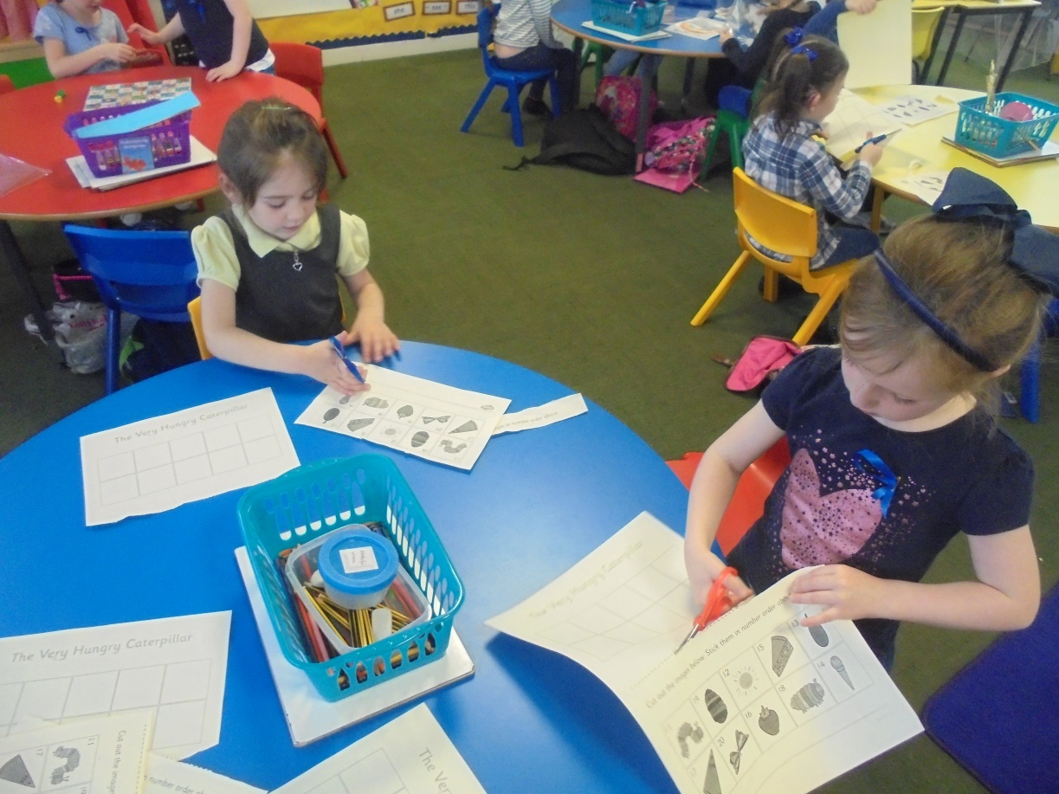
P1 cutting and sticking numbers to 20 in the correct sequence.
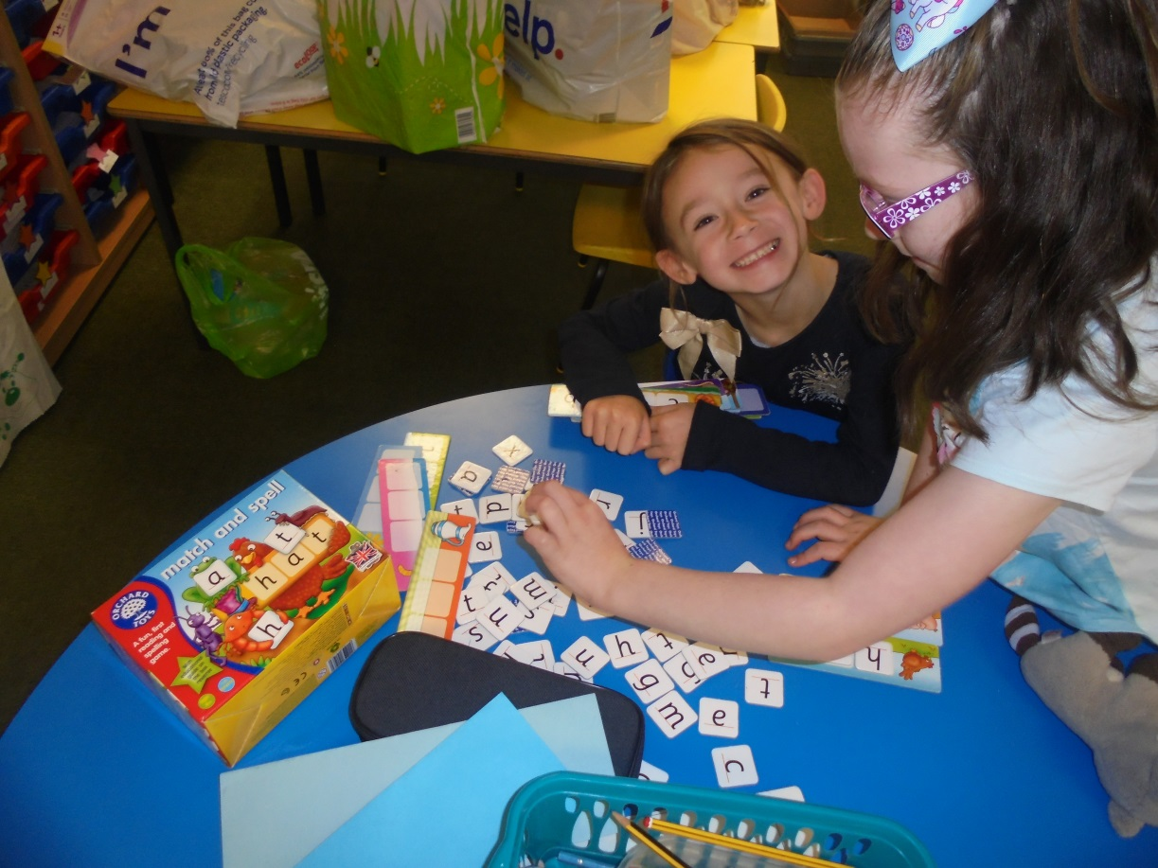
P2 using sounds to make words for pictures.
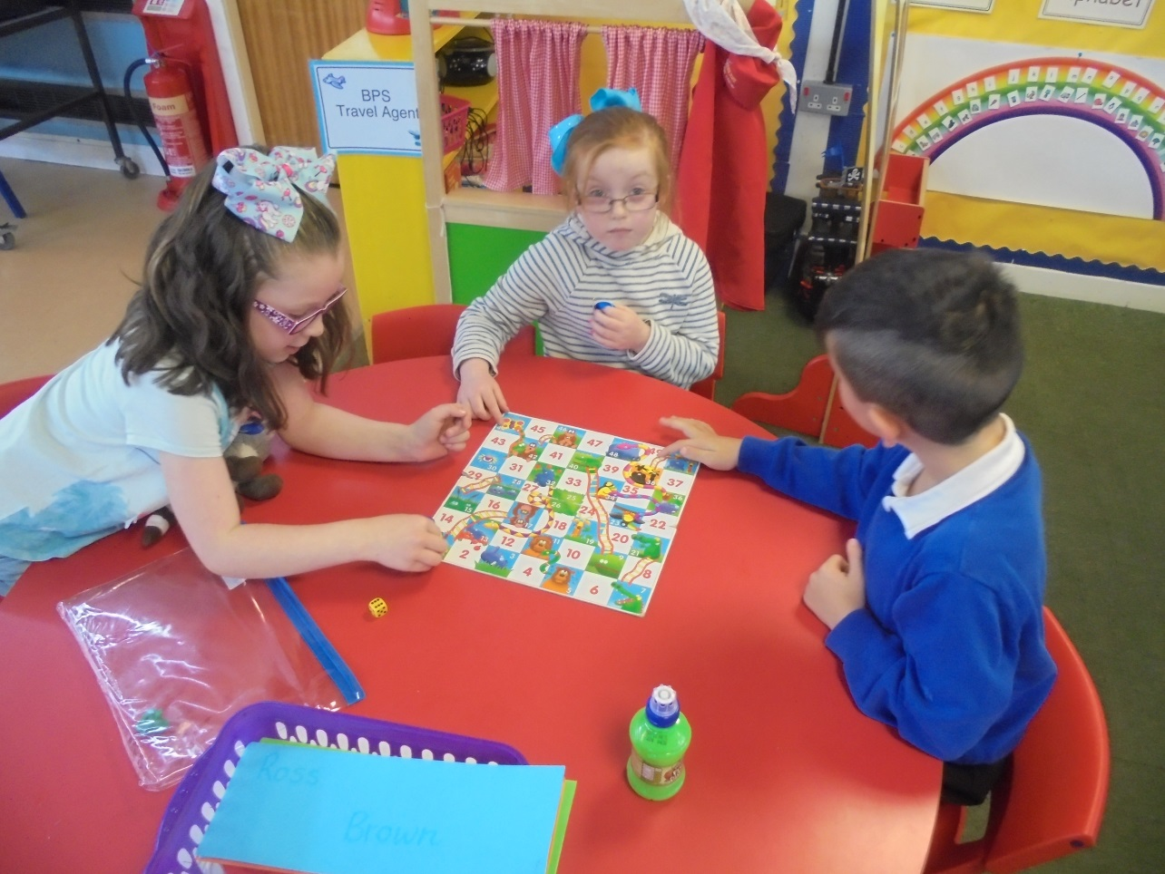
P2 using Snakes and Ladders to help with their counting and recognition of numbers to 50.

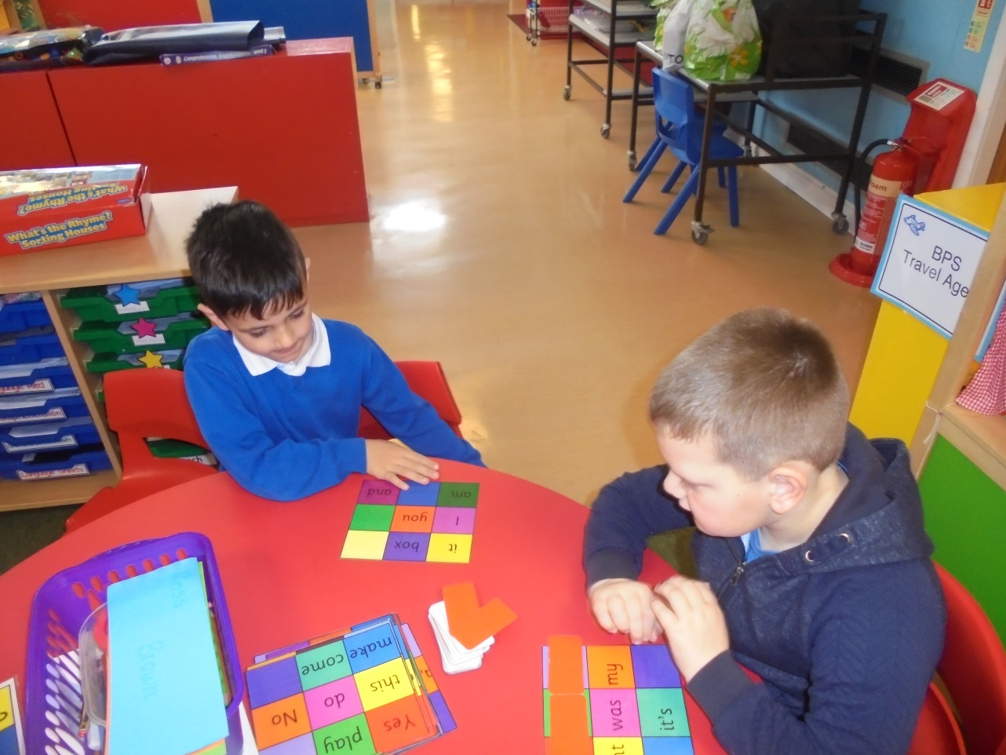
P2 practising common and tricky words through Bingo.

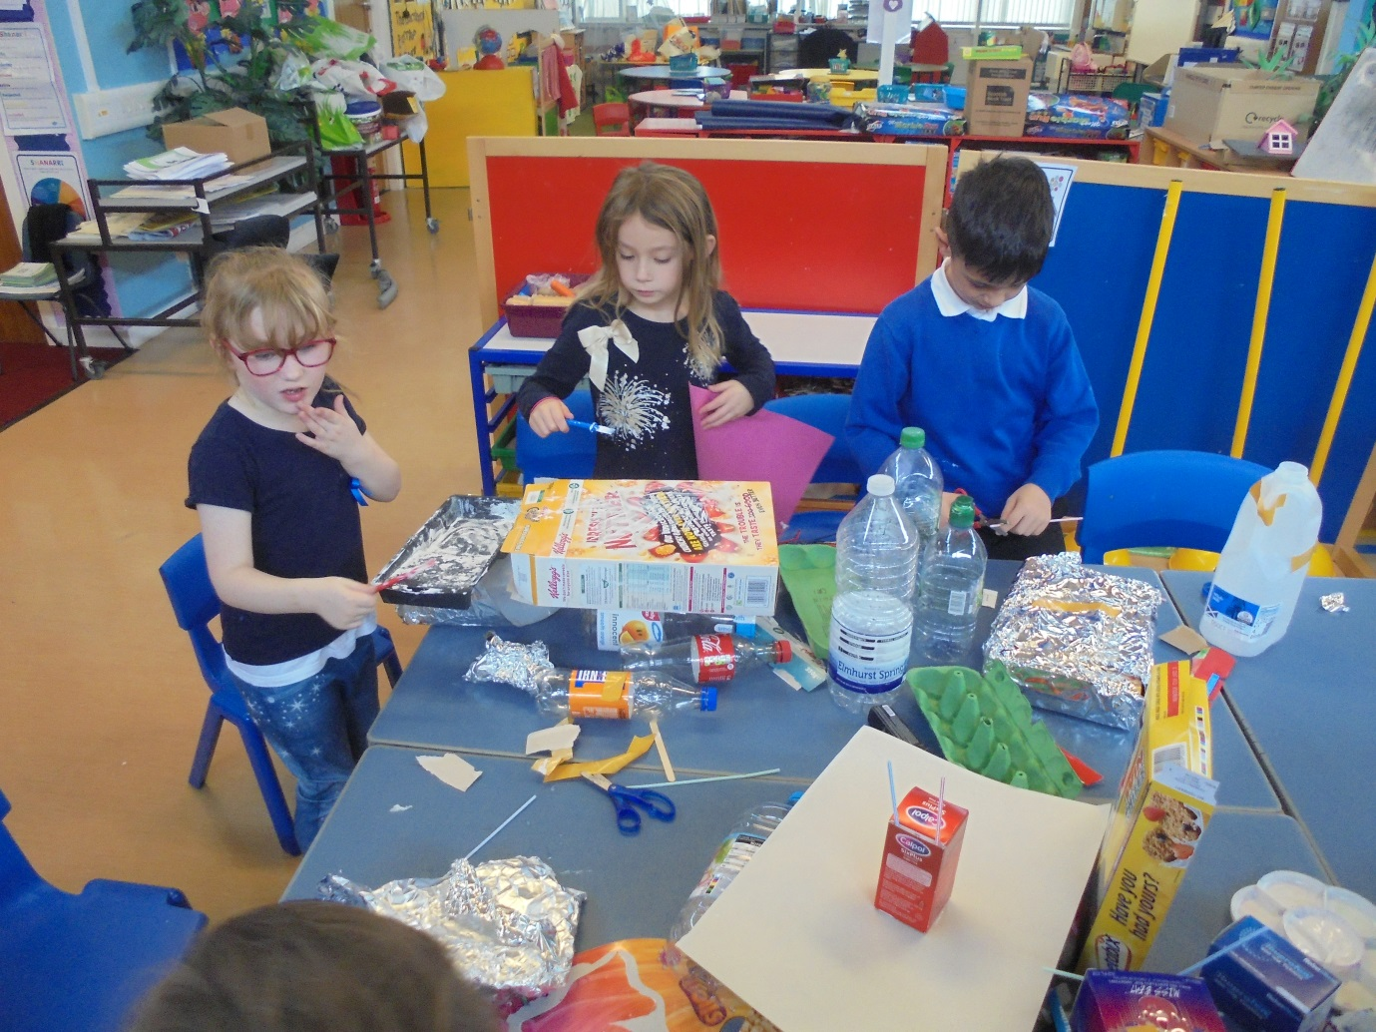
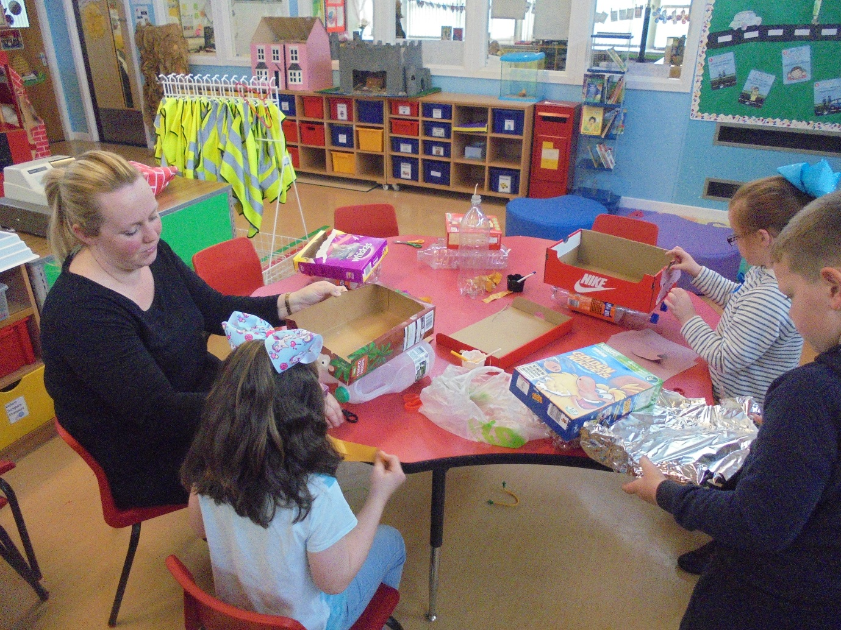
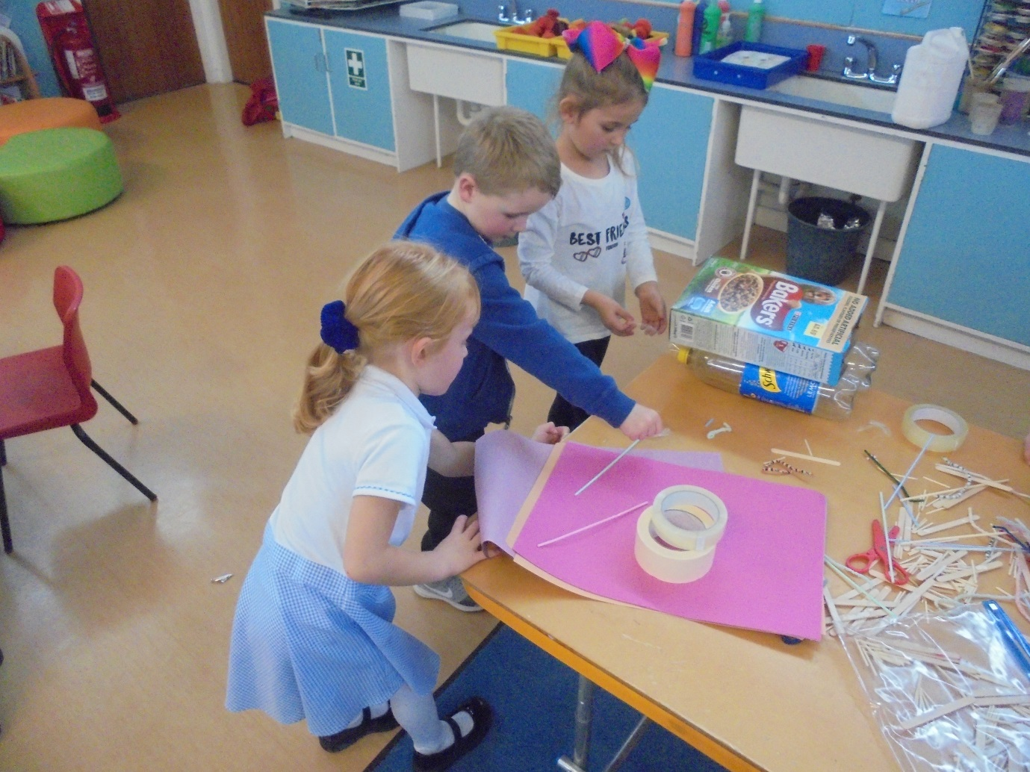
P1/2 creating boats that will float as part of a challenge for our IDL on Transport.

