Feel Good Fridays
Hello everyone, how are you all today? I hope all is well. Today let’s go out a walk or even your backdoor and see if you can find some big rocks/stones.
Once you’ve collected your rocks you will need;
- Bin bags/old sheet/paper
- Paint/pens/crayons
Let’s Get Busy!
Cover your table with bin bags or whatever you have lying around and place your rocks/stones on the top of these! Next grab your paints/pens/crayons! What we are going to do next is decorate them, with what makes you happy/makes someone smile, this can be from rainbows and flowers, to just making them brightly coloured. Once these are finished, write your name on the back of them with FB:Cherrytrees ECC.
Now Lets’ Go Hide Them!
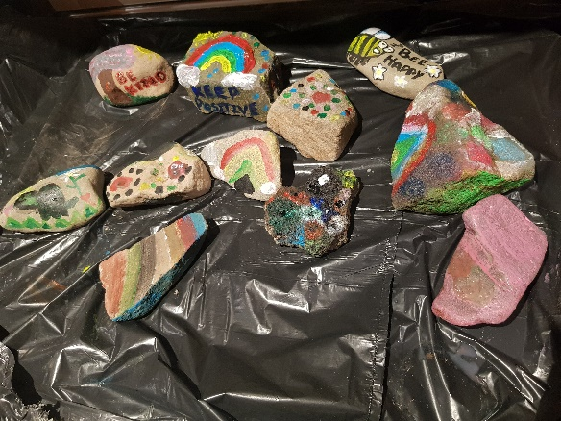
Wrap up nice and warm and go a lovely walk, remember your rocks! What we are going to do is, hide them, either next to a tree, a sign, near a path!
I have done examples (see pictures) and have hide these myself with the help of my little helpers. These can be found behind the nursery on the woodland path near the water and also around the park, up the woodroad. Why don’t you see if you can find them too and others that may have been done and hidden! How exciting!
If you find them or others, take a picture and upload them to the Cherrytrees ECC Facebook page or if you don’t have Facebook email us them. Take pictures of the ones you have hidden, so we can have clues where they are! (Pictures are up where we have hid them)
Let’s start a positive trend and make someone’s day! Making our day a little bit special, finding a beautiful picture of lovely bright colours done by you!
I can’t wait to see them, I will be out looking for yours as well.
Hope you all have as much fun, as I did and so did my little helpers.
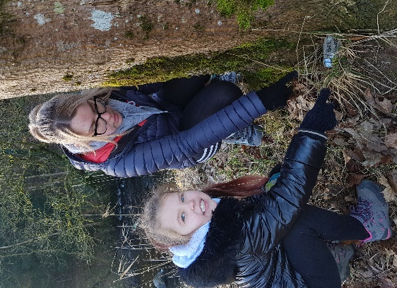
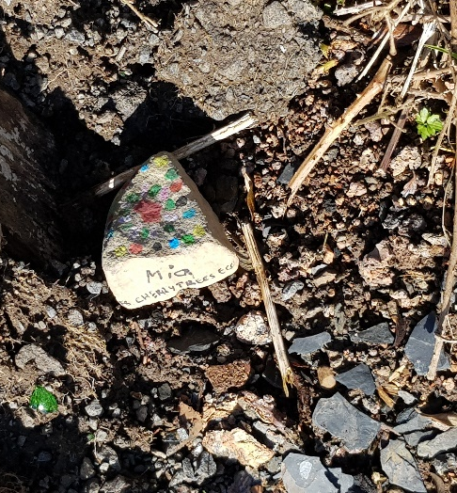
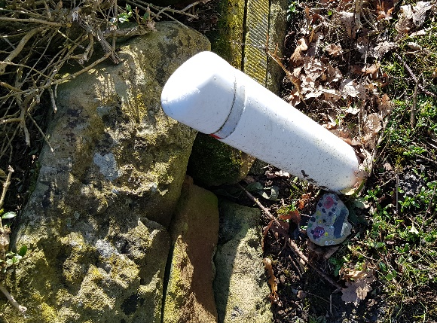
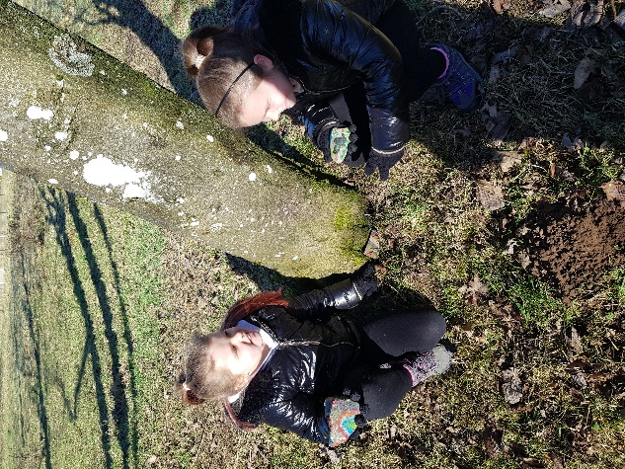
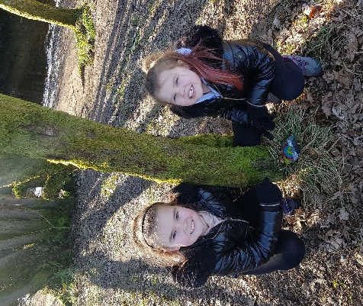
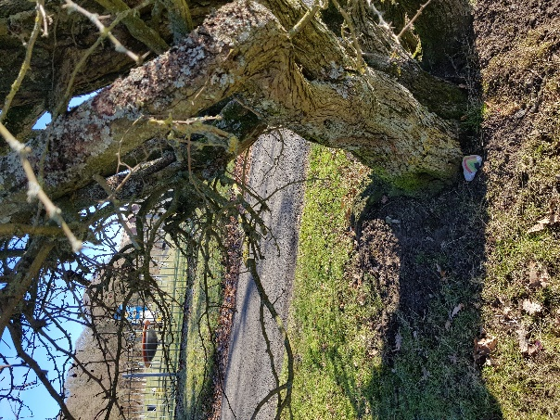
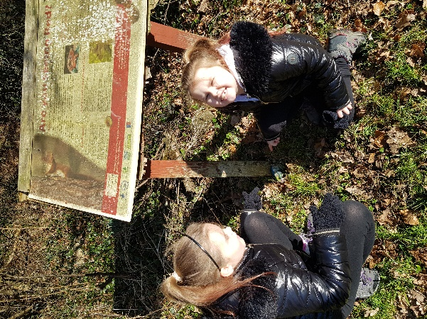
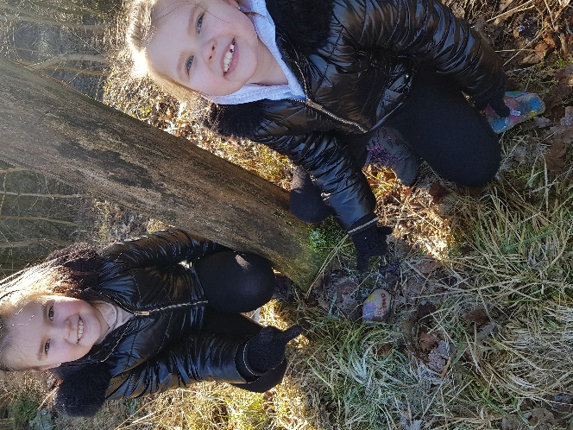
Can You Find Them?

