Its Friday let’s have a relaxing day before the weekend with Bubble Breathing and Yoga.

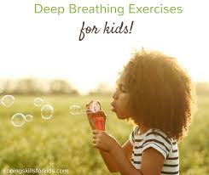

Have fun – bubble breathing
Blowing bubbles is great fun, and it has an added benefit too – the deep breathing required to blow bubbles can help you to relax and feel calm. Follow our recipe for homemade bubbles and learn the calming bubble breathing technique.
‘Bubble breathing’ can even be done without the bubbles, any time you want to feel calm. Simply take a deep breath in through your nose, then breathe out slowly through your mouth with your lips small, as if you were going to blow a bubble. This kind of breathing leaves more room for fresh inhaled air. You can even imagine any worries you might have floating away like bubbles.
What you will need.
A bowl
A whisk or spoon
A cup
4 cups warm water
1/2 cup washing up liquid
Instructions
1. Pour water into bowl
2. Add the washing up liquid and stir to combine.
3. Find some things to blow your bubbles with – you might have an old bubble wand, but if not, try some objects you might have around the house. We used a hairband and a biscuit cutter! Our best bubbles came from a pipe cleaner which we twisted into a homemade bubble wand.
4. Now it’s time to blow some bubbles!
Let’s have a relaxing Friday with some Yoga.
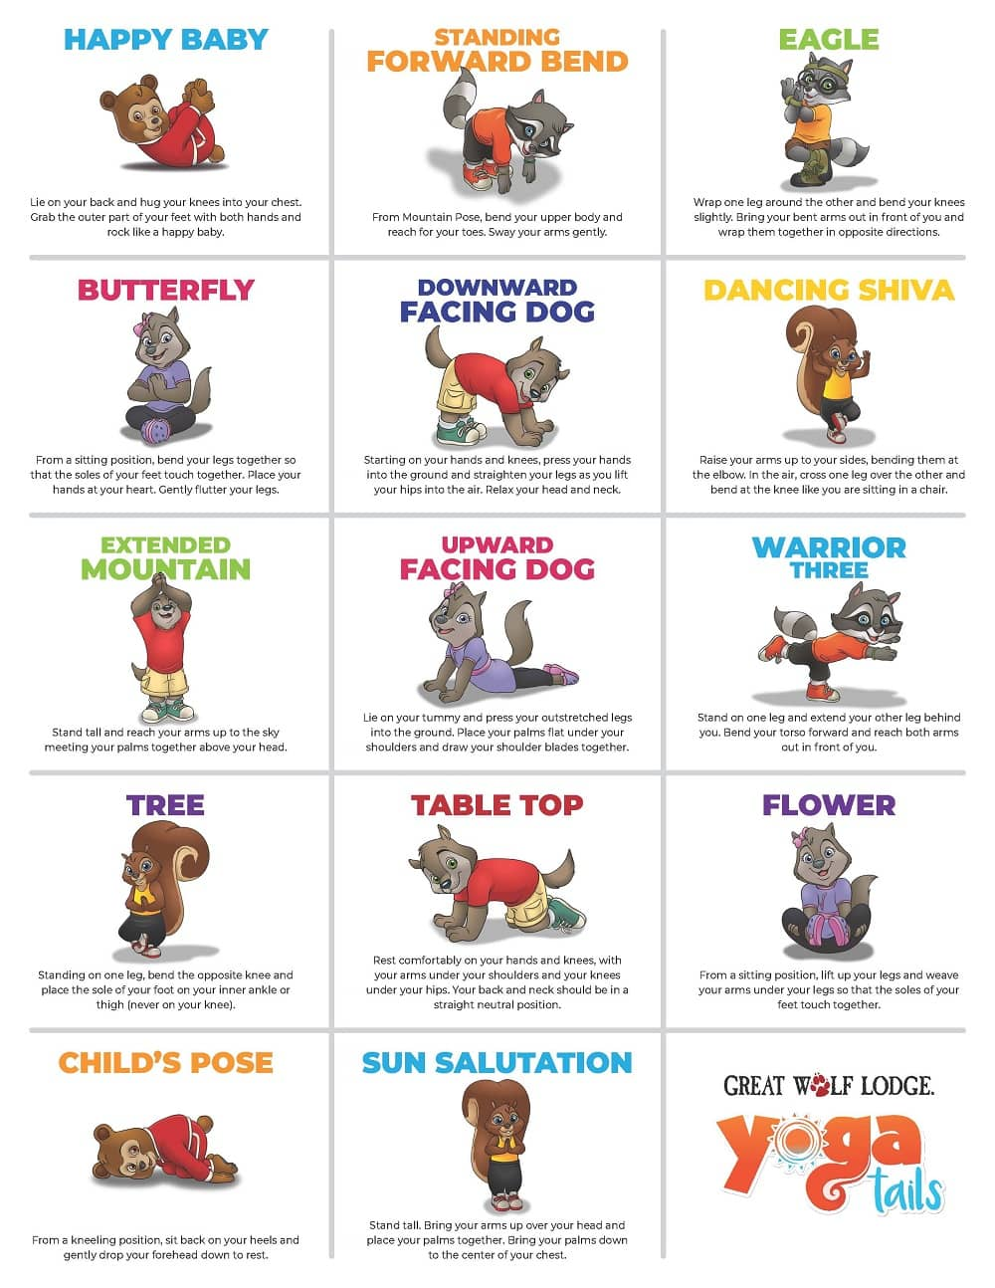
How many of these can you do? Try timing how long you can hold each pose.
Please send us some pictures of your poses.
Here is a link you a cosmic Yoga you can take part with about washing your hands and germs https://www.youtube.com/watch?v=5rymXdOwW68

