Handprint Number Line
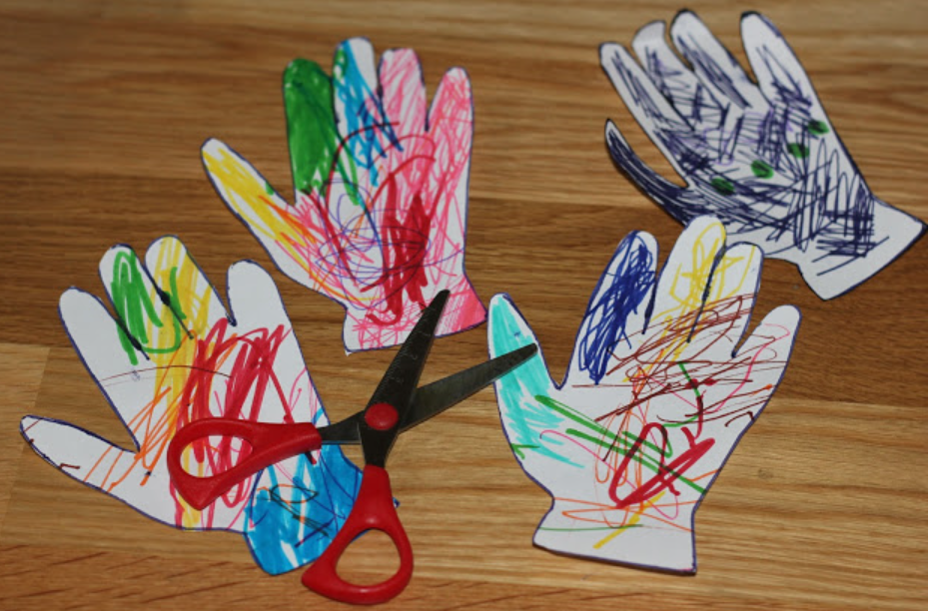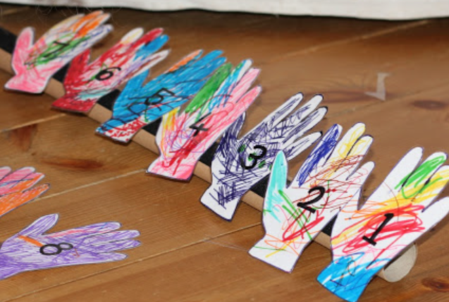
1.Ask a grown up to help you draw around 2. With a little help from your grown up you 3.Write the numbers on the front of your hands
Your hand either 5 or 10 times, you can can carefully cut out your hands
decorate your hands.
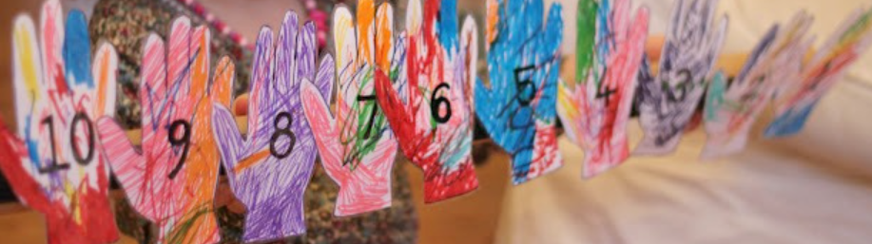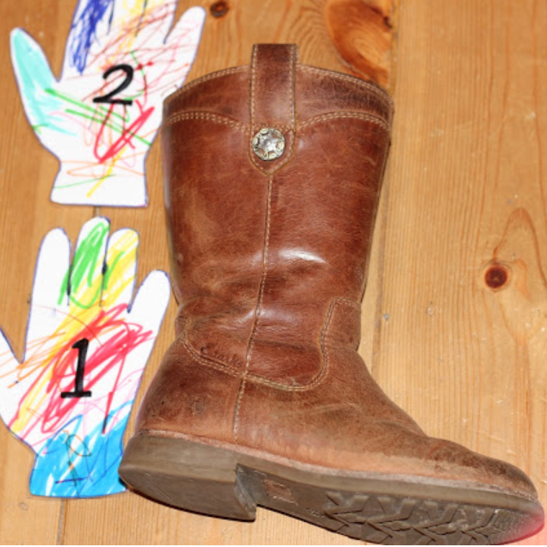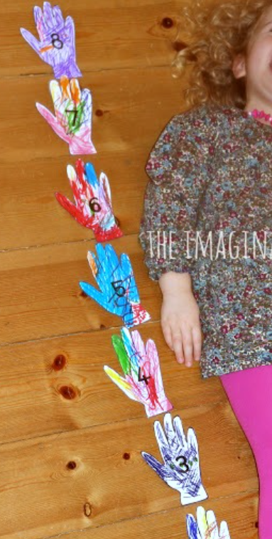
4. You can put these numbers in correct order You could use items around the house to measure how many hands they are, or your grown up
Talking about what numbers they can recognise, could help to measure how many hands tall you are.
Counting how many hands .What number comes before & after each number.
Hope you have fun with this activity, remember and send us your photos.

