What Can You Find?
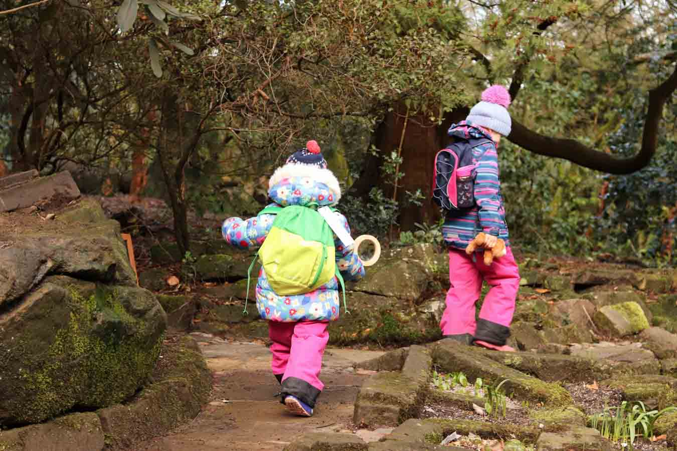
Well hello everyone! I hope you are all well and finding exciting new adventures for you all to do. Speaking of adventures, I have a little adventure for you all today but remember we need to ask our grown-ups, if it is ok.
Why don’t we go on a walk and see what we can find?
What you will need;
- A bag
Remember, wrap up warm as it looks cold outside.
When we are out our little adventure, let’s see what we can find! This can be from sticks and stones, to maybe a handful of grass or leaves or both. We will need the objects you find for something later on. When out your walk, what else can you see? Can you see any wildlife? Are you going somewhere exciting?
Once you have found all your objects, take them home and lay them out.
What you may need;
- Paper
- Pen/pencil’s
- Glue
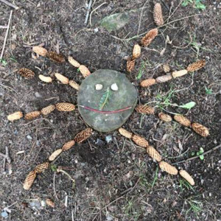
Transient Art
Take your piece of paper and objects that you found out in your walk and place them on your paper to create a picture. What have you been able to create? How many different ways were you able to create a picture?
Or
You can create a picture and use glue to make it stick.
3D Artwork
You can also make 3D art using your objects, this can be from creating figures with sticks. You could even make figures using stones. This is a great way of using your imagination on what images or 3D artwork you can create. What were you able to create?
I hope you enjoyed our little adventure and enjoyed creating your creations. I would love to see your pictures or 3D artwork.
Yellow Bubble

