It’s Yoga Time
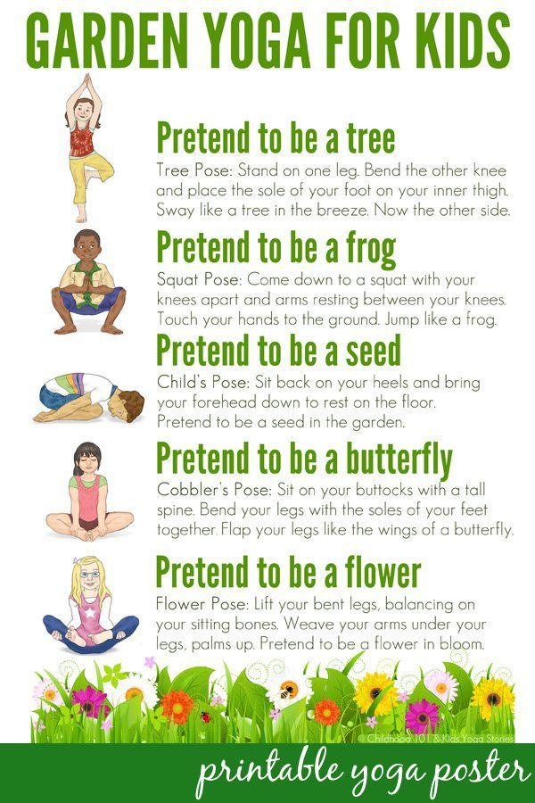
Hello everyone!
How are we all today? I hope your all well and enjoying your extra time with your grown-ups.
If you’re not too busy today, why not try our little activity. I know how much we all like doing our yoga and how much fun we have creating our yoga poses. Here is one for you all to try, it is called Garden Yoga!
When you’re out in the garden you can see all sorts of things from birds and butterflies, to planes and buildings. What can you see from your garden?
If you can find a space in your house, (remember to stretch your arms out wide so you don’t hit anything or anyone) and see if you can do our Garden yoga above. Can you balance and stretch high as a tree? Can you go low and curl into a seed shape?
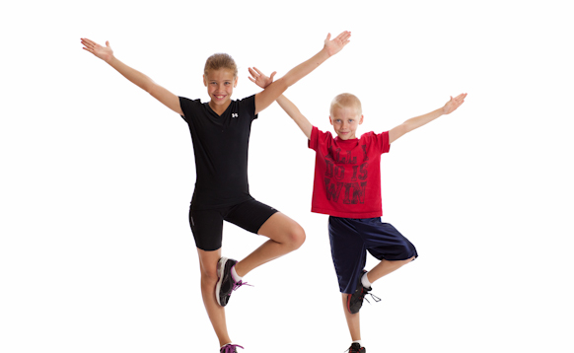
Why not have a little look outside your garden again and see what else you can see, where you can create your own yoga pose? If you see a bird for example; can you stretch your arms out wide and flap them up and down like a birds wings flying through the air?
Hope you all enjoy creating your yoga shapes!

Yellow Bubble
(HWB 0-21a)

