[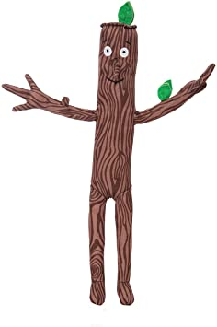](https://www.google.co.uk/url?sa=i&url=https%3A%2F%2Fwww.amazon.co.uk%2FStick-Man-Toys-Quality-Stickman%2Fdp%2FB0788B4KNM&psig=AOvVaw2PigdNgnxtjEk7IT7FDtw6&ust=1610043667674000&source=images&cd=vfe&ved=0CAIQjRxqFwoTCPin1Zn2h-4CFQAAAAAdAAAAABAF)Suggested activities to complete after listening to the story – Stick Man

**Health and wellbeing-** can we get ready to go outdoors? (Developing independence)

Ask your child what they might need to go outdoors; remind them it’s very cold outside.

Maybe a hat, scarf and gloves to go with our jackets.

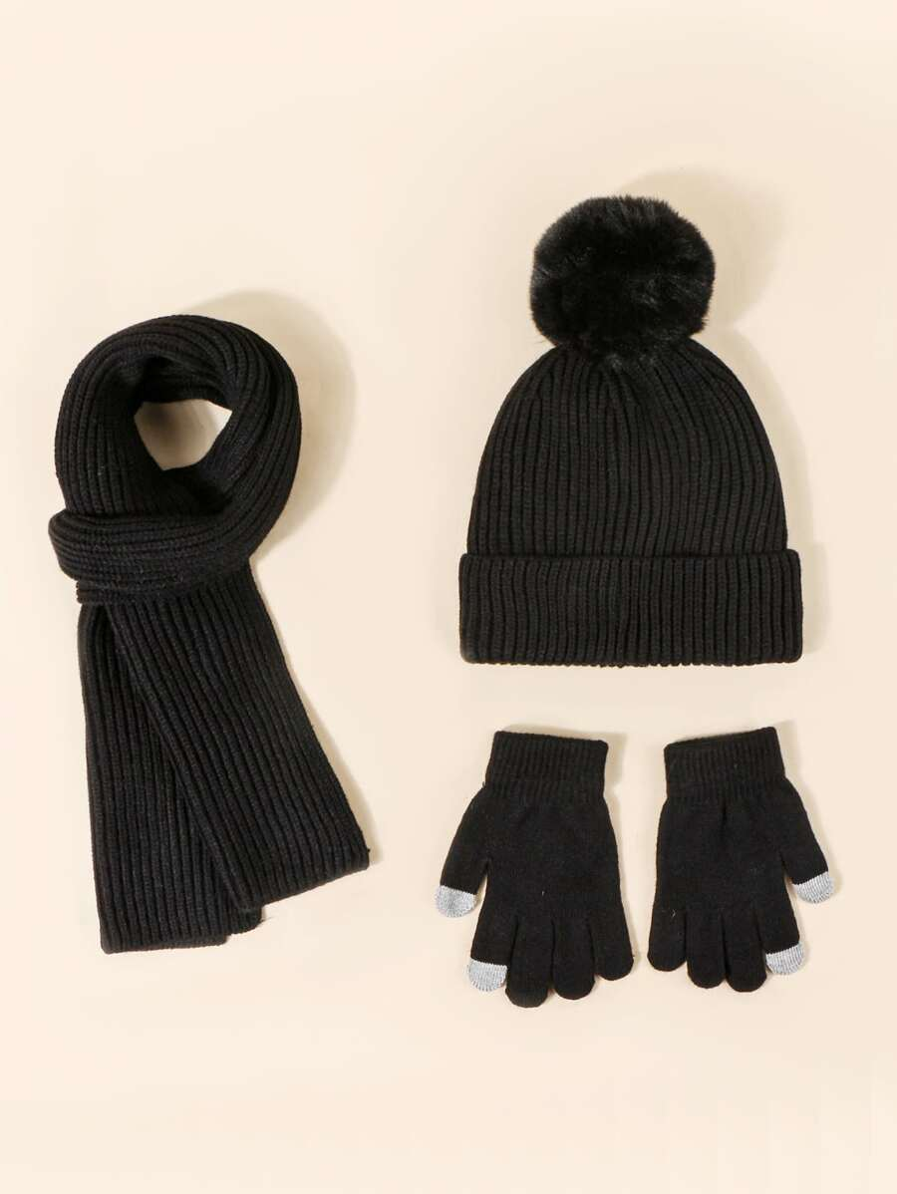

**Outdoors-** Lets go for a walk or out to the garden.

Can you find any stick men on your walk?

Collect any sticks or natural materials (stones, leaves) we can find, look for different shapes and sizes, we will use these when we get back home.

[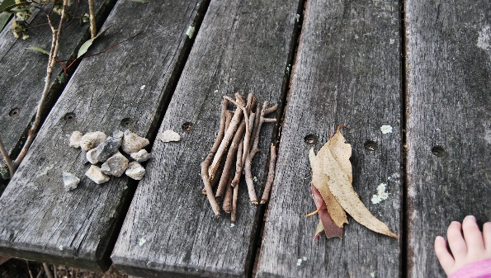](https://www.google.co.uk/url?sa=i&url=http%3A%2F%2Falittlelearningfortwo.blogspot.com%2F2012%2F07%2Fsequencing-with-sticks-stones.html&psig=AOvVaw1e5grgDEJwL5QRoGBCuiXO&ust=1610105161704000&source=images&cd=vfe&ved=0CAIQjRxqFwoTCKCdkqTbie4CFQAAAAAdAAAAABAE)

**Expressive arts-** we can use the stick or other natural materials we have collected to make our own stick family. [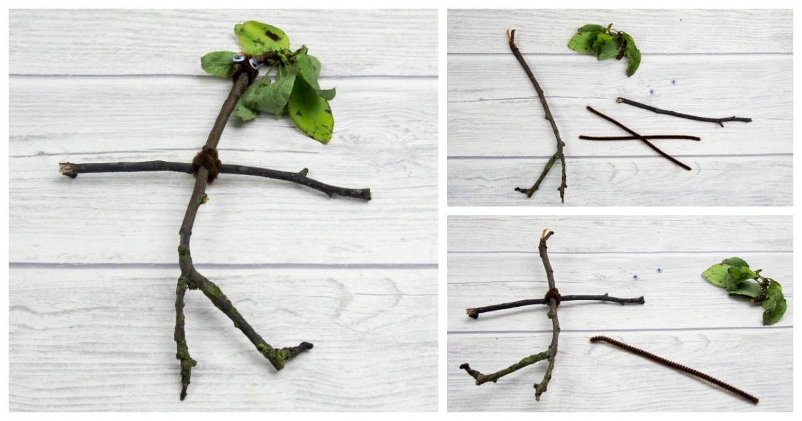](https://www.google.co.uk/url?sa=i&url=https%3A%2F%2Fwww.muminthemadhouse.com%2Fmake-your-own-stickman%2F&psig=AOvVaw0KP7kbGd4qHwFGKr4l1203&ust=1610105215798000&source=images&cd=vfe&ved=0CAIQjRxqFwoTCICNv73bie4CFQAAAAAdAAAAABAE)

**Literacy-**

Can you and your child make up your own Stick Man adventure story?

**Numeracy-** How many duck and ducklings can you count in the river?

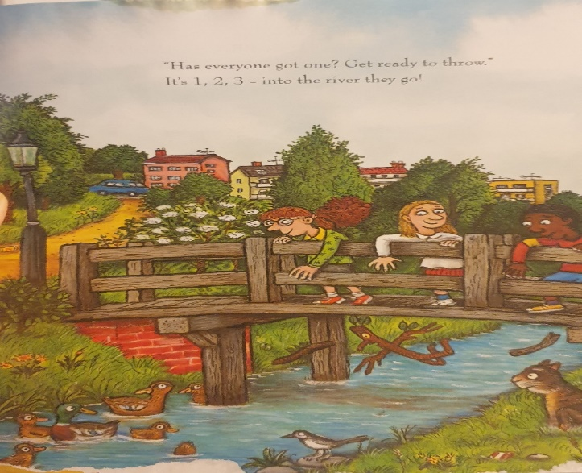

**Technologies-** here is the link to watch the stick man movie maybe you could watch this together with a warm cup of milk after your winter walk. This is 11mins long.

The Stick Man Goes Out For A Run! <https://www.youtube.com/watch?v=1pjpLVg2On4>