Mrs Babington

My News – Easter 2020

Hello Everyone,
This has been the strangest Easter holiday I have ever had. I have missed you all and have missed spending time with my family and my friends.
I have been keeping busy by doing my Spring cleaning, tidying the garden and reading lots of books. I have even learned how to video chat with my son and daughter. I am lucky that I have a park and lots of footpaths right behind my house so I have been going for a walk every day. The only problem is that my cat keeps following me so I have to sneak out when he’s asleep! We have been lucky with the weather. I think the sun is trying to cheer us all up.
Yesterday some of the children who live near me left a painted pebble on my doorstep. I was delighted as it was so thoughtful of them.

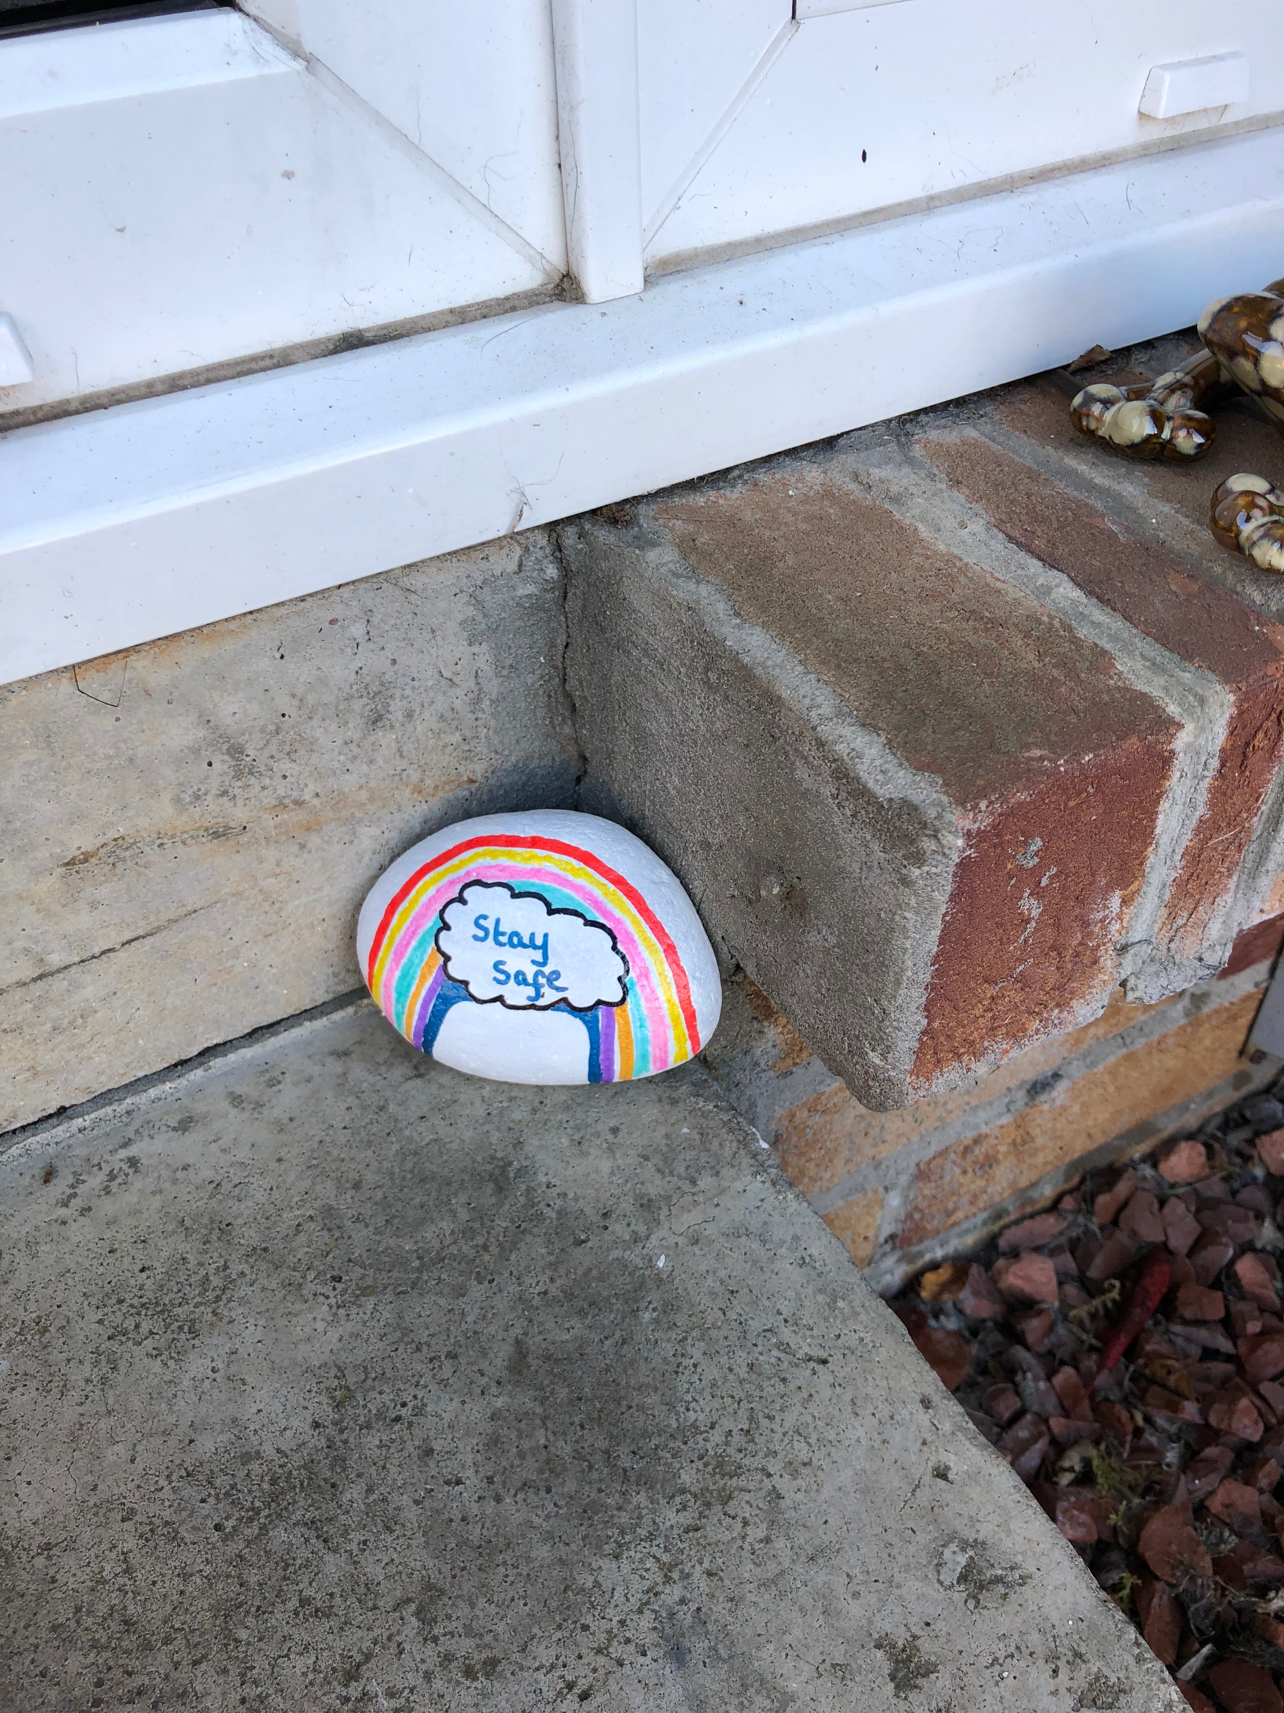
I hope that it will not be too long before we can be all together again in class.

Write or type your holiday news and include a picture if you can.

