Easter Bunny Writing

The Easter Bunny has decided that he wants to retire. He is fed up having to get up really early in the morning to travel around the country to hide eggs for children to find. It is getting too difficult to find good hiding places and the shops have so many chocolate eggs now anyway. Also people are now thinking about healthy eating and too much chocolate is not good for children.

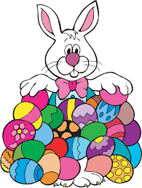

Write a letter to the Easter Bunny to try to persuade him to stay. Use the correct format that we used when writing letters in class. Read over your work to check it makes sense. Make sure you use capital letters, full stops and connectives. Give the Bunny some good reasons to carry on.

