All About Sheep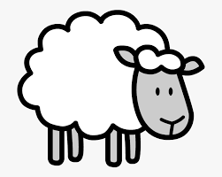

Most sheep farms in Britain are in the hills of Scotland, wales and the north and west of England. Flocks graze on the steep hillsides.
Sheep in the hills do not move far so farmers can usually find their flocks, but most sheep are marked just in case they stray.
Spring is a busy time when the lambs are born. The shepherds hope for good weather so that they can reach the ewes and lambs. New lambs may die if they get wet and cold.
In the summer the ewes are sheared and the wool is sold to factories to make cloth.

- Sheep graze on the steep _______________.
- The ewes give birth to the ___________in Spring.
- If the new lambs get _______ and ________ they may die.

Write a sentence to answer these questions.
- Where are most of the sheep farms in Britain?

- Why does the farmer not usually lose the sheep.

- What happens to the wool when it is sheared?

