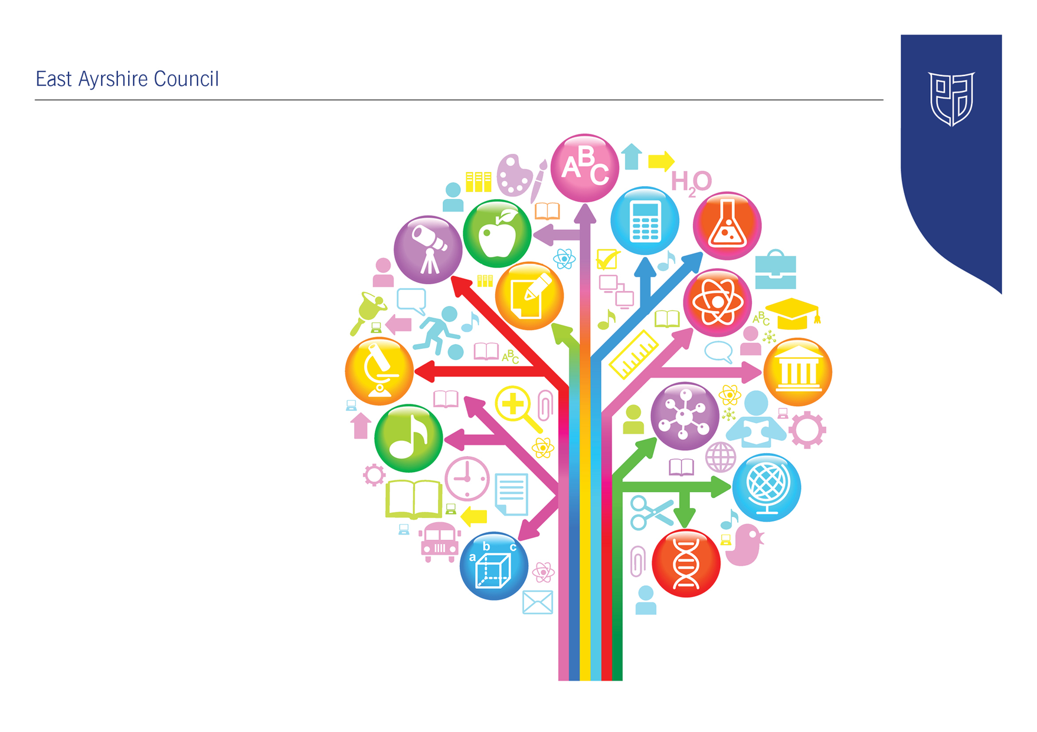
Standards and Quality Report
2025 - 2026

Annanhill Primary School

Be the best you can be!
Establishment Context
Annanhill Primary is a large non-denominational, co-educational school based within Grange Campus, in Kilmarnock. The school opened as part of the Campus in 2008. We are an inclusive community that places high value on equity, ensuring all children receive high-quality learning and teaching experiences. Our focus is on improving attainment and achievement for every learner. Annanhill has a strong reputation within the local community.

The most recent data shows that 12% of our pupils live within SIMD 1–2, with the majority residing in SIMD 6–9. However, there is a degree of hidden poverty in Kilmarnock, often linked to families living in private rented accommodation. Currently, 14% of our pupils are in receipt of free school meals. The school community reflects a diverse range of needs, strengths and aspirations.

Located in the Grange estate, Kilmarnock, our school benefits from a wide range of local facilities that enhance learning and community life, including woodland areas, sports fields, local and town centre shops, businesses, health services, Ayrshire College, and Kilmarnock Football Club. While East Ayrshire Council promotes business growth through local initiatives, employment opportunities in the area remain limited.

A significant number of our families are employed at Crosshouse Hospital, with many coming from abroad to take up posts there. We also have a growing number of families experiencing in-work poverty and requiring additional support. Staff work collaboratively with families and partners to improve outcomes for all our learners.
Our current roll is 478 pupils across 18 classes, supported by 22.6 FTE teaching staff. Two Primary 7 classes are located within Grange Academy, while two Primary 6 classes are accommodated in modular classrooms.

The leadership team currently consists of a Head Teacher, two Depute Head Teachers, two Principal Teachers. Our PEF programme is now embedded in our practice with children experiencing Literacy and Numeracy interventions. We have developed Nurture practices across all stages of the school. The addition of our Sunflower Room, the DEN, LIAM, Seasons for Growth and Junior Duke programmes, have been extremely successful and has been an excellent vehicle for providing our most vulnerable children with support.

Annanhill is part of the Grange Education Group, where strong collaborative planning and effective partnerships are well established across the Executive Team. Notably, 36% of our current roll are placing requests.

HMIe rated the school as Good in 2024 in the areas of Learning, Teaching and Assessment, and Raising Attainment and Achievement. This year we have made significant progress in key areas, especially raising attainment and achievement. We are committed to acting on the recommendations and remain focused on continuous improvement as we move towards excellence.

Establishment Vision, Values and Aims
We all work towards our school vision to “Be the Best You Can Be!


As a school, our values of Achievement, Kindness and Respect are embedded across the school community. We aim to ensure our children and families are kind, caring and connected across our local community.

Our Strengths:
- High quality pastoral care shown by all staff.
- Commitment of staff to improving learning and teaching.
- Range of learning experiences provided for pupils.
- Ethos and teamwork.
- Pupils are friendly, courteous and well mannered.
Our Aims
We aim to give our children skills for learning, life and work. We want to:
- Provide a safe, welcoming and caring environment where children, parents and staff feel included, valued and respected.
- Deliver high quality stimulating and engaging learning experiences for all children.
- Create a nurturing ethos within the school where children feel ready to learn.
- Support our families in learning and be actively involved in the wider community.
- Encourage all our pupils to continue to be lifelong learners and look for opportunities to develop a strong sense of responsibility and citizenship within and beyond the school.
Our Priorities Sessions 2025-26 were:
- By May 2026, 85% of Pr1, Pr 4 and Pr 7 children will be on track to achieve expected levels of attainment in literacy (3 for 3 currently at 71%)
- To deepen conceptual understanding in numeracy and maths for all learners through a consistent focus on problem solving, effective use of concrete, pictorial and abstract approaches, meaningful assessment and the development of mathematical language.
- To develop digital literacy across the curriculum and link this to skills for learning, life and work.
- To increase pupil attendance and engagement by undertaking a curriculum refresh and producing a curriculum that is relevant, stimulating, skills focussed and incorporates the community and local businesses
- To develop consistent approached to learning and teaching across the curriculum
- To develop our nurture and inclusion practices within the early years and aim for early intervention.
This year we have introduced our school pledge:
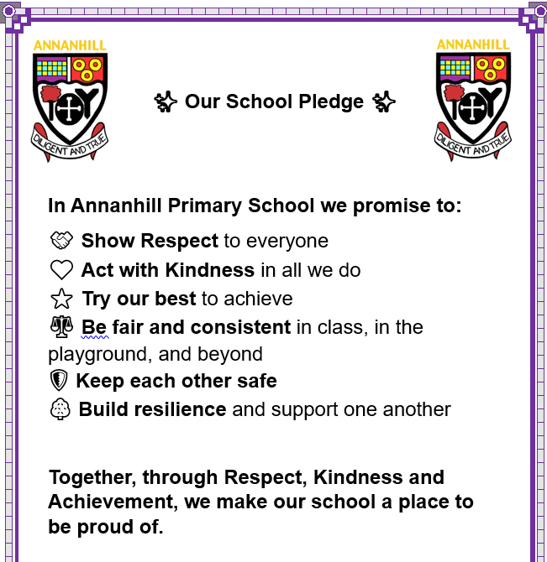

Improvement Priority  (Expressed as outcomes for learners) | Improvement Priority (Expressed as outcomes for learners)  To improve learning and teaching through purposeful and equitable use of digital technology that supports curriculum coverage, develops real-life skills and engages all learners in meaningful and motivating experiences. | Education Service Improvement Plan 1: Our Leadership  We actively support, promote and enact leadership at all levels. Our young people are supported to be leaders of their learning in our centres, schools and wider life experiences. All staff have ready access to appropriate CLPL and experiences to promote leadership in every classroom, playroom and centre.
Our Leadership
Progress and Impact | We have worked hard to ensure digital technology is meaningfully embedded across the curriculum to support high quality learning experiences for all children. We have:  - Developed pupils’ digital literacy skills for life, learning and working including problem solving, collaboration and creativity  - Improved pupil engagement and motivation through interactive and accessible tools  - Built stronger home school community connections through digital platforms in the infant stages of the school  - We have worked hard on our curriculum skills progression and have been linked closely with the digital team focusing on coding, robots, beebots, micro bits and VR headsets  - Some progress has been made in the regular use of the school blog  - Some progress has been made in using the School app for regular updates – X has been used to link with community focused events  - Made progress towards ensuring all children can access a relevant and future focussed curriculum.
Next Steps | - Skills for life, learning and work will be further developed through STEM activities and STEM focus weeks  - Further develop digital literacy skills and ensure each stage has a clear focus on skills development in key programmes  - Profiling of Pr 4-7 targets, evidence and wider achievements through the World of Work profiling tool  - Better use of Promeathan technology and develop capacity across the school in the use of flip charts and interactive supports

Improvement Priority  (Expressed as outcomes for learners) | Improvement Priority (Expressed as outcomes for learners)  To improve literacy attainment and engagement for all learners across the school, with a particular focus on Primary 1, 4 and 7, reducing the attainment gap and ensuring every child achieves their full potential in literacy. | Education Service Improvement Plan Priority 2: Teaching and Learning Together  Our young people should experience a teaching, learning and curriculum offer that meets their needs, and those of our local and national context. All staff should be supported to deliver in new and innovative ways by accessing CLPL relevant to their needs and those of our young people.
Teaching and Learning Together
Progress and Impact | - We have worked hard on ensuring our understanding of achievement of a level is clear and well informed using standardised assessments and end of topic assessments.  - We worked closely with the attainment advisor from Education Scotland to develop our professional knowledge of attainment across a level, data analysis and setting targets.  - Our monitoring and tracking have improved the accuracy of recording children’s progress through challenging professional discussions  - We increase the number of children achieving the expected CfE levels in writing by ?????? through focused assessment, clear and progressive learning and teaching and moderation.  - Through interventions and differentiation, we have increased the number of children on track in all areas of Literacy by 4% by the end of session 2026.  - Our Primary 4 and 5 teaching staff have all undertaken the CYPIC writing and are seeing a significant difference in the capability of children’s writing  - We have improved learner confidence and enjoyment in writing as measure through pupil voice and learner conversations.  - We have tried to close the attainment gap in writing within Primary 4 with a focus on targeted children. All children have improved and SIMD 1 and 2 children have made slight gains.
Next Steps | - We will revisit the understanding of achievement of a level at the beginning of term 1 to ensure we are using all available assessment, data and teacher judgement to ensure we have a sound understanding of achievement across a level.  - We will set clear targets for each class for literacy and numeracy to ensure we maintain or raise attainment.  - We will focus on key interventions to increase attainment for our children who are on the cusp and who need an extra push to achieve or to get back on track.  - We will continue to roll out CYPIC writing by including Pr 5 and 6 staff in the next wave of training. In the second half of the year, we will include Pr 3 in the next cohort. By 2027/28 all teaching staff will be trained in the CYPIC writing approach, a two-year plan.  - Current CYPIC trained staff will support the roll out of the CYPIC writing approach across other stages of the school  - Explore how the CYPIC model could be developed in reading  - Register for reading schools and aim to achieve accreditation to improve enthusiasm for reading and develop vocabulary and imaginative skills.

Improvement Priority  (Expressed as outcomes for learners) | Improvement Priority  (Expressed as outcomes for learners)  To create a nurturing, inclusive and emotionally safe learning environment that supports the wellbeing and neurodiversity needs of all learners, ensuring that every child is ready to learn and thrive. | Education Service Improvement Plan Priority 3: Our Wellbeing and Belonging  We want all our young people to feel supported by people who know them well and feel included in all of our schools and centres. Our staff need to be supported in their working with our young people, especially in times of adversity. As a key universal service, it is our vision that all young people attend our establishments on a full-time and regular basis to support them in their development at all stages.
Our Wellbeing and Belonging
Progress and Impact | This year we have further developed our approach to nurture and inclusion. We have aimed to have a balance of interventions as well as class-based support. We have built capacity across the SMT, and classroom assistant team and we aim to further develop classroom based nurturing approaches. Across the year we have:  - Developed a strategic approach to inclusion to have a shared understanding of wellbeing and strengthened the whole school nurturing approach.  - Increase staff confidence and skill in supporting wellbeing and neurodiversity through training and experience.  - Have begun to develop a robust assessment system in place to support the needs of our learners within the school.  - Continued to Focus on early intervention approaches for children with a neurological profile to access the right support at the right time  - Increased attendance with key pupils but we need to further develop this and focus on cohorts of children and measure impact of interventions.
Next Steps | - Raise awareness and understanding of The Promise and our responsibilities as corporate parents.  - Work with the family wellbeing fund to develop parental support to increase attendance at school.  - Continue to implement the circle framework to ensure all classes cater for the needs of all our pupils.  - Continue to measure the wellbeing of all our children through GMWP and our wellbeing webs.  - Implement a family focused support system through a community practitioner.  - Focus on groups to support our neurodivergent children and families.  - Focus on groups of SIMD 1 and 2 children to close the attainment gap.  - Better use of communication and recording systems such as Pastoral notes, Ayrshare records, Attendance PARS and dysregulation trackers to ensure we have full and robust assessment around GIRFEC.

Improvement Priority  (Expressed as outcomes for learners) | Improvement Priority  (Expressed as outcomes for learners)  By May 2026, 85% of Pr1, Pr 4 and Pr 7 children will be on track to achieve expected levels of attainment in literacy (3 for 3 currently at 71%)  To deepen conceptual understanding in numeracy and maths for all learners through a consistent focus on problem solving, effective use of concrete, pictorial and abstract approaches, meaningful assessment and the development of mathematical language. | Education Service Improvement Plan Priority 4: Our Attainment, Destinations and Achievements  We want the very best for all of our young people in East Ayrshire. We aim to ensure that all young people secure a positive destination through excellent achievement and attainment at all levels.
Our Attainment, Destinations and Achievements
Progress and Impact | This year we have focused on the skills progression and the two-year rolling programme of certain aspects of mathematics. Numeracy has dipped this year due to the focus on literacy. We have seen an increase in the use of Heinemann active maths, but we are not yet seeing the benefits of the new resource in the children’s attainment levels. We have worked on some aspects, but we recognise the need to put more work into numeracy attainment, problem solving and understanding of coverage of a level. We have:  - Improved learner confidence and independence in solving mathematical problems mainly through number talks and focusing on strategies and think it through jotters  - We have developed the effective use of concrete, pictorial and abstract representations in daily learning  - We have strengthened the use of formative and ongoing assessment to inform planning and support  - Most learners can confidently use and understand appropriate mathematical language  - Ensure all staff are consistently applying planning based on assessment and ensure correct use of mathematical language and development of concept  - We have used standardised assessment to help support and inform our teacher judgments in our monitoring and tracking.
Next Steps | - Deepen conceptual understanding in numeracy and maths  - Fully develop a programme of skills development focussing on problem solving in real life contexts and in written problems  - Consistent use of planners, assessment and think it through jotters  - Two-year rolling programme of mathematical skills  - We will revisit the understanding of achievement of a level at the beginning of term 1 to ensure we are using all available assessment, data and teacher judgement to ensure we have a sound understanding of achievement across a level.  - Consistent use of HAM resource and practical activities to support understanding  - Use of world of work resources and input to develop real life contexts for the purpose of numeracy and maths.
Pupil Equity Fund: Evaluation
Approach/Intervention | Impact  Report on how you have improved outcomes for learners impacted by poverty | What evidence do you have of positive impact?  Outline the data that supports your findings.
Develop the skills of Swimming | Focus on SIMD 1 and 2 children to improve experiences in the swimming pool. | Attendance and regulation of key children have dramatically improved.  Key children have developed confidence and increased their self-esteem in physical activity.  Monitoring and tracking of HWB are on track to achieve at the national level of attainment for most children.  Key children’s mental health has improved through a weekly swimming in put to help with regulation techniques.
Junior Duke groups focusing on skills for life,  Groups of children targeting attendance, SIMD1 and 2 develop skills for life through focused activities within the home, the outdoors and within the local community | - Raised awareness of skills for life  - GMWP shows increased scores in responsibility and achievement  - Increased attendance  - Increased independent living skills | Children have a better understanding of the skills required to be developed in the home and outdoors. Parents and children have commented on the independent skills they have and how these help to improve outcomes for their family  We can see more children taking on a caring role in the home and with links to Young Carers we have provided our carers with opportunities out with school to be part of a group.
Children provided financial support to ensure they are included in experiences through trips and activities to ensure all our children have equal access and remove poverty as a barrier. | - By reducing the cost of the school day for key children we can ensure all children are focussed on their learning by eliminating the need for food, resources and clothing  - All children are given the opportunity to have equal experiences  - All children are given support at key times across the year to ensure poverty does not impact on their home life experience eg Christmas, Easter and food packages during school holidays | Children who need support have a key person they can go to and this has developed their confidence in asking for help. We have seen increased scores in GMWP and wellbeing webs that suggest all children feel nurtured, supported and included.  Engagement in school activities has increased due to the removal of financial barriers – afterschool club attendance and trip attendance registers
Nurture and inclusion in mainstream education with the right support at the right time. | - Children are included in wellbeing groups to promote social skills  - Key children are included in nurture provision that also focusses on learning development  - Classroom assistants support children in a mainstream classroom and within flexible and responsive timetables  - Children with significant needs are supported to access the mainstream curriculum with a focus to reduce barriers to learning | Early intervention and appropriate supports are assessed, implemented and measured. The impact of these supports has reduced dysregulated incidents and SHE reports.  Predictable routines, boundaries and timetables ensure children who have significant needs are supported to access a curriculum at their level, have clear individual pathways and have proportionate support.  Children who require reduced timetables have made progress towards their targets in attainment  Behaviour targets are clear responsive and measured.

Establishment Self Evaluation: How Good is Our School? 4 Quality Indicators
Quality Indicator 1.3 Leadership of Change | 5
Quality Indicator 2.3 Learning, Teaching and Assessment | 4
Quality Indicator 3.1 Ensuring Wellbeing, Equality and Inclusion | 5
Quality Indicator 3.2 Raising Attainment and Achievement | 5

Establishment Capacity for Improvement
- Staff have developed calm, purposeful learning environments that support children well.
- Children benefit from very positive relationships with staff and the inclusive ethos across the school.
- Staff have a sound knowledge of attainment across a level, and this will be continued to be build upon next session through collegiate activities and moderation.
- Some staff develop their practice through strong professional partnerships and collaboration as a team. This is improving children’s experiences and helping to meet the needs of children who require support with their learning. Focus on professional development will continue to improve learner’s experience.
- Revise excellent lesson to ensure a pupils and staff know what to expect when teaching and learning is being undertaken.
- Staff will continue to develop a skills-based focus for each area of the curriculum and engage in CIC development from Education Scotland.
- Teachers should continue to develop consistent approaches to learning and teaching. They should support children to experience learning at the right level of difficulty across the curriculum.
- Attainment has increased this session and through quality assurance calendar, better use of data and professional discussion we will aim to maintain or improve these levels.
- Senior leaders should now analyse more rigorously the impact of strategies on children’s progress. This should support them to make informed decisions about approaches that will continue to increase and improve children’s progress and attainment over time.

