



Establishment:
Annanhill Primary School

Establishment
Improvement
Plan
2026-27
East Ayrshire Council
Education and Skills

School Improvement Plan | Annanhill Primary School
Head Teacher | Mrs Emma Johnstone
Date Submitted | Submitted to Chief Education Officer on: 25 June 2026

School / Centre  Vision and Values | Annanhill Primary is an inclusive school based in Grange Campus. We cater for the needs of all children in our care by providing them with high quality learning and teaching experiences, where we strive to improve attainment and achievement for all learners.  Our Strengths:  - High quality pastoral care shown by all staff.  - Commitment of staff to improving learning and teaching.  - Range of learning experiences provided for pupils.  - Ethos and teamwork.  - Pupils are friendly, courteous, and well mannered.  Our Aims  We aim to give our children skills for learning, life, and work. We want to:  - Provide a safe, welcoming, and caring environment where children, parents and staff feel included, valued, and respected.  - Deliver high quality stimulating and engaging learning experiences for all children.  - Create a nurturing ethos within the school where children feel ready to learn.  - Support our families in learning and be actively involved in the wider community.  - Encourage all our pupils to continue to be lifelong learners and look for opportunities to develop a strong sense of responsibility and citizenship within and beyond the school.  Our Priorities  - Deliver high quality learning experiences and raise attainment in literacy and language.  - Deliver high quality learning experiences and raise attainment in numeracy and mathematics.  - Offer opportunities for our children to build their resilience and support mental and physical health.  - Offer a range of opportunities to our families to play an active role in school life and support learning.  Our values of Achievement, Kindness and Respect are embedded across the school community. We aim to ensure our children and families are kind, caring and connected across our local community.  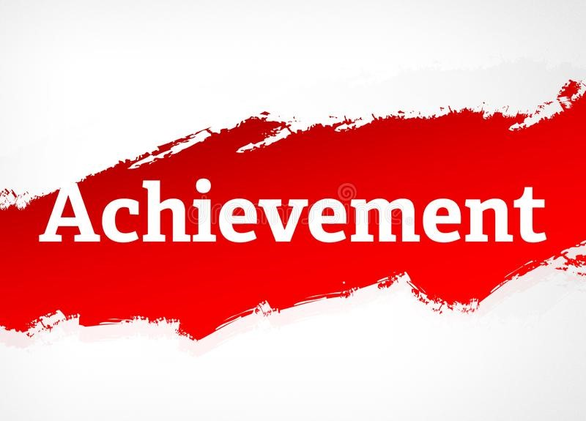    We all work towards our school vision to  “Be the Best You Can Be!”

√Checklist

In line with the Standards in Scotland’s Schools etc. Act 2000 (amended 2016), the following checklist is designed to assist Heads of establishment with whole school/centre improvement planning that fulfils statutory duties in accordance with the Act. This must be completed prior to submission.

SIP Consultation included the following stakeholders: | Complete |  | Content of plan | Complete
Children and Young People | √ |  | Takes account of strategic priorities outlined in the Education Service Improvement Plan. https://www.east-ayrshire.gov.uk/Resources/PDF/E/Education-Service-Improvement-Plan.pdf | √
Parent Council and Forum | √ |  | HGIOS 4 and EYQF are used as the frameworks to inform the content of SIPs. Where appropriate.  https://education.gov.scot/media/v5sh3dqt/frwk2_hgios4.pdf  https://education.gov.scot/inspection-and-review/inspection-frameworks/quality-improvement-framework-for-the-early-learning-and-childcare-sectors/ | √
Teachers, practitioners and ALL school/centre staff | √ |  | There is clear focus throughout the plan on measures to reduce of inequalities of outcome as a result of socio-economic disadvantage.  PEF: https://www.gov.scot/publications/pupil-equity-funding-national-operational-guidance-2023/documents/  CEF: https://www.gov.scot/publications/care-experienced-children-young-people-fund-operational-guidance-2023-24/documents/  SEF: https://www.gov.scot/publications/strategic-equity-funding-national-operational-guidance-2023/documents/ | √
Volunteers/ Community partners | √ |  | Appropriate cognisance has been made of the links between the plan and the working time agreement for teaching staff. | √
Head Teacher / Head of Centre Signature: Mrs Emma Johnstone |  |  | An accessible summary of the SIP is available and contained in this document and will be provided to parents, children and young people. | √

Pupil and parental strategic involvement

For session 2025-26, please describe below how children and young people will be involved in decisions relating to the operation of the school/centre | For session 2025-26, please describe below how parents will be involved in decisions relating to the operation of the school/centre
- Our Pupil Voice Group meets once a fortnight and consists of two children from each class in the school. The children use the evaluation toolkit How Good Is OUR School, to help them evaluate and make improvements. Each child has a journal where they note important information. They feedback to their class and gather the views of others. Other pupil leadership committees include:  - Sports Committee  - Clean Green Committee  - Digital Leaders  - Wellbeing Champions  - P7 Prefects / Buddies and House Captains  Pupil focus groups throughout the session focusing on aspects of the improvement plan during:  - Quality Assurance Calendar  - Citizenship assemblies  - Daily conversations between children and SMT focusing on wellbeing.  - Self-evaluation indicators and values  - Pupil wellbeing questionnaire’s focusing on the wellbeing indicators throughout the year - GMWP.  - Microsoft forms focusing on relevant school issues through SMT classroom monitoring visits, all children will answer key questions based on their experiences and evaluations of the school.  Children participate in the decisions made within their learning and what topics they would like to cover. | - Parent Council will have regular presentations from the Head Teacher and will have full involvement in the Improvement Agenda. They will have monthly meetings with the Head Teacher.  - Parents will be asked to contribute to our self-evaluation processes via the App and through our links to Teams surveys.  - Parents will be encouraged to comment on the work of the class through our school Blog.  - Parents will be given the opportunity to complete surveys based on our key drivers for change.  - Open afternoons and workshops will provide parents with information regarding the learning of their child and the changes in approaches.  - Class teachers will ask for feedback through end of topic evaluations and comments on the Teams or the Blog  - Parents will be invited to work with staff and pupils in forming this session’s Improvement Plan during our Collegiate Night activities.  - Parents who find it difficult to attend events will be asked to email their comments and suggestions into the school or complete Microsoft Forms.  - Curriculum open afternoons / sharing learning sessions  - Information sessions  - Parents’ Evening feedback  - PEF and Improvement plan consultation

Community Plan East Ayrshire  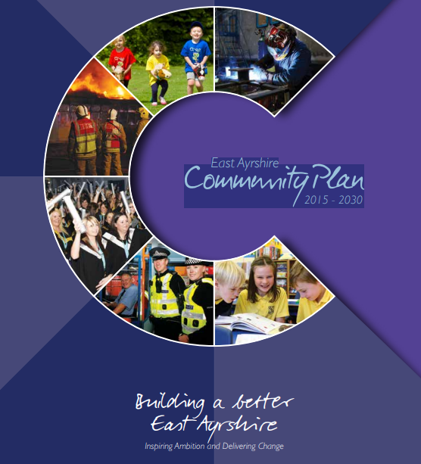  2015 - 2030 | Together, in achieving our Vision, Partners will demonstrate:  Effective leadership  We will provide clear leadership in Community Planning and engage effectively with our employees and communities.  Collective ownership  We will take collective ownership for delivering on the Community Plan, the associated Single Outcome Agreement, and the Community Plan Delivery Plans, and work hard to improve outcomes for local people and communities.  Good governance  We will implement clear operating arrangements to support effective strategic direction, scrutiny and accountability.  Democratic accountability  We will measure and report on the impact of our activities to demonstrate how effectively we are improving outcomes for local people and communities, and all partners will be held to account for their contribution.
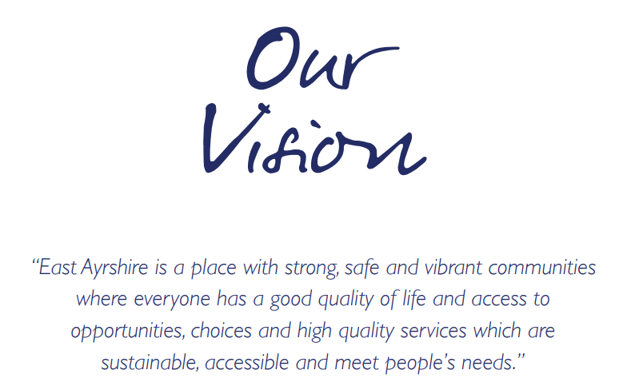  Our Partnership will continue to work to meet the needs of the people who live in our communities. Our guiding principles will be reflected in all that we do and should be evident for all to see. |  | We will:  - Promote lifelong learning.  - Promote equality and tackle inequality.  - Adopt a preventative approach.  - Ensure effective community engagement in the planning and delivery of local services.  - Use the strengths and resilience within communities.  - Drive efficiency and performance improvement.

National and Local Priorities
The Scottish Government’s vision for education in Scotland:  - Excellence through raising attainment and improving outcomes  - Achieving equity  Key priorities of the National Improvement Framework:  - Placing the human rights and needs of every child and young person at the centre of education  - Improvement in children and young people’s health and wellbeing  - Closing the attainment gap between the most and least disadvantaged children and young people  - Improvement in skills and sustained, positive  school-leaver destinations for all young people  - Improvement in attainment, particularly in literacy and numeracy | NIF drivers of improvement in the outcomes achieved by children and young people are:  - School and ELC leadership  - Teacher and practitioner professionalism  - Parent/carer involvement and engagement  - Curriculum and assessment  - School and ELC improvement  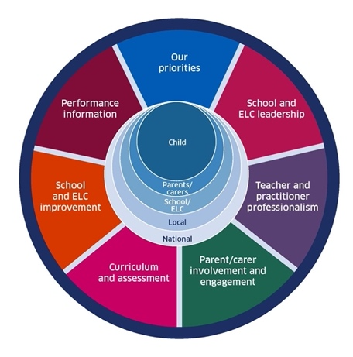  - Performance information | Scottish Attainment Challenge (SAC)  Scottish Attainment Challenge: framework for recovery and accelerating progress  Scottish Attainment Challenge Logic Model – Tackling the Poverty-Related Attainment Gap – Our Theory of Change  SAC organisers:  - Learning and teaching  - Leadership  - Families and communities

East Ayrshire Plans
Key Priorities | Education Service Improvement Plan: | Children’s Services Plan: | Community Learning and Development Plan:
1: Our Leadership | We actively support, promote and enact leadership at all levels. Our young people are supported to be leaders on their learning in our centres, schools and wider life experiences. All staff have ready access to appropriate CLPL and experiences to promote leadership in every classroom and centre. | Priorities for 2023-26:  - Our children and young people feel respected, listened to and influence change  - We are working collaboratively, reducing the impact of social and economic poverty on our children and young people  - Our children and young people feel safe  - Our children and young people have the best start in life  - Our children and young people’s mental health is improving | Outcomes:  - Growth  - Wellbeing  - Fairness  - Sustainability  Action areas  - Youth voice and participation  - Lifelong learning and skills development  - Empowering communities  - Wellbeing and inclusion
2: Teaching and Learning Together | Our young people should experience a teaching, learning and curriculum offer that meets their needs, and those of our local and national context. All staff should be supported to deliver in new and innovative ways by accessing CLPL relevant to their needs and those of our young people.
3: Our Wellbeing and Belonging | We want all of our young people to feel supported by people who know them well, and feel included in all of our schools and centres. Our staff need to be supported in their working with our young people, especially in times of adversity. As a key universal service, it is our vision that all young people attend our establishments on a full-time and regular basis to support them in their development at all stages.
4: Our Attainment, Destinations and Achievements | We want the very best for all of our young people in East Ayrshire. We aim to ensure all young people secure a positive destination through excellent achievement and attainment at all levels.

Our Leadership: Improvement priority: Skills for Learning, Life and Work through Digital Literacy, AI, and Learner Profiling

Target:
By June 2027, all learners will demonstrate progressive development in digital literacy, AI, meta-skills and transferable skills for learning, life and work through planned, relevant and real-life learning experiences across the curriculum. Learners will use Glow Blogs and My World of Work to profile and reflect on their skills, achievements and progress, with at least 90% of learners able to confidently articulate their strengths, identify next steps in their skills development and explain how their learning connects to future pathways and the world of work.

Rationale – Our curriculum refresh is on year 3 of its review and we have made significant progress. Staff evaluated that it is now required to look key areas of STEM, IT, AI and being more explicit with the teaching of metaskills.
NIF key drivers: |  | Teacher & practitioner professionalism |  |  |  | Curriculum & assessment |  |  |  |  |  | Parent/carer involvement & engagement |  |  |  | School & ELC improvement
HGIOS4 QIs: |  | 1.1 |  |  | 2.1 |  | 2.2 |  |  |  |  | 2.4 |  |  | 2.5 |  |  |  | 3.2
QF ELC: |  | Select QI |  |  | Select QI |  | Select QI |  |  |  |  | Select QI |  |  | Select QI |  |  |  | Select QI
ESIP key priorities: |  | N Teaching & Learning |  |  |  |  |  |  |  |  |  | N Our Wellbeing |  |  |  | N Our attainment
Outcomes for our learners  - What do we want to improve/change?  - Who is the target group?  - By how much?  - By when? |  |  | Our actions/Approaches/Interventions  - What are we going to do?  - How are we going to do it? |  |  |  |  | PEF  Tick row if it’s PEF-related |  | Who  Who will lead this work? |  |  | Measures  - How will we measure this?  - What ongoing information will demonstrate progress?  - What does “better” look like?  - How will we recognise better when we see it? |  |  |  | Review/milestones  - Monthly?  - Termly?  - On track to meet deadlines/targets?
Digital literacy progression framework embedded across all stages. |  |  | - Audit current digital literacy and IT skills provision across all stages.  - Create and implement a clear progression pathway for digital skills from Early Level to Second Level.  - Provide professional learning for staff on digital technologies and effective classroom practice. |  |  |  |  |  |  | DHT and working party |  |  | - All classes implement the digital skills progression framework.  - Learners can demonstrate age-appropriate digital literacy skills.  - Increased confidence among staff and learners in using digital technologies. |  |  |  | March 2027
All classes regularly use Glow Blogs to profile learning, achievements and skills development. |  |  | - Use digital tools such as Microsoft 365, Teams, Glow and blogs to support learning and profiling. |  |  |  |  |  |  | Class teachers and digital leader pupil group |  |  | - Regular updates and communication to parents
 | Learners engage with My World of Work activities appropriate to their stage. |  |  | - Introduce regular opportunities for learners to create, communicate, collaborate and problem-solve using technology.  - STEM focus weeks and pupil group work towards STEM Nation accreditation. |  |  |  |  |  |  | Class teachers and digital leader pupil group |  |  | - All learners maintain a digital profile evidencing achievements, skills and next steps.
 | Meta-skills explicitly taught, tracked and reflected upon across the curriculum. |  |  | - Children demonstrate knowledge and apply skills in various meta skills |  |  |  |  |  |  | Class teacher |  |  | - Measured progress in skills development through applying skills in different contexts
 | Evidence from learner conversations shows increased understanding of transferable skills and their relevance to life and work. |  |  | - Embed online safety and digital citizenship learning across all stages. |  |  |  |  |  |  | Working party |  |  | - Demonstrate appropriate tools to support learning and use of IT to support skills for work, learning and life
 | Monitoring and tracking demonstrate progression in skills for learning, life and work across all stages. |  |  | - Monitor and track digital literacy progression through learner profiles, evidence of learning and moderation activities.  - Share effective practice through collegiate sessions and peer observations. |  |  |  |  |  |  | Working party |  |  | - Digital literacy attainment data shows measurable improvement across all stages by June 2027.
 | Increased learner confidence in discussing strengths, achievements and future aspirations. |  |  | - Use My World of Work and Meta-skills resources to support skills development and learner reflection.  - Undertake STEM focus activities |  |  |  |  |  |  | Digital leaders |  |  | - Learner and staff surveys show improved confidence and engagement with digital learning.
Teaching and Learning Together: Improvement priority:
Raising Attainment and Achievement in Numeracy
Target:
By June 2027, attainment in numeracy will increase by at least 5% across all stages, with a reduction in the attainment gap for identified learners. Through consistent implementation of high-quality learning and teaching, active maths approaches, problem-solving strategies and appropriate support and challenge, learners will demonstrate increased confidence, accuracy, and resilience in mathematical thinking.

Rationale – Due to a high concentration on the consistency and delivery of literacy our numeracy data has fallen slightly. We have introduced new resources, and we need to have a consistent approach to the skills progression. Problem solving has been an area we have evaluated as need a more robust and progressive structure, to ensure skills development.

NIF key drivers: | Performance information |  |  | Curriculum & assessment |  |  |  | School & ELC improvement |  |  | Select driver
HGIOS4 QIs: | 1.1 |  | 2.1 |  | 2.3 |  |  | 3.1 |  | Select QI |  |  | Select QI
QF ELC: | Select QI |  | Select QI |  | Select QI |  |  | Select QI |  | Select QI |  |  | Select QI
ESIP key priorities: | N Our Leadership |  |  |  |  |  |  | N Our Wellbeing |  |  | N Our attainment
Outcomes for our learners  - what do we want to improve/change?  - who is the target group?  - by how much?  - by when? |  | Our actions/Approaches/Interventions  - what are we going to do?  - how are we going to do it? |  |  |  | PEF  Tick row if it’s PEF-related | Who  Who will lead this work? |  | Measures  - how will we measure this?  - what ongoing information will demonstrate progress?  - what does “better” look like?  - how will we recognise better when we see it? |  |  | Review/milestones  - monthly?  - termly?  - on track to meet deadlines/targets?
At least 85% of learners achieve expected Curriculum for Excellence levels in numeracy.  A 5% increase in attainment data across all stages compared to June 2026 baseline data. |  | - Implement a consistent whole-school approach to numeracy and mathematics learning and teaching.  - Embed active maths approaches across all stages to increase engagement, understanding and application of concepts.  - Develop high-quality questioning and mathematical dialogue to deepen thinking and reasoning.  - Ensure lessons provide appropriate pace, challenge and differentiation for all learners.  - staff in professional learning focused on numeracy pedagogy, active maths and problem-solving approaches.  - Facilitate collaborative planning, peer observations and sharing of effective practice. |  |  |  |  | DHT, PT and working party |  | - Active maths and problem-solving approaches evident in all classes.  - Increased learner confidence and engagement in numeracy.  - Consistent use of assessment data to inform planning and interventions. |  |  | Dec 2026
Evidence from assessments shows improved performance in problem-solving and reasoning tasks. |  | - Provide regular opportunities for learners to apply numeracy skills in real-life and interdisciplinary contexts. |  |  |  |  | Class teachers |  |  |  |  | Feb 2026
All classes implement agreed active maths and problem-solving approaches consistently. |  | - Explicitly teach problem-solving strategies and mathematical reasoning skills. |  |  |  |  | Working party |  | - Use a resource to support a skills development for all stages of the school to focus on.
Learner voice surveys indicate increased confidence and positive attitudes towards numeracy. |  | - Promote resilience through challenging tasks, collaborative learning and growth mindset approaches.  - Increase learner ownership through self-assessment, goal setting and reflection on progress.  - Promote positive attitudes towards numeracy and celebrate success in mathematical learning. |  |  |  |  | pupils |  | - Positive evidence from learner voice, classroom observations and quality assurance activities
Targeted interventions demonstrate measurable progress for identified learners through tracking and monitoring data. |  | - Use a range of formative and summative assessments to identify strengths, gaps and next steps in learning.  - Strengthen moderation activities to ensure consistency of teacher professional judgement.  - Use tracking and monitoring data effectively to identify learners requiring support, challenge or intervention. |  |  |  |  | Class teachersEAST support |  | - Improved attainment data across all stages.  - Reduction in the attainment gap for identified learners.
Learning visits and quality assurance evidence show high-quality numeracy learning experiences, with appropriate pace, challenge, and differentiation in all classes. |  | - Deliver targeted interventions for learners at risk of not achieving expected levels.  - Provide enhanced challenge for higher-attaining learners to maximise achievement.  - Monitor the impact of interventions regularly and adjust support as required. |  |  |  |  | SMT and peer observations |  | - Classroom visits and quality assurance  - Professional discussions  - Target setting  - Assessment |  |  | Sept and May

Our Wellbeing and Belonging: Improvement priority:
Literacy, Languages and Global Citizenship

Improve learner engagement and attainment in Literacy and 1+2 Languages through the development of a progressive, skills-based curriculum.
This will be achieved by introducing opportunities for learning in Spanish, Mandarin, and British Sign Language (BSL), ensuring a clear progression of language skills across all stages. Through high-quality learning experiences, learners will develop confidence in communication, increase their awareness of diverse cultures, and enhance their global citizenship skills. We also aim to further enhance our Reading Schools accreditation.

Rationale – we have started in our journey to improve learner engagement in reading and need to continue this into this session. We are also striving for a consistent approach to the delivery of reading skills and 1+2 languages through introducing clear learning pathways. This will give our children experience in these cultures and languages in order to progress in Grange Academy as they have introduced these to their curriculum, replacing French.
NIF key drivers: | School & ELC improvement |  |  | Teacher & practitioner professionalism |  |  |  | Select driver |  |  | Select driver
HGIOS4 QIs: | Select QI |  | Select QI |  | Select QI |  |  | Select QI |  | Select QI |  |  | Select QI
QF ELC: | Select QI |  | Select QI |  | Select QI |  |  | Select QI |  | Select QI |  |  | Select QI
ESIP key priorities: | N Our Leadership |  |  | N Teaching & Learning |  |  |  | N Our attainment
Outcomes for our learners  - what do we want to improve/change?  - who is the target group?  - by how much?  - by when? |  | Our actions/Approaches/Interventions  - what are we going to do?  - how are we going to do it? |  |  |  | PEF  Tick row if it’s PEF-related | Who  Who will lead this work? |  | Measures  - how will we measure this?  - what ongoing information will demonstrate progress?  - what does “better” look like?  - how will we recognise better when we see it? |  |  | Review/milestones  - monthly?  - termly?  - on track to meet deadlines/targets?
- Completion of the reading school’s accreditation |  | Completion of plan to achieve success in Reading Schools through:  Appropriate resourcing,  Clear criteria,  Pupil group,  Evaluation of impact  Data analysis |  |  |  |  | DHT, PT and working party |  | By June 2027 we will have been awarded Reading schools |  |  | June 2027
- A progressive skills framework for Spanish, Mandarin and BSL is in place. |  | Create a clear progression pathway from P1–P7 that identifies the key skills learners will develop in:  - Listening and responding  - Talking and communication  - Reading and understanding  - Intercultural awareness  - Signing and non-verbal communication (BSL) |  |  |  |  | DHT, PT and working party |  | By June 2027, a progressive skills-based framework for Spanish, Mandarin and BSL will be embedded across the school. |  |  | May 2027
- Learners demonstrate increased confidence and engagement in language learning. |  | - Spanish as the core L2 language across the school.  - Mandarin as an enrichment language, focusing on cultural understanding and introductory communication.  - BSL integrated throughout the school to promote inclusion and communication skills. |  |  |  |  | PT and working party |  | Learner voice will show increased confidence and engagement in language learning, with all classes demonstrating progression in communication skills and intercultural understanding through planned learning experiences.
- Evidence of progression in listening, talking, reading and intercultural understanding. |  | - Ensure skills build progressively across stages rather than repeating the same content each year.
- Staff are supported to deliver high-quality language learning experiences. |  | - Provide professional learning and shared resources.  - Use online platforms, local authority support and partner organisations.  - Develop simple lesson structures and progression guides for staff. |  |  |  |  | Working party and class teachers |  |  |  |  | Feb in-service day
- Learner voice indicates positive attitudes towards language learning and cultural awareness. |  | - Language ambassadors and pupil leadership groups.  - Language-themed days and cultural celebrations.  - Digital tools and interactive resources.  - Links with secondary schools and community partners. |  |  |  |  | Pupils and PT
- Increased awareness of diverse cultures and enhance global citizenship skills and community links. |  | Create opportunities to use languages in:  - Daily routines and classroom instructions  - Assemblies and celebrations  - Music, PE and outdoor learning  - International and cultural events  - Rights Respecting Schools and global citizenship work |  |  |  |  |  |  | Gather evidence through:  - Learner voice surveys.  - Classroom observations.  - Samples of learner work.  - Tracking engagement and participation.  - Staff evaluations of confidence and delivery.

Our Attainment, Destinations and Achievements: Improvement priority:

Raise attainment in Writing through effective learning, teaching and assessment with a clear focus on achieving success criteria.

Rationale:
Improve consistency and quality of writing through the effective implementation of the CYPIC Writing Framework across P3–P6, ensuring a progressive approach to writing skills development and assessment.
Last session our Primary 4 and 5’s undertook this and the impact on our attainment data has been incredible. We want to spread this further across the school.
NIF key drivers: | Teacher & practitioner professionalism |  |  | Performance information |  |  |  | Curriculum & assessment |  |  | Parent/carer involvement & engagement
HGIOS4 QIs: | 2.1 |  | 2.2 |  | 2.3 |  |  | 3.1 |  | Select QI |  |  | Select QI
QF ELC: | Select QI |  | Select QI |  | Select QI |  |  | Select QI |  | Select QI |  |  | Select QI
ESIP key priorities: | N Our Leadership |  |  | N Teaching & Learning |  |  |  | N Our Wellbeing
Outcomes for our learners  - what do we want to improve/change?  - who is the target group?  - by how much?  - by when? |  | Our actions/Approaches/Interventions  - what are we going to do?  - how are we going to do it? |  |  |  | PEF  Tick row if it’s PEF-related | Who  Who will lead this work? |  | Measures  - how will we measure this?  - what ongoing information will demonstrate progress?  - what does “better” look like?  - how will we recognise better when we see it? |  |  | Review/milestones  - monthly?  - termly?  - on track to meet deadlines/targets?
By June 2028, all teaching staff will confidently implement the CYPIC Writing Framework across all stages, resulting in improved learner engagement, increased attainment in writing and enhanced staff capacity through professional learning, moderation and collaborative practice. |  | - Provide professional learning on the CYPIC Writing Framework.  - Create a clear progression pathway from P1–P7.  - Use model lessons, peer observations and collaborative planning.  - Develop shared expectations for planning, teaching and assessing writing.  - Ensure success criteria are co-constructed with learners where appropriate.  - Use success criteria consistently during lessons, self-assessment and feedback.  - Introduce writing checklists linked to CYPIC expectations.  - Support learners to identify next steps in their writing.  - Deliver regular high-quality writing lessons using agreed approaches.  - Use high-quality texts and writing stimuli.  - Ensure appropriate pace, challenge and differentiation.  - Provide targeted support and extension opportunities. |  |  |  |  | HT, current trained staff and Pr5 and Pr6 staff |  | - Increased percentages of learners on track in P1, P4 and P7.  - Improved writing attainment data across all stages.  - Consistent CYPIC approaches evident in learning visits and jotter monitoring. |  |  | January 2027
By May 2027, 85% of P1, P4 and P7 learners will be on track to achieve expected Curriculum for Excellence levels in writing, as evidenced through teacher professional judgement, moderation activities, and assessment data. |  | - Schedule termly moderation activities within and across stages.  - Gather and analyse writing evidence using local authority benchmarks.  - Use attainment meetings to track progress and identify interventions.  - Develop a shared understanding of achievement of a level. |  |  |  |  | DHT and working party |  | Moderation evidence showing increased staff confidence and consistency.
By June 2028, attainment in writing will increase by at least 5% across all stages, with a reduction in the attainment gap and an increase in the number of learners achieving beyond expected levels. |  | - Use writing assessments and professional judgement to identify learners requiring support or challenge.  - Implement targeted interventions for identified groups.  - Monitor impact through tracking data and learner work. |  |  |  |  | SMT and class teacher |  | Improved quality of writing samples across genres  Moderation evidence showing increased staff confidence and consistency.
By June 2028, 90% of learners will demonstrate improved ability to use success criteria independently to plan, monitor and evaluate their writing, evidenced through learner conversations, writing samples and quality assurance activities. |  | - Give learners regular opportunities to write for real-life purposes and audiences.  - Use learner conversations to discuss progress and next steps.  - Celebrate writing achievements through displays, assemblies and digital platforms.  - Encourage self and peer assessment. |  |  |  |  | Class teacher and pupils |  | Learners able to explain success criteria and identify next steps in their writing.  Positive feedback from learners and staff regarding engagement and confidence in writing.

2024-25 baseline |  |  |  |  |  | 2025-26 targets |  |  |  |  |  | 2025-26 actual
 | Reading | Writing | L&T | Literacy | Numeracy |  | Reading | Writing | L&T | Literacy | Numeracy |  | Reading | Writing | L&T | Literacy | Numeracy
P1 |  |  |  |  |  | P1 | 100 | 100 | 100 | 100 | 100 | P1 | 97 | 92 | 100 | 92 | 100
P2 | 86 | 72 | 93 | 72 | 91 | P2 | 95 | 93 | 97 | 93 | 97 | P2 | 93 | 93 | 98 | 93 | 97
P3 | 86 | 85 | 89 | 85 | 92 | P3 | 86 | 83 | 92 | 83 | 86 | P3 | 86 | 83 | 92 | 83 | 86
P4 | 80 | 67 | 93 | 67 | 69 | P4 | 81 | 78 | 94 | 78 | 74 | P4 | 84 | 81 | 96 | 81 | 79
P5 | 75 | 69 | 89 | 69 | 68 | P5 | 80 | 71 | 89 | 71 | 68 | P5 | 81 | 94 | 92 | 81 | 64
P6 | 85 | 75 | 77 | 75 | 68 | P6 | 85 | 79 | 90 | 79 | 83 | P6 | 81 | 77 | 92 | 77 | 86
P7 | 73 | 59 | 83 | 59 | 68 | P7 | 76 | 75 | 89 | 75 | 74 | P7 | 77 | 74 | 84 | 74 | 80

Reading | P1 | P2 | P3 | P4 | P5 | P6 | P7 |  | Writing | P1 | P2 | P3 | P4 | P5 | P6 | P7 |  | L&T | P1 | P2 | P3 | P4 | P5 | P6 | P7 |  | Numeracy | P1 | P2 | P3 | P4 | P5 | P6 | P7
P1 | 97 |  |  |  |  |  |  |  | P1 | 92 |  |  |  |  |  |  |  | P1 | 100 |  |  |  |  |  |  |  | P1 | 100
P2 | 91 | 93 |  |  |  |  |  |  | P2 | 86 | 93 |  |  |  |  |  |  | P2 | 98 | 98 |  |  |  |  |  |  | P2 | 95 | 97
P3 | 91 | 86 | 86 |  |  |  |  |  | P3 | 97 | 75 | 83 |  |  |  |  |  | P3 | 91 | 88 | 92 |  |  |  |  |  | P3 | 83 | 80 | 86
P4 | 83 | 83 | 83 | 84 |  |  |  |  | P4 | 83 | 89 | 80 | 81 |  |  |  |  | P4 | 92 | 94 | 94 | 96 |  |  |  |  | P4 | 92 | 86 | 82 | 79
P5 | 79 | 71 | 70 | 77 | 81 |  |  |  | P5 | 76 | 76 | 67 | 71 | 94 |  |  |  | P5 | 90 | 80 | 74 | 88 | 92 |  |  |  | P5 | 79 | 74 | 70 | 68 | 64
P6 | 92 | 89 | 55 | 79 | 84 | 81 |  |  | P6 | 89 | 87 | 58 | 76 | 79 | 77 |  |  | P6 | 97 | 91 | 66 | 89 | 92 | 92 |  |  | P6 | 85 | 88 | 55 | 75 | 68 | 86
P7 |  | 74 | 67 | 79 | 69 | 74 | 77 |  | P7 |  | 76 | 65 | 64 | 67 | 70 | 74 |  | P7 |  | 78 | 56 | 81 | 80 | 86 | 84 |  | P7 |  | 73 | 63 | 68 | 68 | 75 | 80

Summary of Improvement Plan directly linking to Education Service Improvement Plan

Our Leadership | Teaching and Learning Together
- Strengthen Leadership at all levels  - Build staff capacity and confidence  - Pupil leadership and voice  - Driving improvement through data and self-evaluation | - High quality teaching and learning in literacy and numeracy  - Progressive curriculum pathways  - Develop a progressive approach to problem solving and link to real-life experiences
Our wellbeing and belonging | Our Attainment, Destinations and Achievements
- Nurture, inclusion and supportive environment  - Promoting positive behaviour and relationships  - Mental health and wellbeing  - Skills for life, learning and work  - Strong partnerships | - Raising attainment in literacy and numeracy  - Tracking progress and closing gaps  - Developing skills for life, learning and work  - Celebrate achievements and aspirations

