Supporting Inclusion in the Mainstream Classroom
A Practical Guide for Class Teachers
Purpose of this Guide
This guide is intended to support class teachers in meeting the needs of children and young people with Additional Support Needs (ASN) within a mainstream classroom environment. It is grounded in:
- The CIRCLE Framework
- Inclusive practice within Scottish education
- The professional responsibilities of the class teacher
- Universal supports and differentiated planning
- Nurture and trauma-informed approaches
The aim is to promote participation, independence, regulation and engagement through practical classroom supports that can be embedded into daily practice.
This guide recognises that Classroom Assistant (CA) support may be limited and therefore prioritises high-quality universal supports that benefit all learners.

The Role of the Class Teacher
The class teacher has responsibility for:
- Creating an inclusive learning environment
- Planning differentiated learning experiences
- Supporting wellbeing and emotional regulation
- Ensuring all learners can access the curriculum
- Identifying and reducing barriers to learning
- Working collaboratively with support staff and families
- Embedding universal supports into everyday practice
While support staff can provide valuable assistance, responsibility for planning, differentiation and pastoral care remains with the class teacher.

The CIRCLE Framework
The CIRCLE Framework encourages staff to consider:
- The Environment
- Structures and Routines
- Motivation and Relationships
- Skills Development
The framework promotes the understanding that adjustments to the environment, routines and teaching approaches can significantly improve participation and inclusion.

Universal Supports in the Classroom
Universal supports should be available to all pupils and embedded consistently within classroom practice.
These supports:
- Reduce anxiety
- Increase predictability
- Support independence
- Improve engagement
- Reduce reliance on adults
- Benefit a wide range of learners

1. Visual Timetables and “Map of the Day”
Purpose
A visual timetable or “Map of the Day” helps pupils understand:
- What is happening
- When activities will occur
- What changes may happen
- When breaks and transitions are coming
This reduces uncertainty and supports emotional regulation.
Good Practice
- Display the timetable clearly at pupil eye level
- Refer to it throughout the day
- Use visuals alongside text where appropriate
- Highlight any changes early
- Remove or tick off completed activities
Benefits
- Supports transitions
- Reduces anxiety by creating predictability
- Encourages independence
- Improves attention and participation
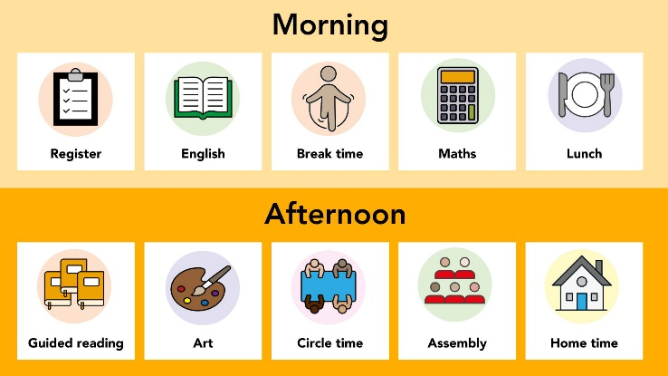
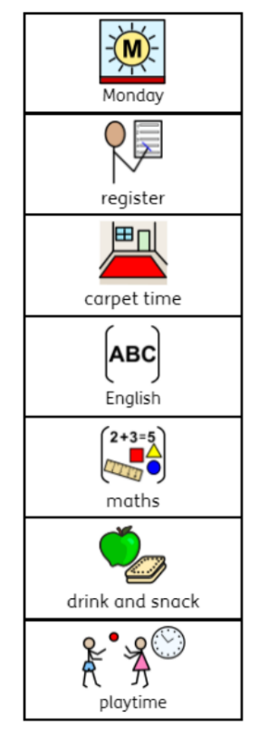
Examples



2. Checklists
Purpose
Checklists support learners to:
- Break tasks into manageable steps
- Organise themselves independently
- Reduce cognitive overload
- Experience success through completion
Good Practice
Checklists should:
- Use simple language
- Include visuals where needed
- Be short and achievable
- Be individualised when appropriate
Examples include:
- Morning routine checklists
- Task completion checklists
- Writing reminders
- Packing-up routines
Benefits
- Supports executive functioning
- Encourages independence
- Reduces adult prompting
- Builds confidence
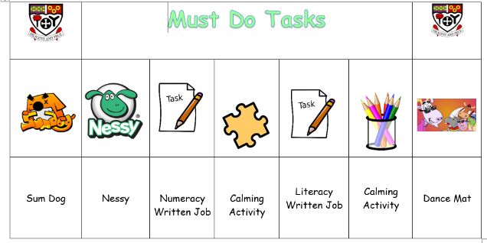
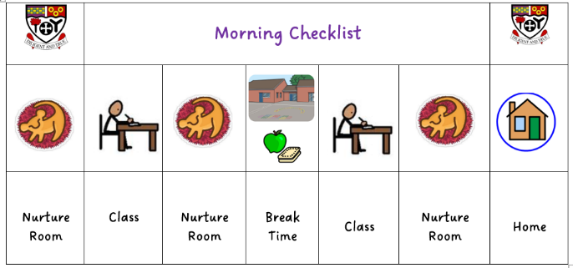
Examples

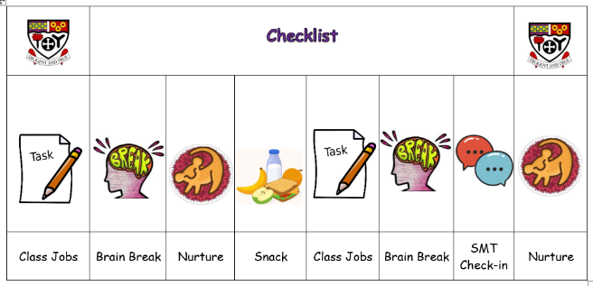

3. Timetabling and Brain Breaks
Purpose
Many learners require planned movement and regulation opportunities throughout the day.
Brain breaks are proactive supports rather than rewards.
They can:
- Improve concentration
- Support sensory regulation
- Reduce dysregulation
- Increase engagement in learning
Good Practice
Brain breaks should:
- Be built into planning
- Be predictable where possible
- Be short and purposeful
- Match learner needs
Examples include:
- Movement breaks
- Stretching
- Sensory activities
- Mindfulness
- Outdoor learning opportunities
- Calm breathing exercises
Timetabling Considerations
When planning learning:
- Alternate active and seated tasks
- Consider cognitive demand across the day
- Allow processing time
- Plan transitions carefully
- Bespoke options e.g. life skills, outdoor time
- Use visual countdowns and warnings
Benefits
- Improves regulation
- Supports attention and focus
- Reduces the feel of being overwhelmed
- Promotes readiness to learn
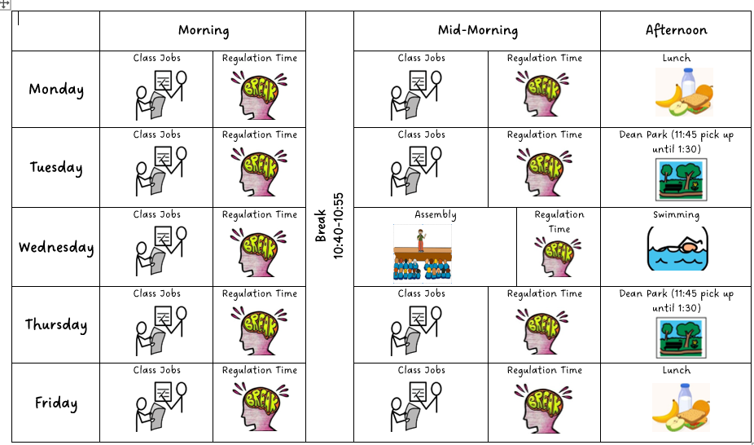
Examples

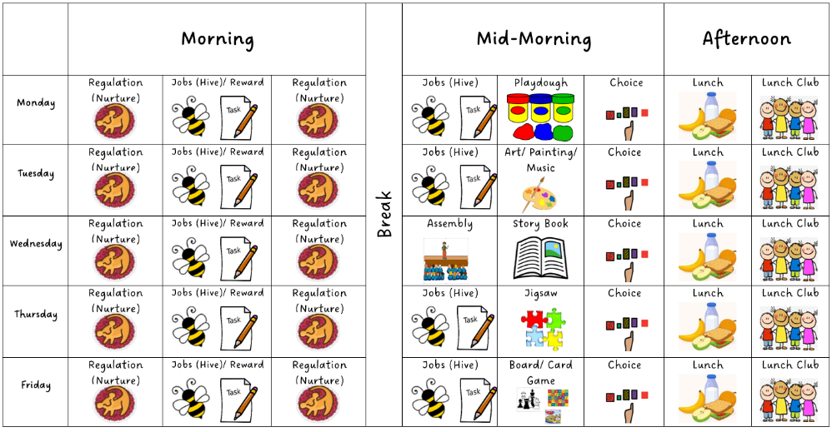

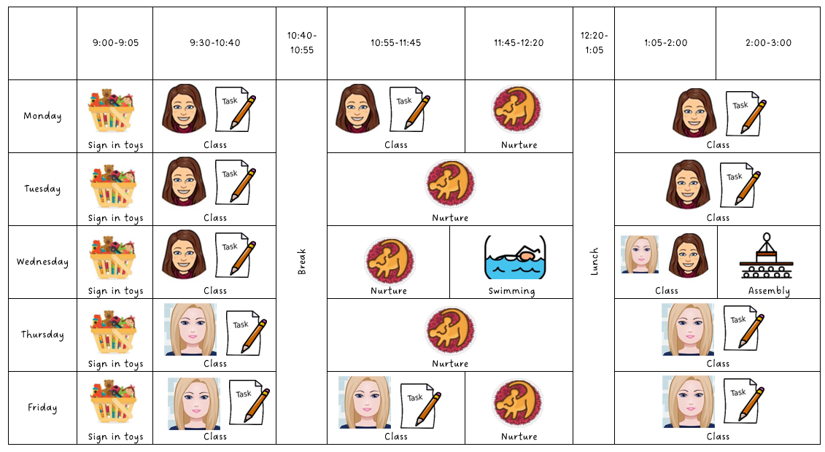

4. Purposeful Use of Classroom Assistant Support
Key Principle
If a pupil or group is working with a Classroom Assistant outside of the classroom, there should be a clear purpose linked to learning, wellbeing or participation.
Support should:
- Promote independence
- Be targeted and planned
- Have a clear intended outcome
- Support inclusion rather than separation
Appropriate Reasons for Targeted CA Support
Examples may include:
- Targeted literacy or numeracy intervention
- Emotional regulation support
- Sensory regulation
- Pre-teaching or overlearning concepts
- Supporting a safe transition
- Small group social communication work
Avoid
- Removing pupils simply because they are struggling to engage
- Over-reliance on adult support
- Creating learned dependence
- Isolating pupils from peers unnecessarily
Good Practice
- Ensure communication between teacher and CA is clear
- Share learning intentions and success criteria
- Review support regularly
- Encourage supported independence

Differentiation in Practice
Differentiation should be planned by the class teacher and may include:
Differentiation by Support
- Visual supports
- Adult prompting
- Peer support
- Chunked instructions
Differentiation by Task
- Reduced written workload
- Alternative recording methods
- Structured templates
- Accessible resources
Differentiation by Outcome
- Personalised targets
- Opportunities for challenge and support
Differentiation by Environment
- Flexible seating plan
- Workspaces
- Sensory supports (ear defenders, fidgets)
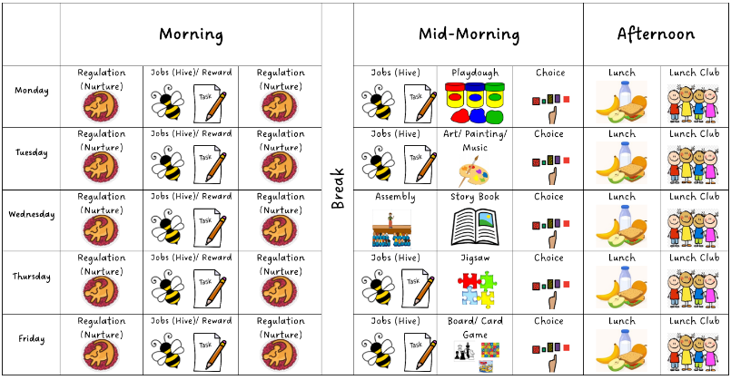
Examples

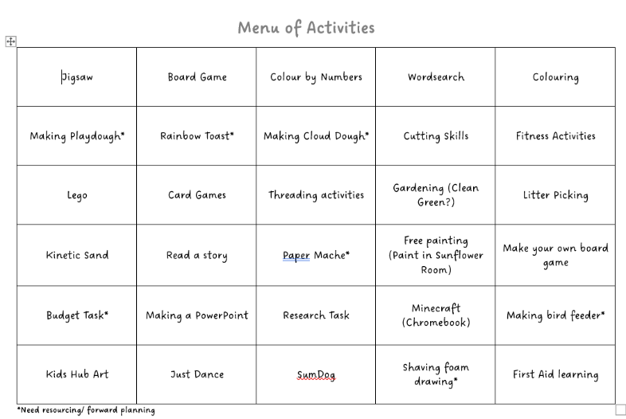

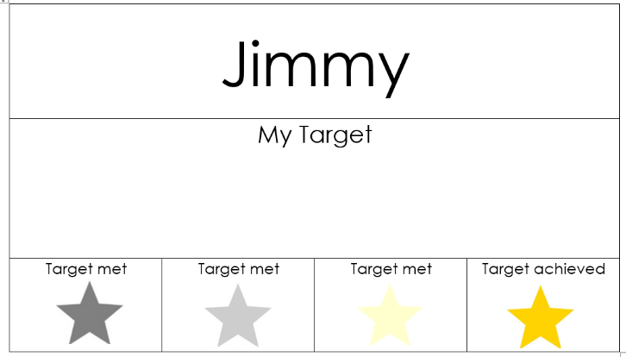

Supporting Emotional Regulation
Children learn best when they feel safe, regulated and connected.
Classroom approaches may include:
- Emotion check-ins
- Calm spaces
- Predictable routines
- Co-regulation with adults
- Relationship-based approaches
- Use of restorative language
- Regulation strategies taught and agreed collaboratively
Adults should aim to:
- Remain calm and consistent
- Validate emotions while maintaining boundaries
- Focus on support rather than punishment
- Use clear and concise language

Promoting Independence
A key aim of support should always be increasing pupil independence.
Strategies include:
- Visual prompts instead of repeated verbal prompts
- Encouraging problem-solving
- Giving processing time
- Using now/next boards
- Teaching routines explicitly
- Gradually reducing adult support
The long-term goal is for learners to:
- Understand routines
- Access supports independently
- Self-regulate more effectively
- Participate confidently in learning

Planning Considerations for Teachers
When planning learning experiences, consider:
Environment
- Is the classroom calm and predictable?
- Are supports visible and accessible?
Communication
- Are instructions clear and concise?
- Are visuals used consistently?
Participation
- Can all learners access the task?
- Are there multiple ways to engage?
Regulation
- Have movement and sensory needs been considered?
- Are there planned regulation opportunities?
Independence
- Are pupils relying on adults unnecessarily?
- What supports encourage self-management?

Support Plans
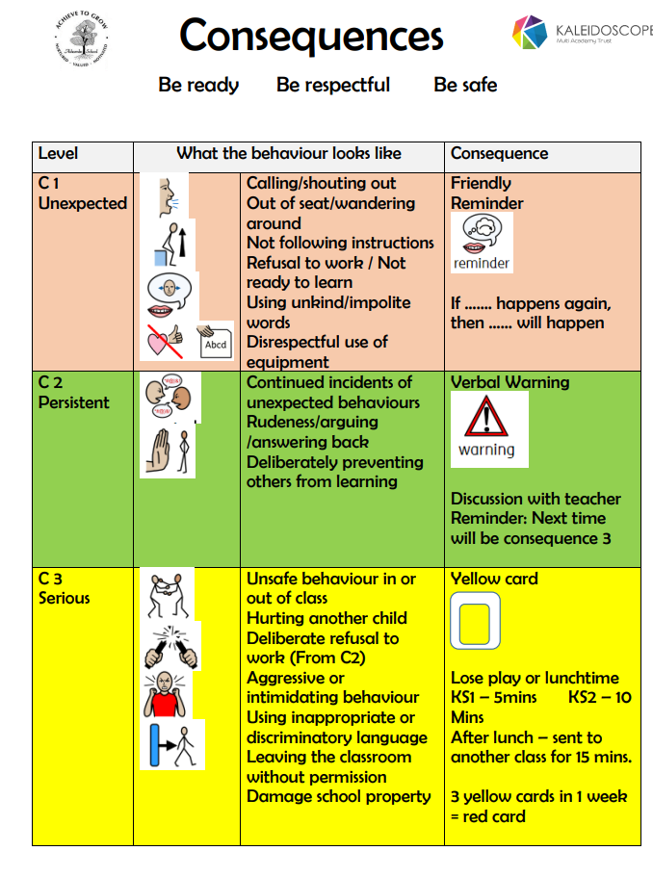

Support Plans
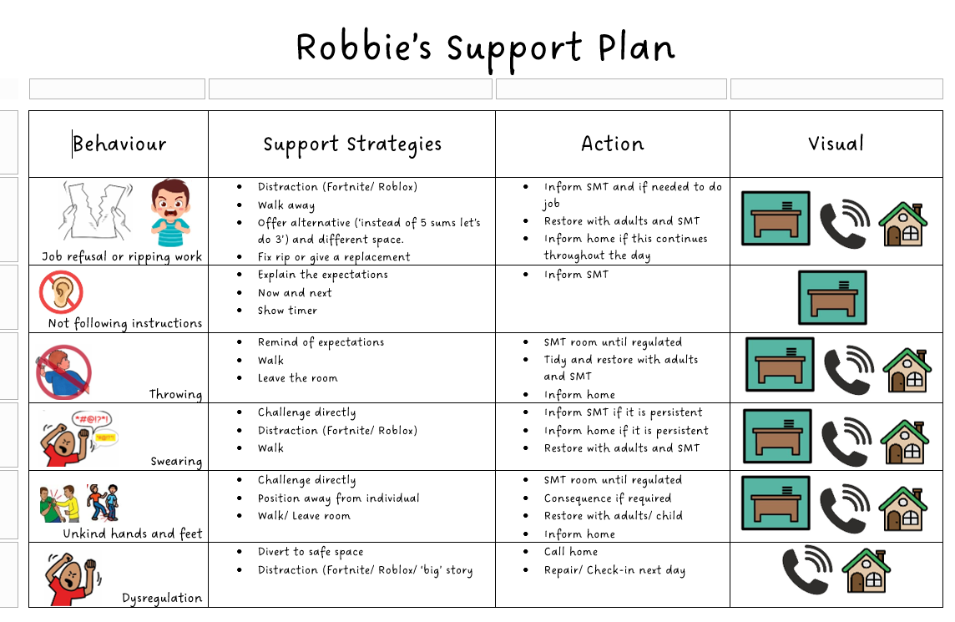

Safety Plans
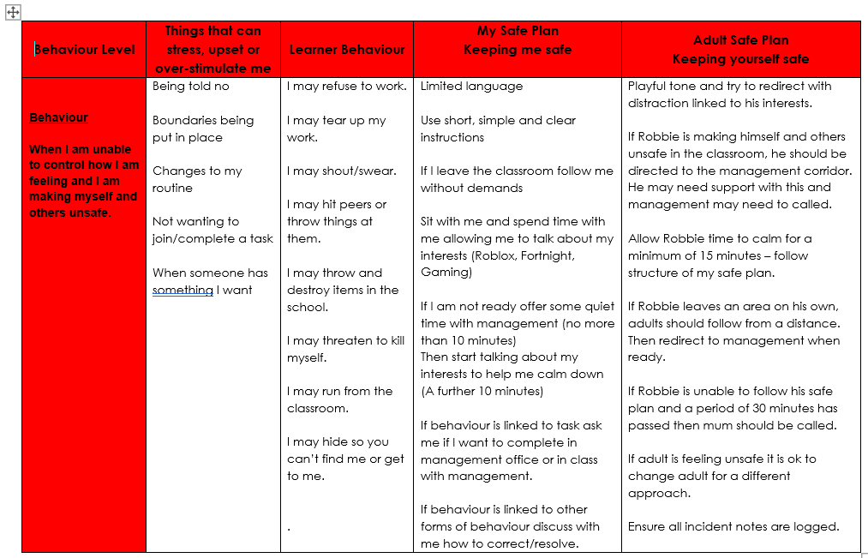

Visual Timetables
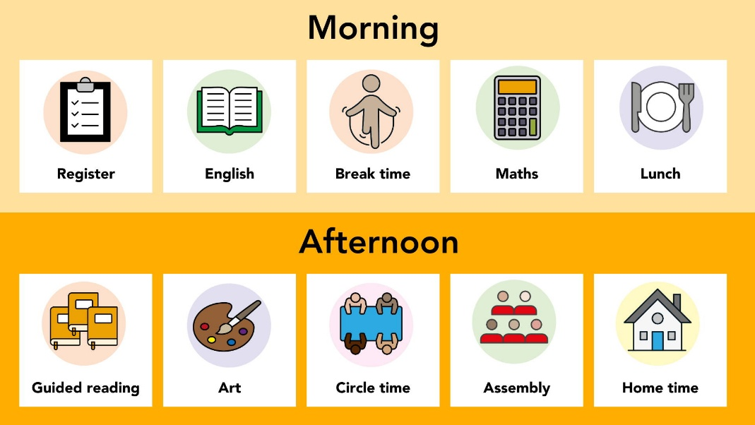



Checklists

Bespoke Support

Bespoke Timetables



Checklist of Strategies and Support
Strategy | Trialled | Impact  (traffic light with the support of observations and regulation trackers)
Whole class Map of the Day
Personalised Map of the Day
Visual Timetable
Now and Next Board
Daily Checklists
Calm area
Individualised supports (e.g. wiggle cushions, fidgets, chew toys, chunked tasks, job then reward, IT)
Timetabled Brain Breaks (menu)
Bespoke timetable (e.g. baking, outdoors, life skills)
Individual Targets (assessment informed)
Targeted Intervention with CA
Targeted Intervention with Nurture Department
Support Plans
Safety Plans
Individual Timetable (out of class)
Reduced timetable

